








Manage and execute a detailed tour itinerary
D2.TTO.CL4.09
Trainer Guide

Manage and execute a detailed tour itinerary
D2.TTO.CL4.09
Trainer Guide





Project Base
William Angliss Institute of TAFE
555 La Trobe Street
Melbourne 3000 Victoria
Telephone: | (03) 9606 2111
Facsimile: | (03) 9670 1330
Acknowledgements
Project Director: | Wayne Crosbie
Project Manager | Jim Irwin
Chief Writer: | Alan Hickman
Subject Writer: | Catherine Dubois
Editor: | Jim Irwin
DTP/Production: | Daniel Chee, Mai Vu, Cindy Curran

The Association of Southeast Asian Nations (ASEAN) was established on 8 August 1967. The Member States of the Association are Brunei Darussalam, Cambodia, Indonesia, Lao PDR, Malaysia, Myanmar, Philippines, Singapore, Thailand and Viet Nam.
The ASEAN Secretariat is based in Jakarta, Indonesia.
General Information on ASEAN appears online at the ASEAN Website: www.asean.org.
All text is produced by William Angliss Institute of TAFE for the ASEAN Project on “Toolbox Development for Tourism Labour Divisions for Travel Agencies and Tour Operations”.
This publication is supported by the Australian Government’s aid program through the ASEAN-Australia Development Cooperation Program Phase II (AADCP II).
Copyright: Association of Southeast Asian Nations (ASEAN) 2015.
All rights reserved.
Disclaimer
Every effort has been made to ensure that this publication is free from errors or omissions. However, you should conduct your own enquiries and seek professional advice before relying on any fact, statement or matter contained in this book. The ASEAN Secretariat and William Angliss Institute of TAFE are not responsible for any injury, loss or damage as a result of material included or omitted from this course. Information in this module is current at the time of publication. Time of publication is indicated in the date stamp at the bottom of each page.
Some images appearing in this resource have been purchased from stock photography suppliers Shutterstock and iStockphoto and other third party copyright owners and as such are non-transferable and non-exclusive. Clip arts, font images and illustrations used are from the Microsoft Office Clip Art and Media Library. Some images have been provided by and are the property of William Angliss Institute.
Additional images have been sourced from Flickr and SXC and are used under Creative Commons licence: http://creativecommons.org/licenses/by/2.0/deed.en
File name: TG_Manage_exe_detailed tour itinerary_170715





Table of contents
Competency Based Training (CBT) and assessment – An introduction for trainers 1
Competency standard 11
Notes and PowerPoint slides 15
Recommended training equipment 111
Instructions for Trainers for using PowerPoint – Presenter View 113
Appendix – ASEAN acronyms 115

Competency Based Training (CBT) and assessment – An introduction for trainers

Competency
Competency refers to the ability to perform particular tasks and duties to the standard of performance expected in the workplace.
Competency requires the application of specified knowledge, skills and attitudes relevant to effective participation, consistently over time and in the workplace environment.
The essential skills and knowledge are either identified separately or combined.
Knowledge identifies what a person needs to know to perform the work in an informed and effective manner.
Skills describe the application of knowledge to situations where understanding is converted into a workplace outcome.
Attitude describes the founding reasons behind the need for certain knowledge or why skills are performed in a specified manner.
Competency covers all aspects of workplace performance and involves:
- Performing individual tasks
- Managing a range of different tasks
- Responding to contingencies or breakdowns
- Dealing with the responsibilities of the workplace
- Working with others.

Unit of competency
Like with any training qualification or program, a range of subject topics are identified that focus on the ability in a certain work area, responsibility or function.
Each manual focuses on a specific unit of competency that applies in the hospitality workplace.
In this manual a unit of competency is identified as a ‘unit’.
Each unit of competency identifies a discrete workplace requirement and includes:
- Knowledge and skills that underpin competency
- Language, literacy and numeracy
- Occupational safety and health requirements.
Each unit of competency must be adhered to in training and assessment to ensure consistency of outcomes.

Element of competency
An element of competency describes the essential outcomes within a unit of competency.
The elements of competency are the basic building blocks of the unit of competency. They describe in terms of outcomes the significant functions and tasks that make up the competency.
In this manual elements of competency are identified as an ‘element’.

Performance criteria
Performance criteria indicate the standard of performance that is required to demonstrate achievement within an element of competency. The standards reflect identified industry skill needs.
Performance criteria will be made up of certain specified skills, knowledge and attitudes.

Learning
For the purpose of this manual learning incorporates two key activities:
- Training
- Assessment.
Both of these activities will be discussed in detail in this introduction.
Today training and assessment can be delivered in a variety of ways. It may be provided to participants:
- On-the-job – in the workplace
- Off-the-job – at an educational institution or dedicated training environment
- As a combination of these two options.
No longer is it necessary for learners to be absent from the workplace for long periods of time in order to obtain recognised and accredited qualifications.

Learning approaches
This manual will identify two avenues to facilitate learning:
Competency Based Training (CBT)
This is the strategy of developing a participant’s competency.
Educational institutions utilise a range of training strategies to ensure that participants are able to gain the knowledge and skills required for successful:
- Completion of the training program or qualification
- Implementation in the workplace.
The strategies selected should be chosen based on suitability and the learning styles of participants.

Competency Based Assessment (CBA)
This is the strategy of assessing competency of a participant.
Educational institutions utilise a range of assessment strategies to ensure that participants are assessed in a manner that demonstrates validity, fairness, reliability, flexibility and fairness of assessment processes.

Flexibility in learning
It is important to note that flexibility in training and assessment strategies is required to meet the needs of participants who may have learning difficulties. The strategies used will vary, taking into account the needs of individual participants with learning difficulties. However they will be applied in a manner which does not discriminate against the participant or the participant body as a whole.
Catering for participant diversity
Participants have diverse backgrounds, needs and interests. When planning training and assessment activities to cater for individual differences, trainers and assessors should:
- Consider individuals’ experiences, learning styles and interests
- Develop questions and activities that are aimed at different levels of ability
- Modify the expectations for some participants
- Provide opportunities for a variety of forms of participation, such as individual, pair and small group activities
- Assess participants based on individual progress and outcomes.
The diversity among participants also provides a good reason for building up a learning community in which participants support each other’s learning.
Participant centred learning
This involves taking into account structuring training and assessment that:
- Builds on strengths – Training environments need to demonstrate the many positive features of local participants (such as the attribution of academic success to effort, and the social nature of achievement motivation) and of their trainers (such as a strong emphasis on subject disciplines and moral responsibility). These strengths and uniqueness of local participants and trainers should be acknowledged and treasured
- Acknowledges prior knowledge and experience – The learning activities should be planned with participants’ prior knowledge and experience in mind
- Understands learning objectives – Each learning activity should have clear learning objectives and participants should be informed of them at the outset. Trainers should also be clear about the purpose of assignments and explain their significance to participants
- Teaches for understanding – The pedagogies chosen should aim at enabling participants to act and think flexibly with what they know
- Teaches for independent learning – Generic skills and reflection should be nurtured through learning activities in appropriate contexts of the curriculum. Participants should be encouraged to take responsibility for their own learning
- Enhances motivation – Learning is most effective when participants are motivated. Various strategies should be used to arouse the interest of participants
- Makes effective use of resources – A variety of teaching resources can be employed as tools for learning
- Maximises engagement – In conducting learning activities, it is important for the minds of participants to be actively engaged
- Aligns assessment with learning and teaching – Feedback and assessment should be an integral part of learning and teaching
- Caters for learner diversity – Trainers should be aware that participants have different characteristics and strengths and try to nurture these rather than impose a standard set of expectations.
Active learning
The goal of nurturing independent learning in participants does not imply that they always have to work in isolation or solely in a classroom. On the contrary, the construction of knowledge in tourism and hospitality studies can often best be carried out in collaboration with others in the field. Sharing experiences, insights and views on issues of common concern, and working together to collect information through conducting investigative studies in the field (active learning) can contribute a lot to their eventual success.
Active learning has an important part to play in fostering a sense of community in the class. First, to operate successfully, a learning community requires an ethos of acceptance and a sense of trust among participants, and between them and their trainers. Trainers can help to foster acceptance and trust through encouragement and personal example, and by allowing participants to take risks as they explore and articulate their views, however immature these may appear to be. Participants also come to realise that their classmates (and their trainers) are partners in learning and solving.
Trainers can also encourage cooperative learning by designing appropriate group learning tasks, which include, for example, collecting background information, conducting small-scale surveys, or producing media presentations on certain issues and themes. Participants need to be reminded that, while they should work towards successful completion of the field tasks, developing positive peer relationships in the process is an important objective of all group work.

Competency Based Training (CBT)
Principle of Competency Based Training
Competency based training is aimed at developing the knowledge, skills and attitudes of participants, through a variety of training tools.
Training strategies
The aims of this curriculum are to enable participants to:
- Undertake a variety of subject courses that are relevant to industry in the current environment
- Learn current industry skills, information and trends relevant to industry
- Learn through a range of practical and theoretical approaches
- Be able to identify, explore and solve issues in a productive manner
- Be able to become confident, equipped and flexible managers of the future
- Be ‘job ready’ and a valuable employee in the industry upon graduation of any qualification level.
To ensure participants are able to gain the knowledge and skills required to meet competency in each unit of competency in the qualification, a range of training delivery modes are used.
Types of training
In choosing learning and teaching strategies, trainers should take into account the practical, complex and multi-disciplinary nature of the subject area, as well as their participant’s prior knowledge, learning styles and abilities.
Training outcomes can be attained by utilising one or more delivery methods:
Lecture/tutorial
This is a common method of training involving transfer of information from the trainer to the participants. It is an effective approach to introduce new concepts or information to the learners and also to build upon the existing knowledge. The listener is expected to reflect on the subject and seek clarifications on the doubts.
Demonstration
Demonstration is a very effective training method that involves a trainer showing a participant how to perform a task or activity. Through a visual demonstration, trainers may also explain reasoning behind certain actions or provide supplementary information to help facilitate understanding.
Group discussions
Brainstorming in which all the members in a group express their ideas, views and opinions on a given topic. It is a free flow and exchange of knowledge among the participants and the trainer. The discussion is carried out by the group on the basis of their own experience, perceptions and values. This will facilitate acquiring new knowledge. When everybody is expected to participate in the group discussion, even the introverted persons will also get stimulated and try to articulate their feelings.
The ideas that emerge in the discussions should be noted down and presentations are to be made by the groups. Sometimes consensus needs to be arrived at on a given topic. Group discussions are to be held under the moderation of a leader guided by the trainer. Group discussion technique triggers thinking process, encourages interactions and enhances communication skills.
Role play
This is a common and very effective method of bringing into the classroom real life situations, which may not otherwise be possible. Participants are made to enact a particular role so as to give a real feel of the roles they may be called upon to play. This enables participants to understand the behaviour of others as well as their own emotions and feelings. The instructor must brief the role players on what is expected of them. The role player may either be given a ready-made script, which they can memorize and enact, or they may be required to develop their own scripts around a given situation. This technique is extremely useful in understanding creative selling techniques and human relations. It can be entertaining and energizing and it helps the reserved and less literate to express their feelings.

Simulation games
When trainees need to become aware of something that they have not been conscious of, simulations can be a useful mechanism. Simulation games are a method based on "here and now" experience shared by all the participants. The games focus on the participation of the trainees and their willingness to share their ideas with others. A "near real life" situation is created providing an opportunity to which they apply themselves by adopting certain behaviour. They then experience the impact of their behaviour on the situation. It is carried out to generate responses and reactions based on the real feelings of the participants, which are subsequently analysed by the trainer.
While use of simulation games can result in very effective learning, it needs considerable trainer competence to analyse the situations.
Individual /group exercises
Exercises are often introduced to find out how much the participant has assimilated. This method involves imparting instructions to participants on a particular subject through use of written exercises. In the group exercises, the entire class is divided into small groups, and members are asked to collaborate to arrive at a consensus or solution to a problem.
Case study
This is a training method that enables the trainer and the participant to experience a real life situation. It may be on account of events in the past or situations in the present, in which there may be one or more problems to be solved and decisions to be taken. The basic objective of a case study is to help participants diagnose, analyse and/or solve a particular problem and to make them internalize the critical inputs delivered in the training. Questions are generally given at the end of the case study to direct the participants and to stimulate their thinking towards possible solutions. Studies may be presented in written or verbal form.
Field visit
This involves a carefully planned visit or tour to a place of learning or interest. The idea is to give first-hand knowledge by personal observation of field situations, and to relate theory with practice. The emphasis is on observing, exploring, asking questions and understanding. The trainer should remember to brief the participants about what they should observe and about the customs and norms that need to be respected.
Group presentation
The participants are asked to work in groups and produce the results and findings of their group work to the members of another sub-group. By this method participants get a good picture of each other's views and perceptions on the topic and they are able to compare them with their own point of view. The pooling and sharing of findings enriches the discussion and learning process.
Practice sessions
This method is of paramount importance for skills training. Participants are provided with an opportunity to practice in a controlled situation what they have learnt. It could be real life or through a make-believe situation.

Games
This is a group process and includes those methods that involve usually fun-based activity, aimed at conveying feelings and experiences, which are everyday in nature, and applying them within the game being played. A game has set rules and regulations, and may or may not include a competitive element. After the game is played, it is essential that the participants be debriefed and their lessons and experiences consolidated by the trainer.
Research
Trainers may require learners to undertake research activities, including online research, to gather information or further understanding about a specific subject area.

Competency Based Assessment (CBA)
Principle of Competency Based Assessment
Competency based assessment is aimed at compiling a list of evidence that shows that a person is competent in a particular unit of competency.
Competencies are gained through a multitude of ways including:
- Training and development programs
- Formal education
- Life experience
- Apprenticeships
- On-the-job experience
- Self-help programs.
All of these together contribute to job competence in a person. Ultimately, assessors and participants work together, through the ‘collection of evidence’ in determining overall competence.
This evidence can be collected:
- Using different formats
- Using different people
- Collected over a period of time.
The assessor who is ideally someone with considerable experience in the area being assessed, reviews the evidence and verifies the person as being competent or not.
Flexibility in assessment
Whilst allocated assessment tools have been identified for this subject, all attempts are made to determine competency and suitable alternate assessment tools may be used, according to the requirements of the participant.
The assessment needs to be equitable for all participants, taking into account their cultural and linguistic needs.
Competency must be proven regardless of:
- Language
- Delivery Method
- Assessment Method.
Assessment objectives
The assessment tools used for subjects are designed to determine competency against the ‘elements of competency’ and their associated ‘performance criteria’.
The assessment tools are used to identify sufficient:
- Knowledge, including underpinning knowledge
- Skills
- Attitudes
Assessment tools are activities that trainees are required to undertake to prove participant competency in this subject.
All assessments must be completed satisfactorily for participants to obtain competence in this subject. There are no exceptions to this requirement, however, it is possible that in some cases several assessment items may be combined and assessed together.
Types of assessment
Allocated Assessment Tools
There are a number of assessment tools that are used to determine competency in this subject:
- Work projects
- Written questions
- Oral questions
- Third Party Report
- Observation Checklist.
Instructions on how assessors should conduct these assessment methods are explained in the Assessment Manuals.
Alternative assessment tools
Whilst this subject has identified assessment tools, as indicated above, this does not restrict the assessor from using different assessment methods to measure the competency of a participant.
Evidence is simply proof that the assessor gathers to show participants can actually do what they are required to do.
Whilst there is a distinct requirement for participants to demonstrate competency, there are many and diverse sources of evidence available to the assessor.
Ongoing performance at work, as verified by a supervisor or physical evidence, can count towards assessment. Additionally, the assessor can talk to customers or work colleagues to gather evidence about performance.
A range of assessment methods to assess competency include:
- Practical demonstrations
- Practical demonstrations in simulated work conditions
- Problem solving
- Portfolios of evidence
- Critical incident reports
- Journals
- Oral presentations
- Interviews
- Videos
- Visuals: slides, audio tapes
- Case studies
- Log books
- Projects
- Role plays
- Group projects
- Group discussions
- Examinations.
Recognition of Prior Learning
Recognition of Prior Learning is the process that gives current industry professionals who do not have a formal qualification, the opportunity to benchmark their extensive skills and experience against the standards set out in each unit of competency/subject.
Also known as a Skills Recognition Audit (SRA), this process is a learning and assessment pathway which encompasses:
- Recognition of Current Competencies (RCC)
- Skills auditing
- Gap analysis and training
- Credit transfer.
Assessing competency
As mentioned, assessment is the process of identifying a participant’s current knowledge, skills and attitudes sets against all elements of competency within a unit of competency. Traditionally in education, grades or marks were given to participants, dependent on how many questions the participant successfully answered in an assessment tool.
Competency based assessment does not award grades, but simply identifies if the participant has the knowledge, skills and attitudes to undertake the required task to the specified standard.
Therefore, when assessing competency, an assessor has two possible results that can be awarded:
- Pass Competent (PC)
- Not Yet Competent (NYC).
Pass Competent (PC)
If the participant is able to successfully answer or demonstrate what is required, to the expected standards of the performance criteria, they will be deemed as ‘Pass Competent’ (PC).
The assessor will award a ‘Pass Competent’ (PC) if they feel the participant has the necessary knowledge, skills and attitudes in all assessment tasks for a unit.
Not Yet Competent’ (NYC)
If the participant is unable to answer or demonstrate competency to the desired standard, they will be deemed to be ‘Not Yet Competent’ (NYC).
This does not mean the participant will need to complete all the assessment tasks again. The focus will be on the specific assessment tasks that were not performed to the expected standards.
The participant may be required to:
a) Undertake further training or instruction
b) Undertake the assessment task again until they are deemed to be ‘Pass Competent’.

Competency standard
UNIT TITLE: MANAGE AND EXECUTE A DETAILED TOUR ITINERARY |  | NOMINAL HOURS: 80
UNIT NUMBER: D2.TTO.CL4.09
UNIT DESCRIPTOR: This unit deals with skills and knowledge required to manage and execute a prepared and detailed tour itinerary that involves multiple products, services and sites: the unit addresses management practices that underpin the on tour activities of tour group leaders/guides and does not address the leading of a tour
ELEMENTS AND PERFORMANCE CRITERIA | UNIT VARIABLE AND ASSESSMENT GUIDE
Element 1: Prepare for tour itinerary  - Identify the requirements in the itinerary  - Clarify requirements relating to the itinerary  - Plan tour in accordance with briefing information  - Identify tour-related risks  - Develop contingency plans for risks  - Confirm reserved tour components  Element 2: Conduct departure-related activities  - Greet tour group members  - Complete outstanding customer details  - Distribute tour-related information  - Provide tour briefing | Unit Variables  The Unit Variables provide advice to interpret the scope and context of this unit of competence, allowing for differences between enterprises and workplaces. It relates to the unit as a whole and facilitates holistic assessment  This unit applies to all industry sectors that provide detailed tour itineraries for customers within the labour divisions of the hotel and travel industries and may include:  - Tour Operation  The requirements in the itinerary may be related to:  - Inclusions  - Dates and times  - Destinations  - Activities  - Carriers  - Suppliers and providers, including identification of specific products and/or services to be delivered
- Provide last-minute confirmations, payments and booking details to suppliers, providers and carriers  Element 3: Brief tour staff  - Provide tour details to tour staff  - Provide resources to support tour  Element 4: Liaise with external industry colleagues throughout the tour  - Liaise with industry personnel to facilitate tour implementation  - Request assistance, where appropriate  - Make on tour agreements with organisations to respond to issues arising  Element 5: Manage on tour itinerary  - Facilitate conduct of the tour schedule  - Advise tour staff regarding issues arising  - Re-plan itinerary as required  - Maintain contact with those responsible for resolving on tour issues  - Advise industry colleagues regarding tour changes  - Maintain regular contact with tour group  - Monitor the tour area  Element 6: Deal with unexpected events  - Initiate contingency planning actions | - Booking details, including customer contact details  - Payment for the tour  - Recent changes made to advertised activities, destinations and experiences.  Clarify requirements will include:  - Verifying that payments and deposits have been paid in accordance with organisational policies/terms and conditions  - Obtaining final decisions from customers regarding their preferences for available options  - Following-up with potential customers who have failed to confirm and/or pay for their tour.  Plan tour in accordance with briefing information will include confirming existing arrangements with suppliers, providers and carriers and may be related to:  - Sourcing and establishing a business relationship with suppliers, providers and carriers to accommodate service provision where no existing relationship exists  - Advising existing suppliers, providers and carriers  - Seeking input and information from existing and potential suppliers, providers and carriers  - Liaising with handling agents to identify relevant information  - Making bookings  - Confirming access to and availability of inclusions  - Ensuring integration of activities, destinations and carriers  - Allowing for and meeting promises made in the promotion for the tour  - Aligning with specific customer requests  - Generating alternatives for options and expectations that cannot be accommodated  - Making arrangements to cater for individual customer needs and preferences.
- Support tour group leaders/guides  - Research and suggest additional action to be taken  - Make arrangements in response to identified emergencies  - Handle media interest  - Amend tour itinerary as required  Element 7: Finalise tour  - Solicit feedback from tour group members  - Solicit feedback from suppliers, providers and carriers  - Debrief tour staff  - Prepare tour report  - Share information with suppliers, providers and carriers  - Archive information for future reference | Tour-related risks may include:  - Weather and seasonal factors  - Environmental conditions, including natural and built environment, and issues relating to minimal impact operations, sustainability and responsible tourism as well as impact of natural and other emergencies  - Political factors, including aspects impacting on safety and security of persons and property  - Transport and access issues, including mode of transport, duration of tour, permits and authorities  - Infrastructure, including on tour availability of medical assistance, police services, food and beverages, accommodation, industry support, advice from government agencies  - Specific risks presented by individual tour group members, including health and fitness, mobility, disability, language, cultural issues, food allergies  - Activities to be undertaken as part of the tour experience  - Instances where there is a tight timing schedule  - Potential service delivery difficulties.  Confirm reserved tour components may include:  - Providing names to identified suppliers, providers and carriers with whom commercial arrangements already exist  - Providing and/or validating booking numbers  - Identifying relevant tour group member details, including age, gender, level of fitness, weight, expectations, previous history/experience and other relevant factors, as appropriate  - Obtaining hard copy confirmations for all bookings placed  - Making payment/advance deposits for relevant bookings

- Obtaining necessary tickets and vouchers from suppliers, providers and carriers
- Updating customer files and tour file to reflect bookings
- Obtaining and recording relevant contact details of key personnel from suppliers, providers and carriers involved in service delivery for the tour
- Determining procedures at each booking/venue, including check-in procedures, obtaining keys, parking, assembly and meeting points, information to be distributed to tour group members prior to arrival, processes to be used by tour group leader/guide.
Greet tour group members may include:
- Welcoming people
- Encouraging feelings of goodwill
- Building rapport with and between tour group members
- Employing appropriate interpersonal skills.
Outstanding customer details may relate to:
- Obtaining payment
- Issuing receipts
- Clarifying spelling of names
- Confirming the options that tour group members have chosen from the alternatives available in a package
- Checking travel documentation where prior concern existed
- Issuing travel bags, luggage and other items to customers who could not be earlier supplied
- Up-dating files and documents as required on the basis of action taken, payment received, options chosen and other issues.

Notes and PowerPoint slides
Slide
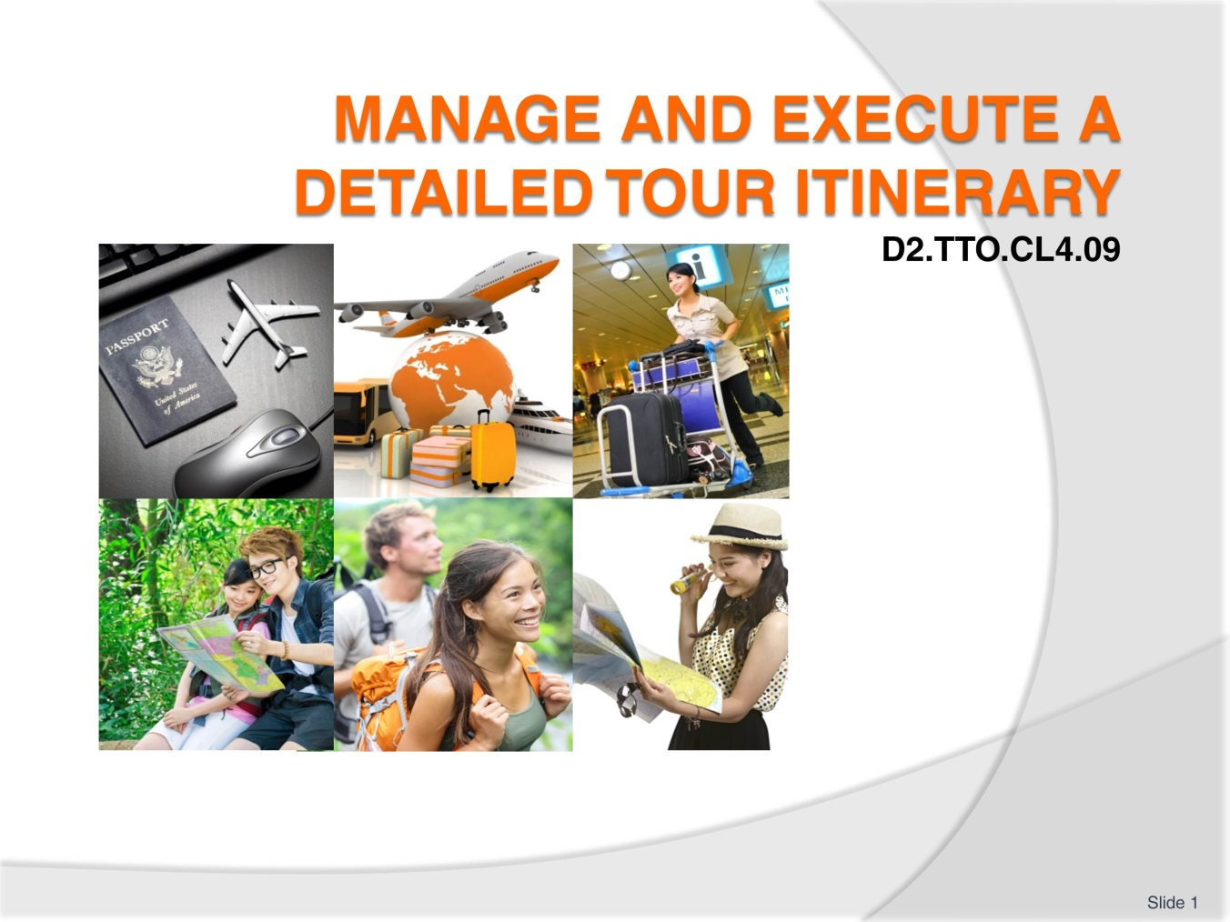
Slide No | Trainer Notes
 | Trainer welcomes students to class.

Slide
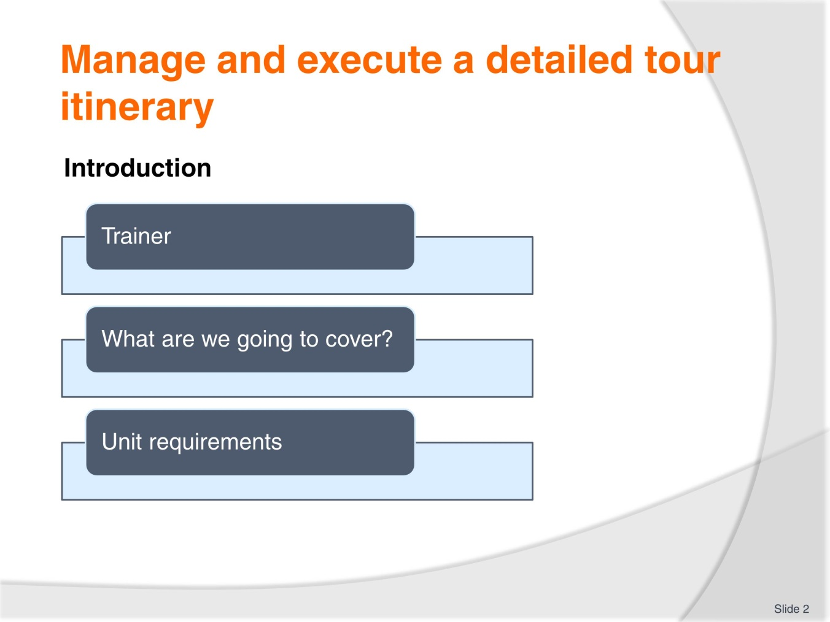
Slide No | Trainer Notes
Session introduction
- Trainer to greet the trainees and introduce himself or herself
- Explain the unit is looking at the skills and knowledge required to manage and execute a detailed tour itinerary
- Explain to the trainees they are expected to actively participate in the learning process : from giving examples to complete research and participate during class work and activities.

Slide
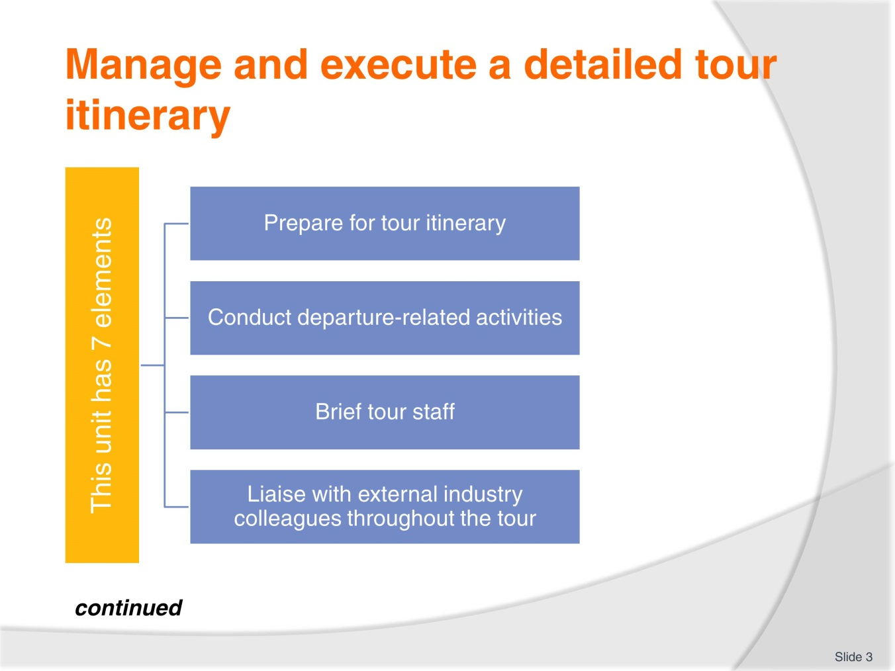
Slide No | Trainer Notes
Trainer to list all elements, explain to the trainees some topics, contents will be common to a few elements.
Clarify that the unit addresses the management practices underpinning the on tour activities the tour leaders/guides will undertake and does not address the leading of the tour.

Slide
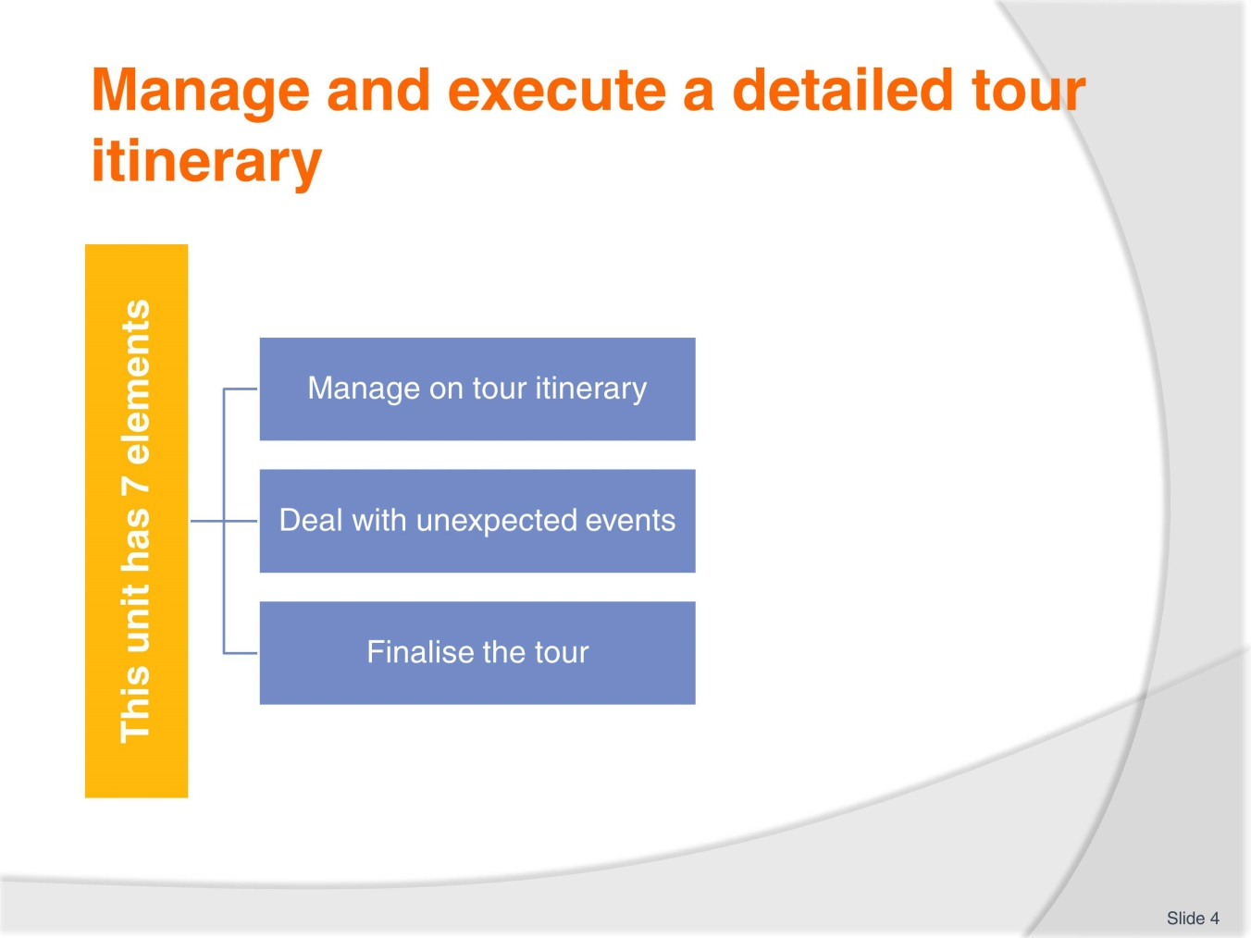
Slide No | Trainer Notes
 | Trainer to make clear that the elements follow the order in which tour management and execution takes place.

Slide
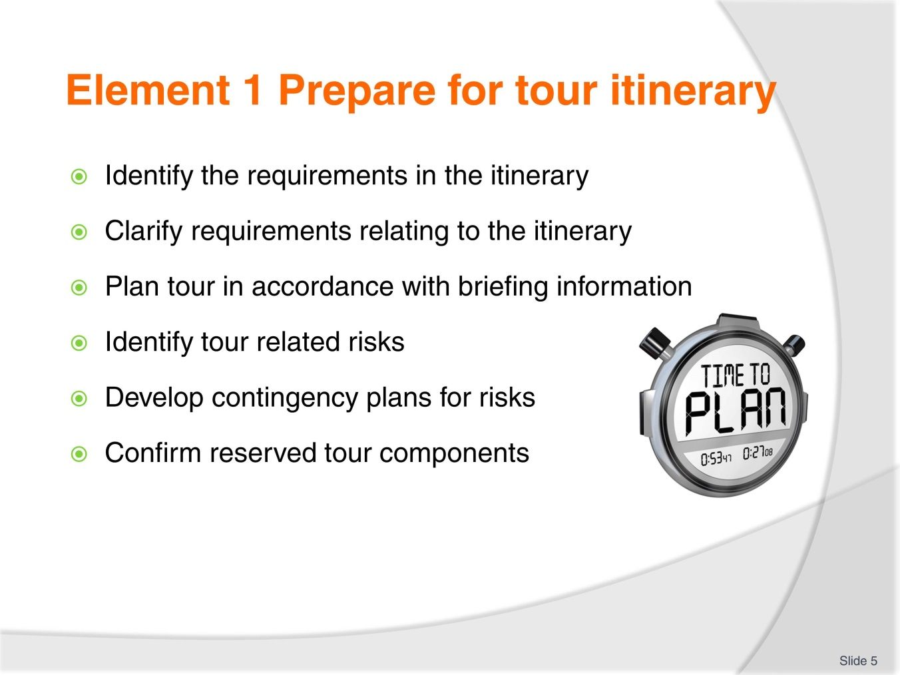
Slide No | Trainer Notes
 | Each of the 5 specific criteria details recommended steps for the preparation of a tour itinerary.

Slide
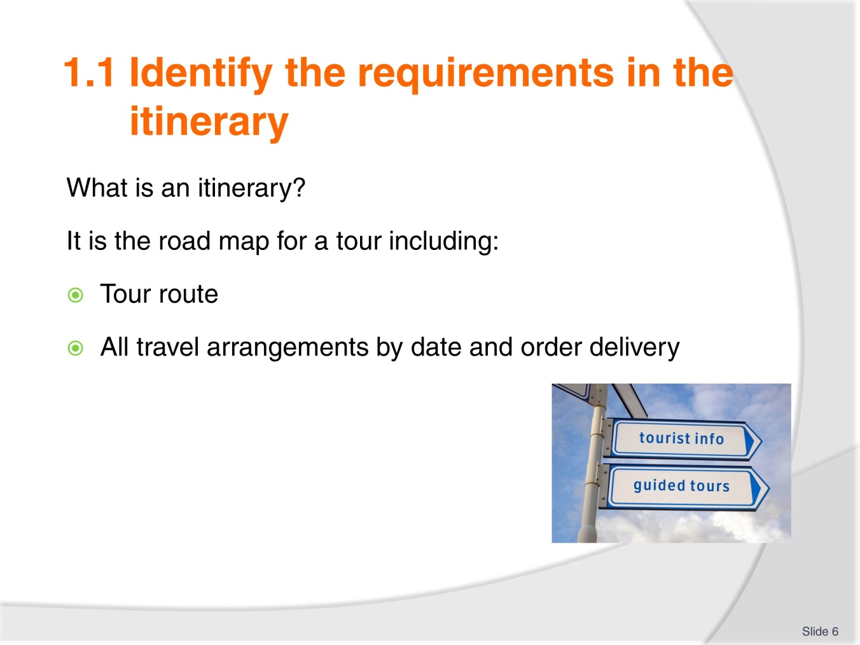
Slide No | Trainer Notes
Trainer to clearly explain what an itinerary is and its importance as the ‘data base’ framework for the tour including all the information necessary to organise the tour.
Tour route means: where is the tour going?
ALL travel arrangements means : every aspect of the tour from transport to accommodation, meals, activities etc.

Slide
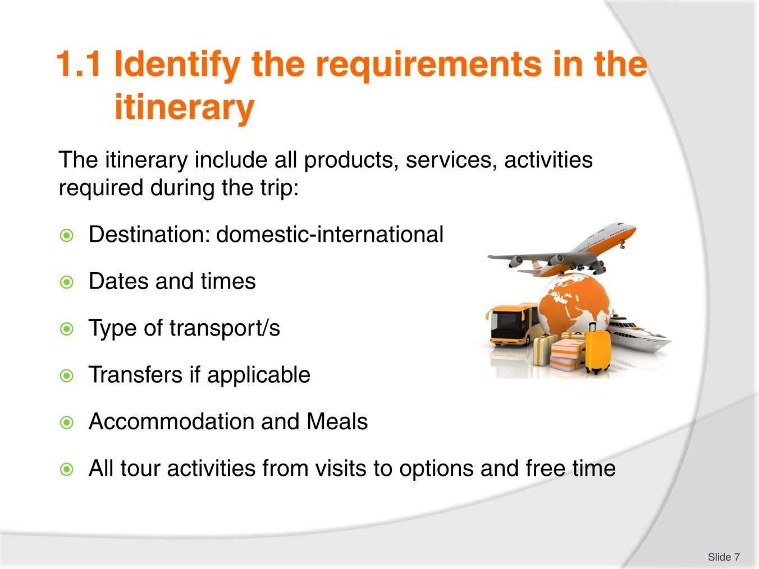
Slide No | Trainer Notes
Clearly identifying ALL requirements needs to take place to make sure the tour can be delivered in an efficient and successful manner.
Every step of the itinerary needs to be listed with as much information as is available at this preparation time.
Trainer to organise the trainees in small 5 groups and ask each group to identify the products, services and activities that will be required for the following tours:
- Day city tour
- Galleries, museums day tour
- One day reef tour
- Overnight bush camping tour
- 2 days cruise.

Slide
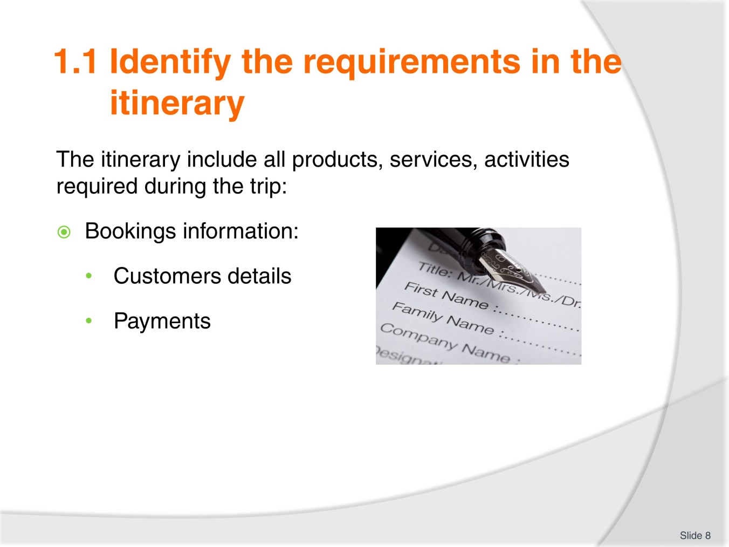
Slide No | Trainer Notes
Trainer to insist on the importance of
Knowing who your customers are so you, as the tour guide, are aware of the group profile: younger, older, families for example. This will help you understand the group profile and understand better the tour group members needs and expectations.
Payments also need to be recorded and checked.
If some destinations, activities have had to be changed , you need to know.
Clarification on all products and services scheduled to be part of the tour need to be take place and it is paramount to have all suppliers contact details on hand at any time during the tour.

Slide
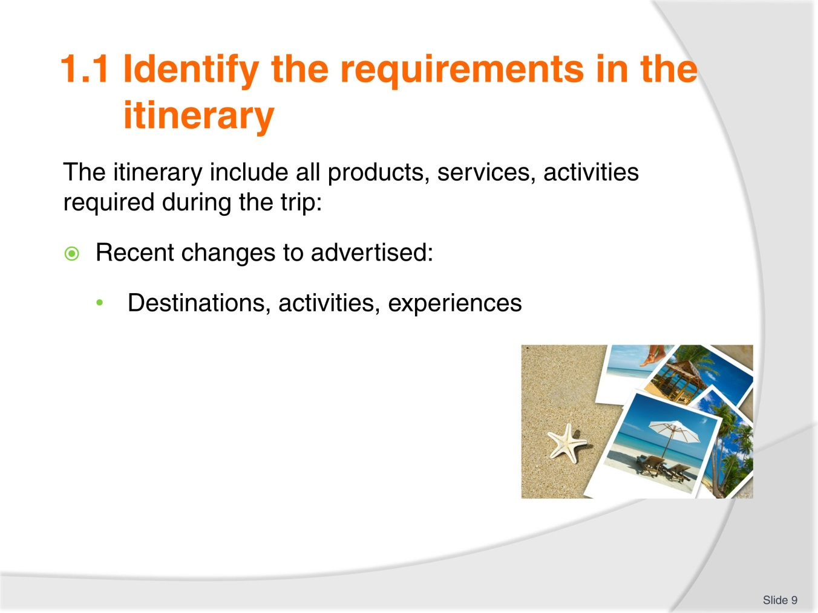
Slide No | Trainer Notes
Any changes to destinations, activities and experiences need to be taken into account. Those changes might be due to seasonal changes, one off event such as an exhibition.
Trainer to ask trainees to research on the internet, in their country, region, specific events, exhibition, shows that they think could be included in tours while they take place.

Slide
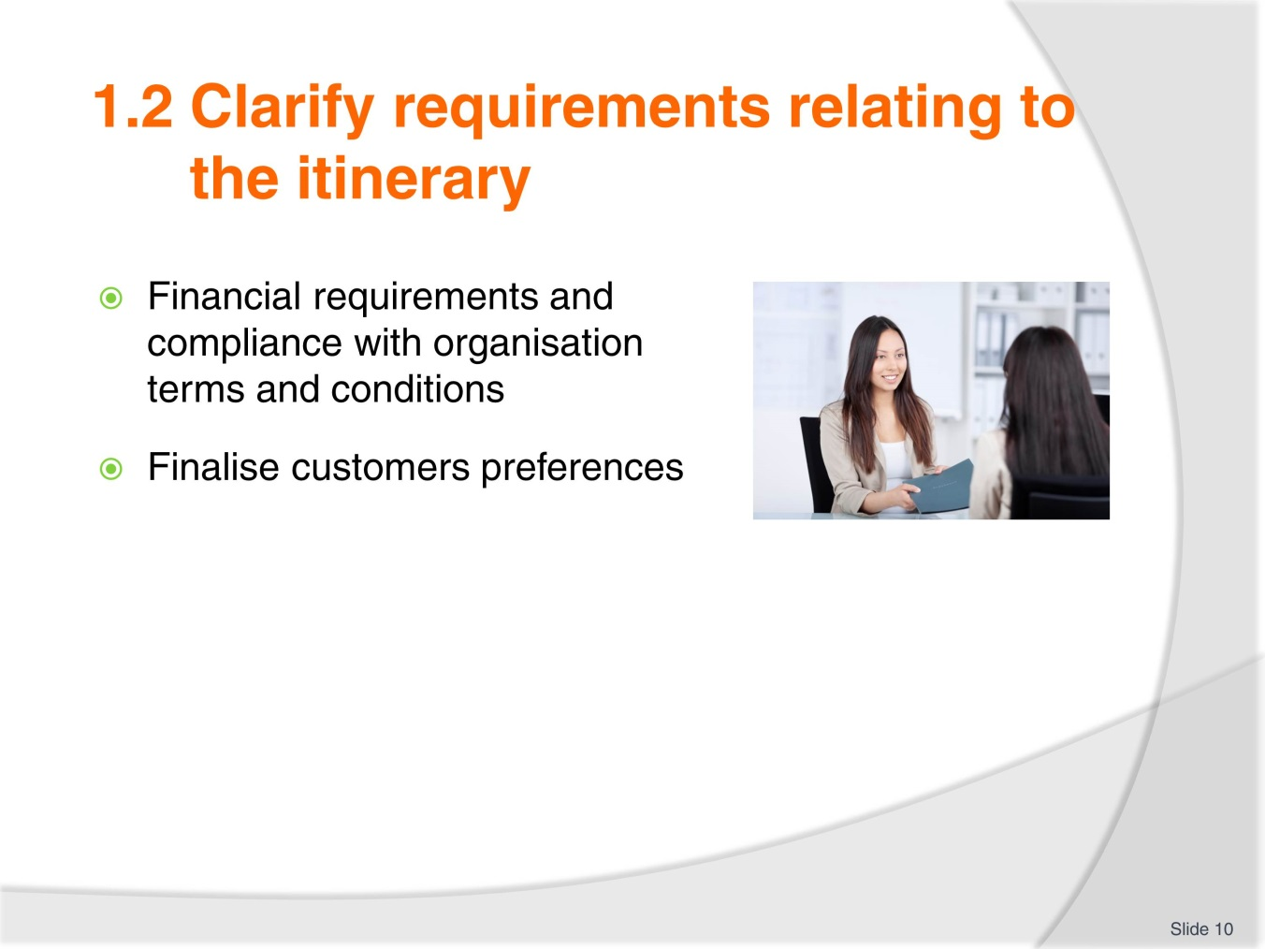
Slide No | Trainer Notes
Trainer to list the requirements and divide the class in small working groups.
Trainees to research publicised financial terms and conditions for different tour organisations and discuss why they think why it is important.
Trainer to insist on to importance of finalising customers preferences prior to the beginning of the tour. Knowing which activities, options they have chosen is important to confirm numbers to the suppliers of products and services.

Slide
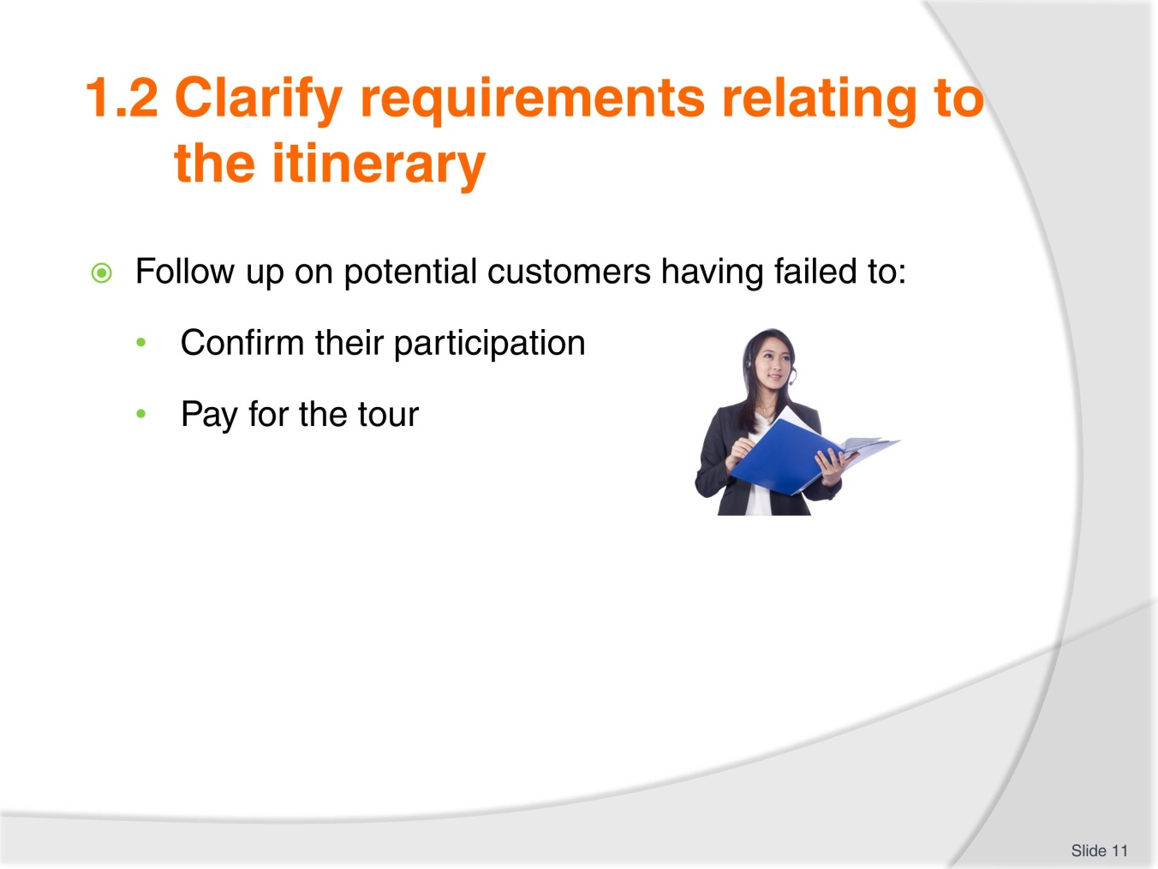
Slide No | Trainer Notes
Trainer to explain that this stage is about contacting potential customers who are on file as having contacted the organisation in regards to the tour but have not followed up on:
- Confirming if they are still interested in participating to the tour
- Obtaining payment if applicable
This will finalise the number of participants. It is also an important part of customer service delivery as some potential customer might simply have forgotten to send payment.

Slide
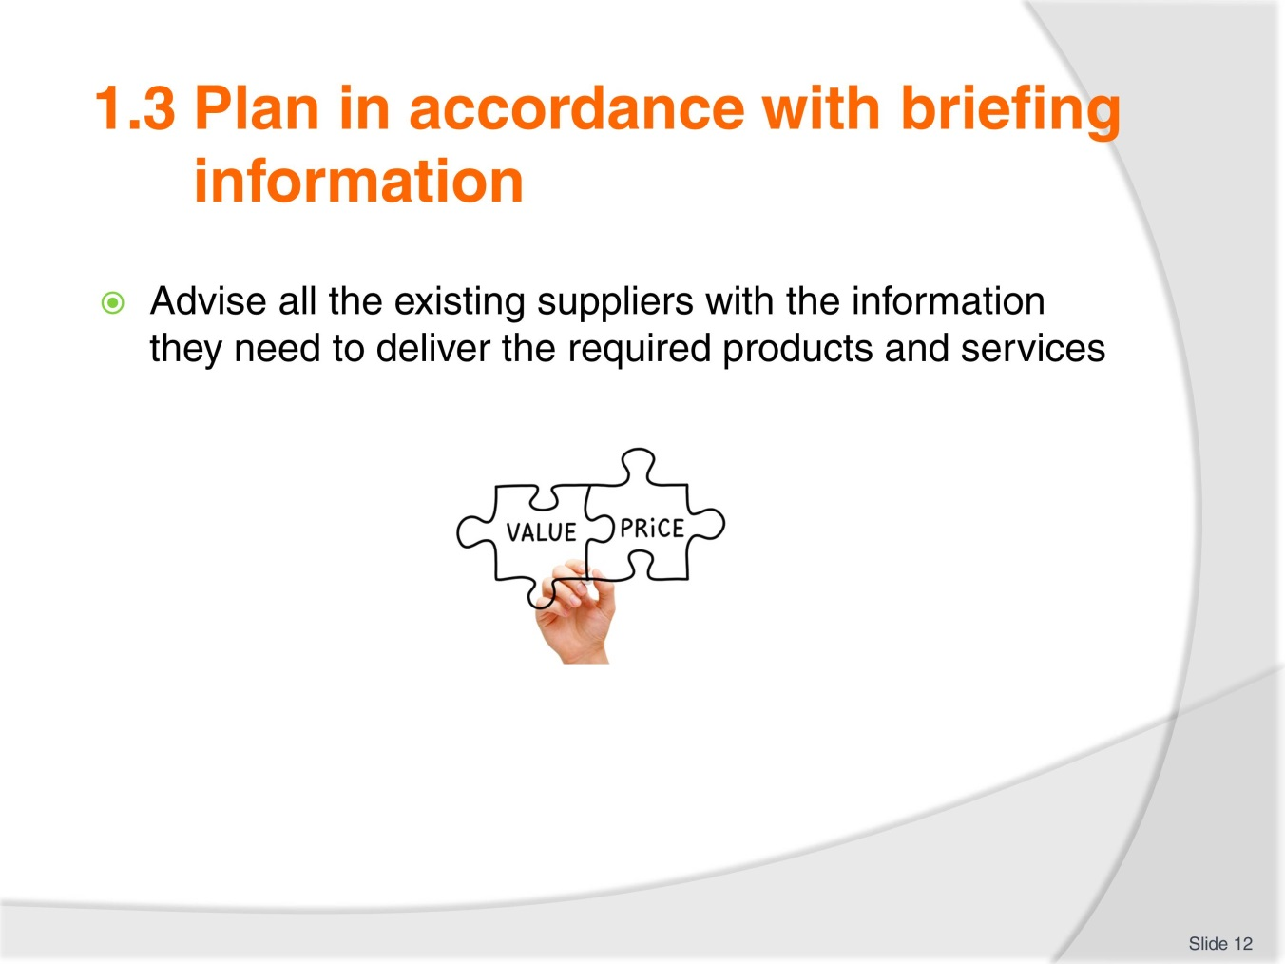
Slide No | Trainer Notes
Trainer to remind trainees of the importance of the ‘preparation work’ and how all the information collected will now be used to plan the tour.
Trainer to explain that we are now at the planning stage of the tour using the information we have on hand.
The first step is to contact all suppliers to confirm the delivery of products and services for the tour:
- Transport-Accommodation-Catering and all activities included in the tour
Trainer to explain that timeline is important to give suppliers enough time to get organised to deliver the products, services they are contracted for with the organization/

Slide
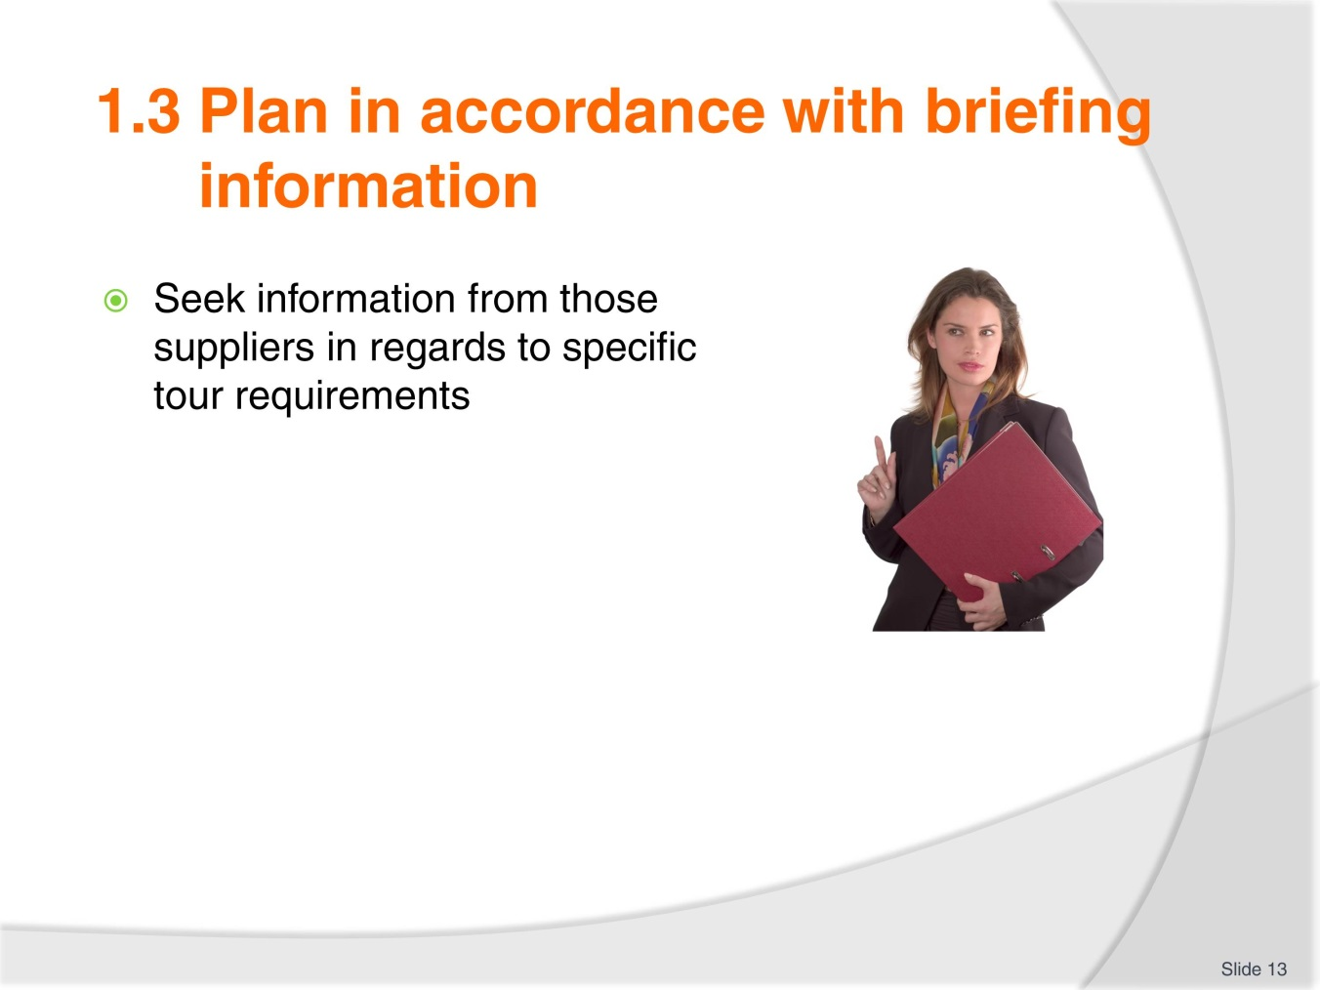
Slide No | Trainer Notes
Using the examples from the workbook or its/her own, the trainer illustrates when, why you would seek information in regards to:
- Accommodation
- Catering
- Specific equipment.

Slide
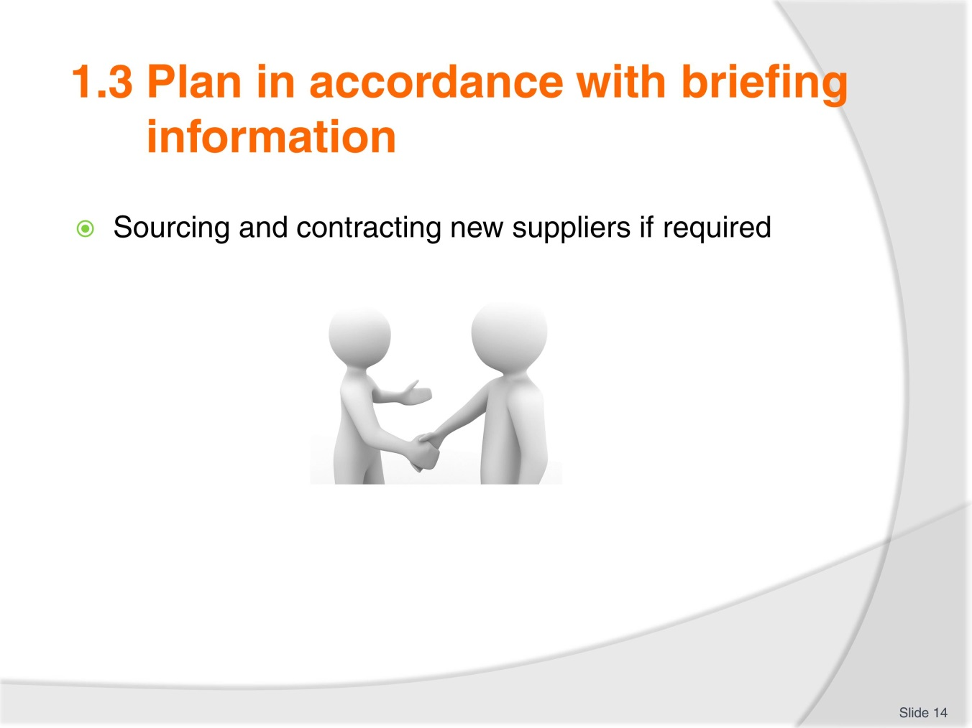
Slide No | Trainer Notes
Trainer explain that sometimes the organisation will need to source and contract new suppliers. This business process is time consuming and reinforces the importance of having as much tour specific information as early as possible.
Using the examples from the workbook or its, her own trainer to illustrate the point just made.

Slide
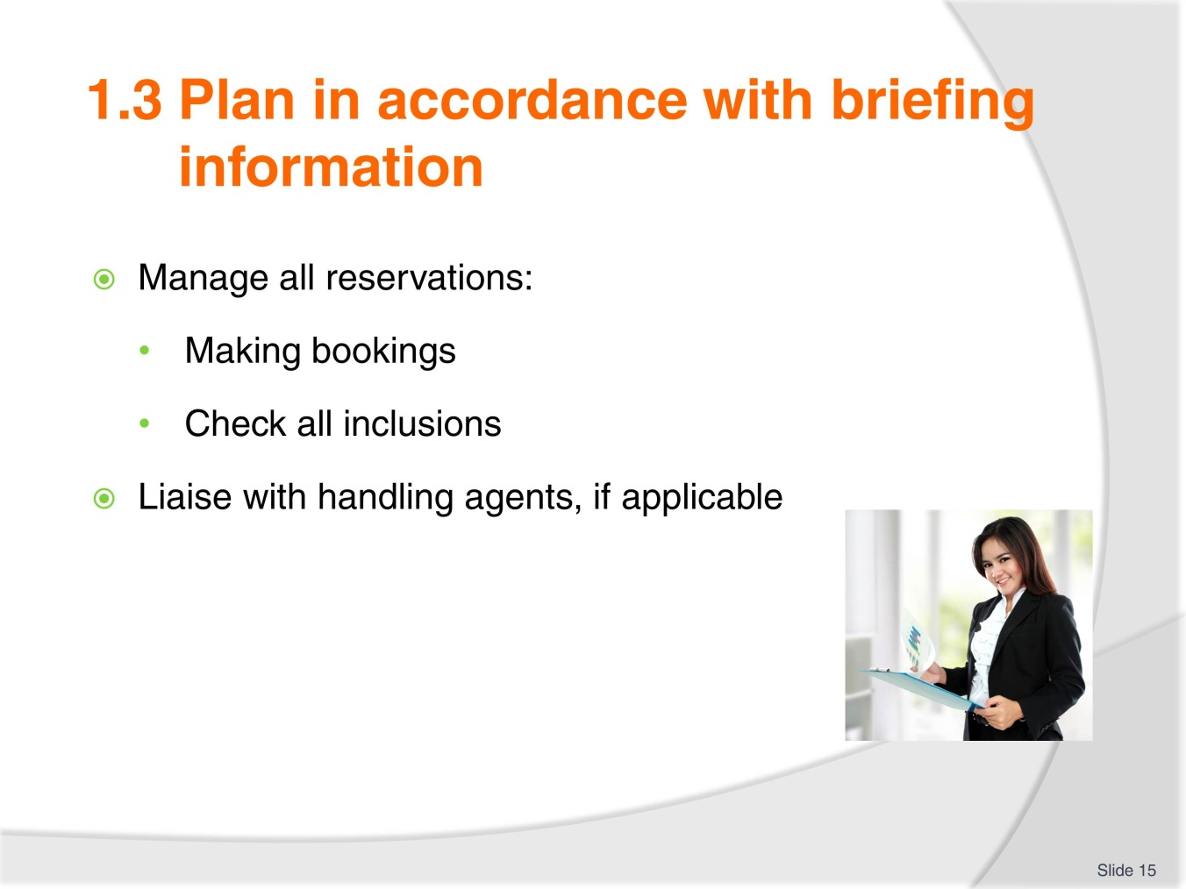
Slide No | Trainer Notes
Trainer to clarify that all reservations includes all products and services part of the tour.
Prior to the beginning of the tour, inclusions must all be checked to make sure they can take place: some places might be closed for winter, summer, renovations. You must always make sure you have the latest information on hand and a handling agent, on the ground, will help with this. Trainer to remind trainees of what a handling agent : your organisation representative on the ground.

Slide
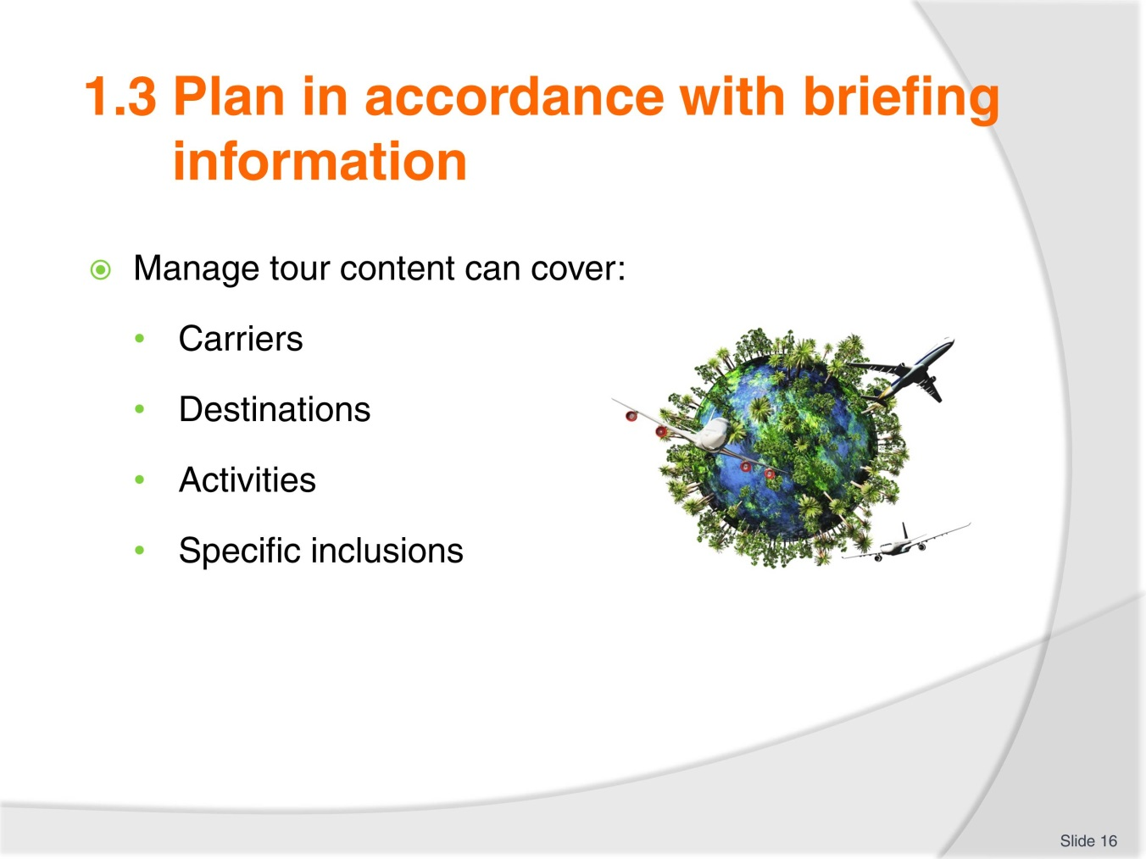
Slide No | Trainer Notes
 | Trainer to ask the trainees to give one example for each of the listed tour content components and share with the rest of the class.

Slide
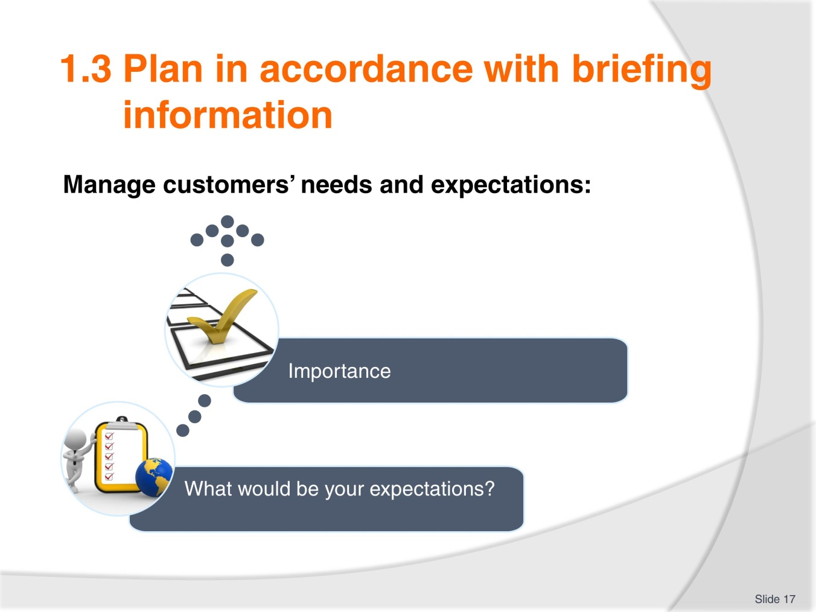
Slide No | Trainer Notes
Trainer to insist on the importance of managing customers’ needs and expectations to make sure the tour meets the group members needs and expectations from beginning to end.
Trainees to reflect on what expectations they would have if they were doing an educational day tour, visiting one museum and one art gallery. Trainer to write all the board the answers and discuss them with the group.

Slide
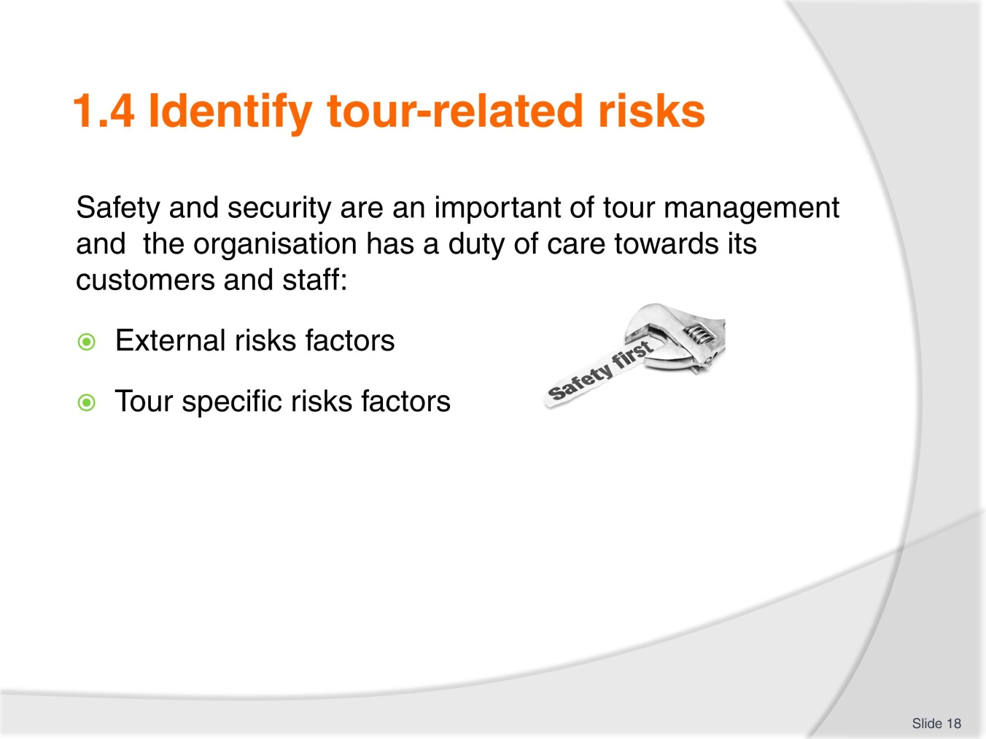
Slide No | Trainer Notes
Trainer to remind trainees of what Duty of Care is and clarify that the safety and security requirements for a tour will be different according to the country the tour takes place, and the type and length of the tour.
Trainer to explain how it is almost impossible to forecast every risk.

Slide
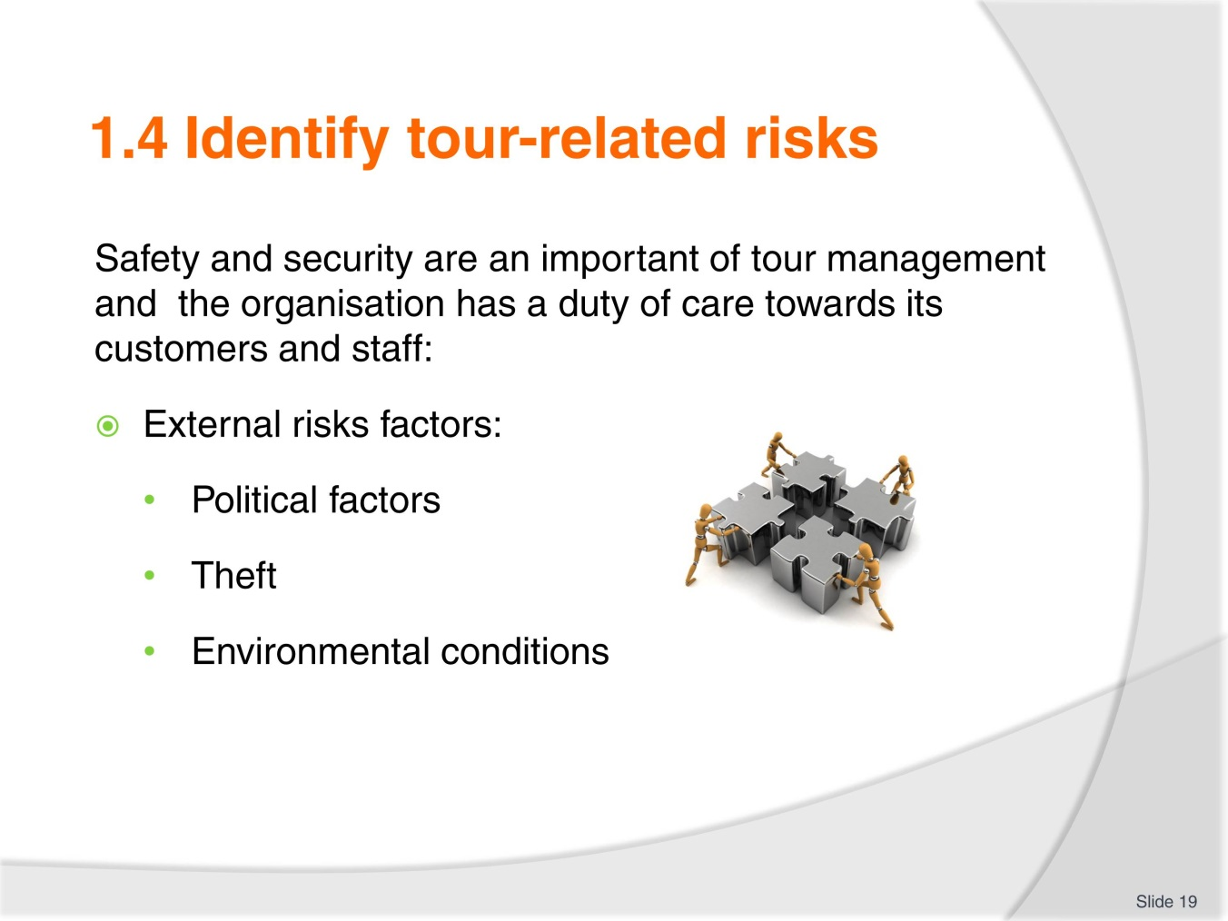
Slide No | Trainer Notes
 | Trainer to explain how some risk are more ‘serious’ that others, present more danger and ask the trainees to rate the 3 risks on from 1: highest risk to 3 lowest risk. Trainees to share and explain their ranking.

Slide
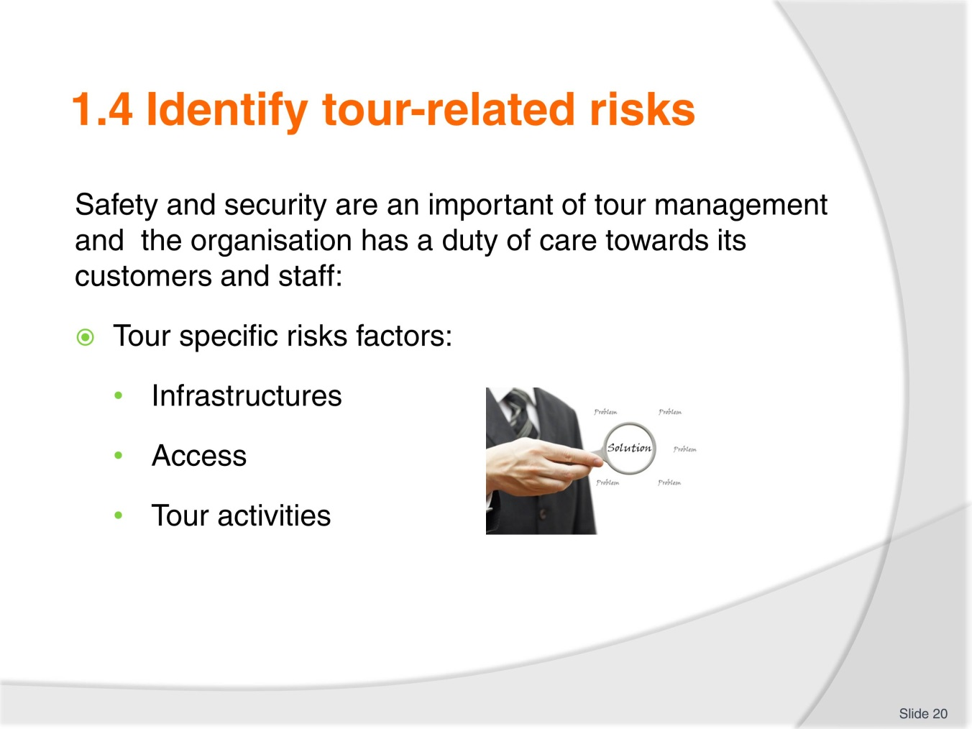
Slide No | Trainer Notes
Tour specific risks factors need to be closely monitored to ensure the safety and security of all tour group and cover all aspects, inclusions of the tour.
Using the workbook as a guide, the trainer can again split the group into 5 small groups and allocate one of the 5 topics on the 2 slides to investigate. The tour is an overnight bush tour.
Trainees to share the identified risk with the rest of the class and trainer to reinforce the importance of risk management.

Slide
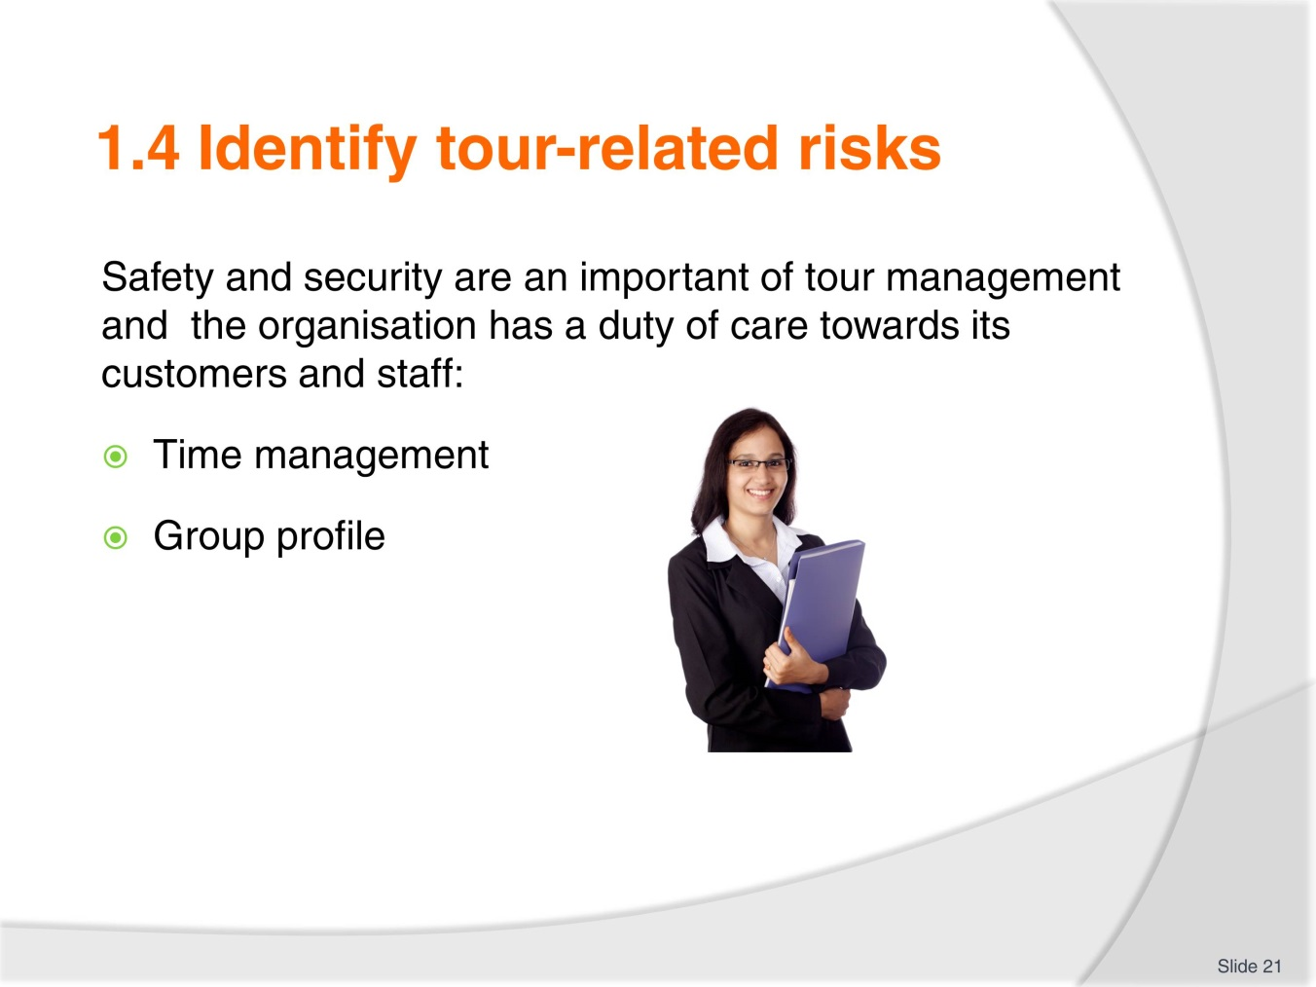
Slide No | Trainer Notes
Tour specific risks factors need to be closely monitored to ensure the safety and security of all tour group and cover all aspects, inclusions of the tour.
Using the workbook as a guide, the trainer can again split the group into 5 small groups and allocate one of the 5 topics on the 2 slides to investigate. The tour is an overnight bush tour.
Trainees to share the identified risk with the rest of the class and trainer to reinforce the importance of risk management.

Slide
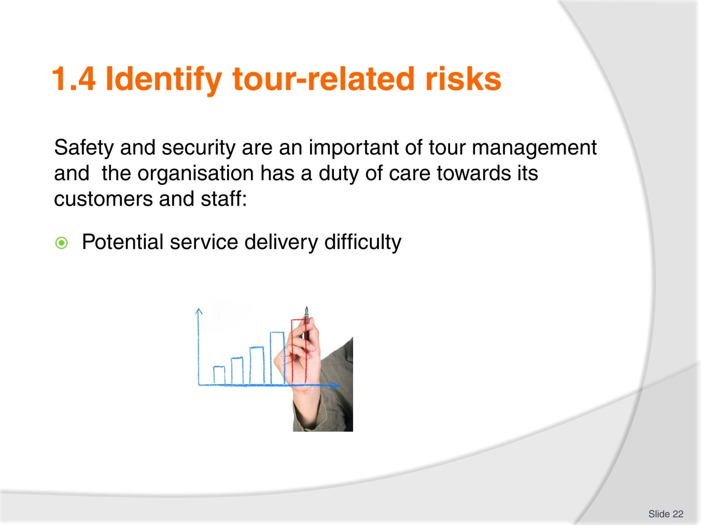
Slide No | Trainer Notes
Brainstorming activity:
- When
- Why when would potential service delivery difficulties happen?

Slide
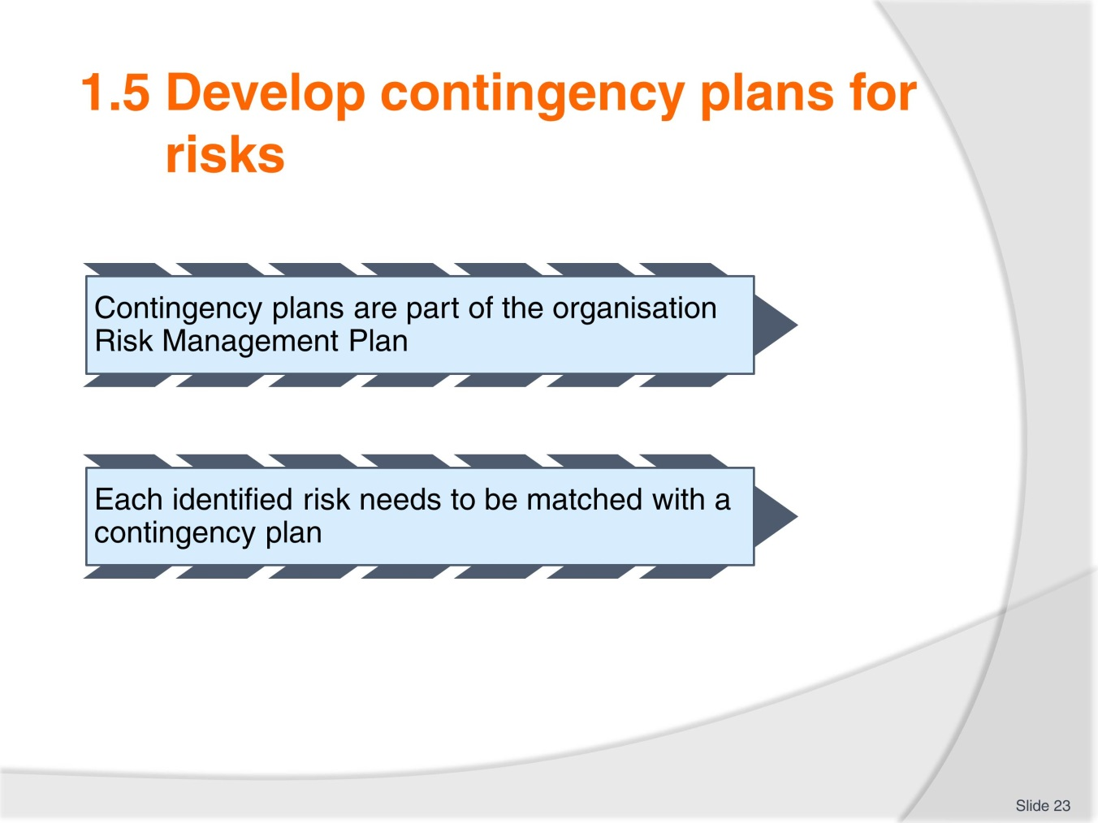
Slide No | Trainer Notes
 | Trainer to clarify where contingency plans fit with the organisation RMP.

Slide
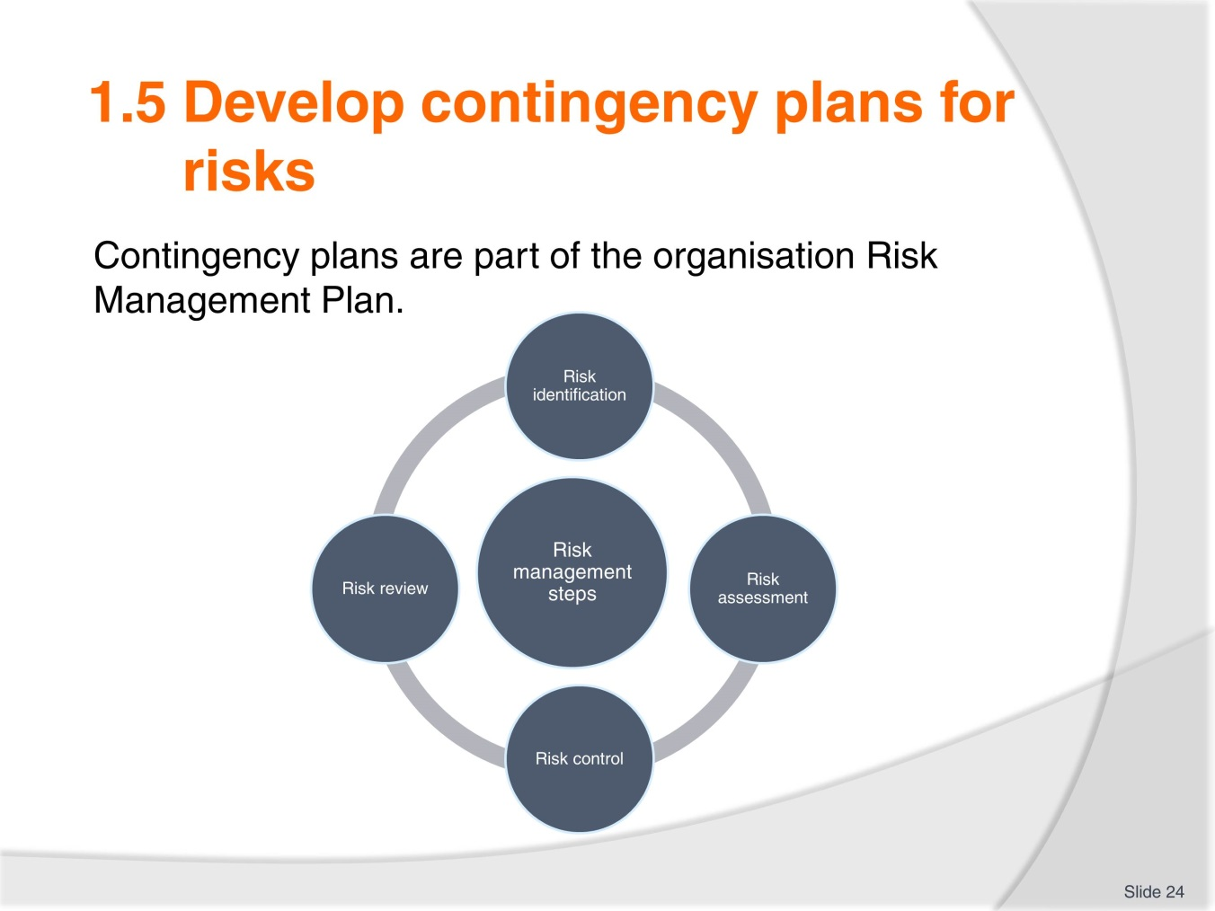
Slide No | Trainer Notes
 | Trainer to briefly go through those 4 steps and explain that we will mainly look at 1, 2 and 3 in this unit.

Slide
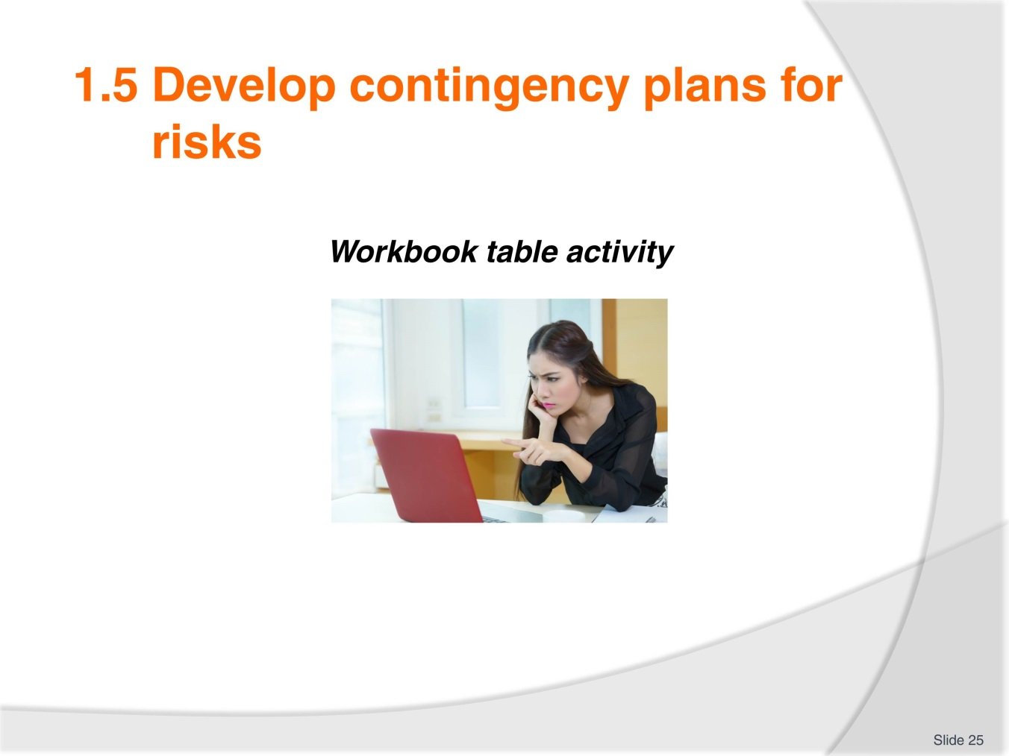
Slide No | Trainer Notes
 | Trainer and trainees to consult the table with the risk identified + proposed contingency plans and discuss if other contingency plans would be applicable for some of the risks identified.

Slide
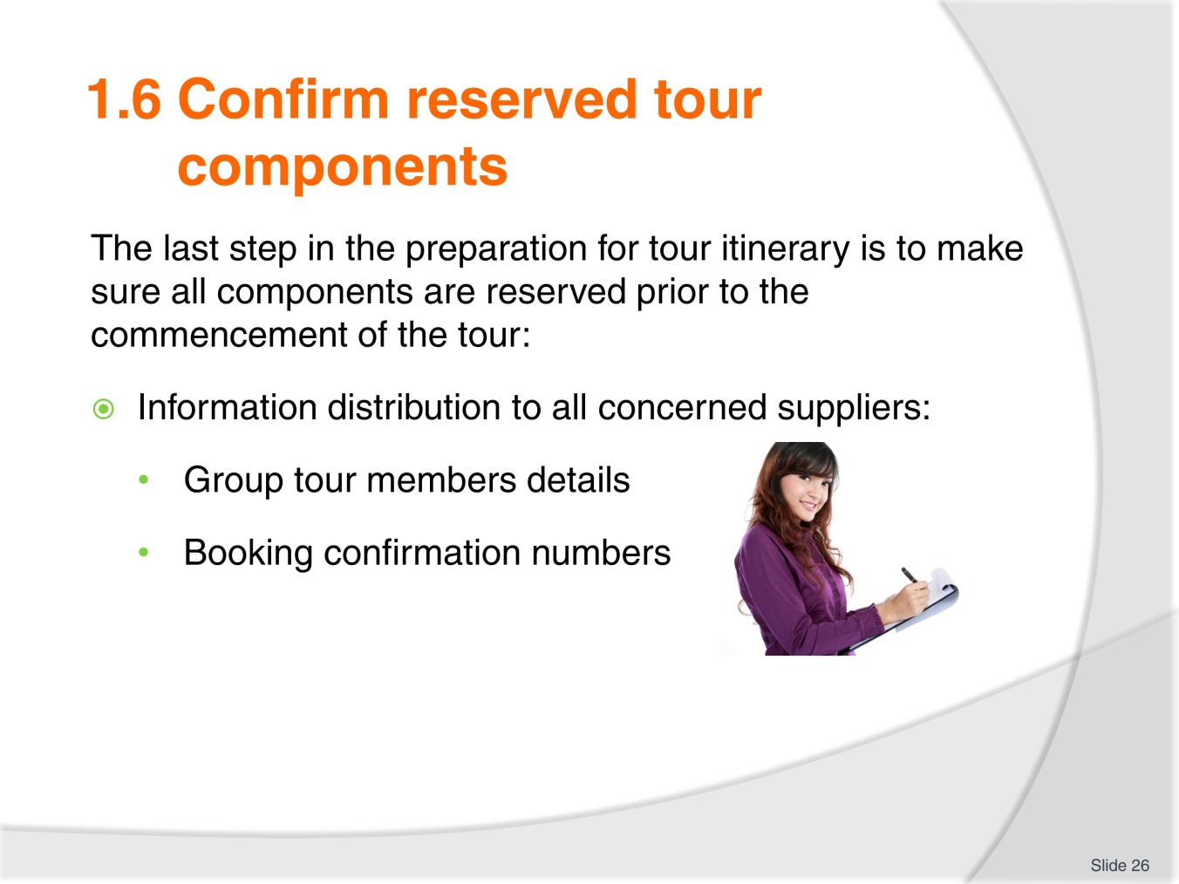
Slide No | Trainer Notes
Trainer to explain that distributing the correct information is paramount to the successful delivery of the tour.
Suppliers need to know participants numbers, in regards to transport and accommodation, their names.
The group profile information: age, gender, interest will also ensure the service will be more customised to the tour group members.
Booking numbers are a way of confirming that services are reserved.

Slide
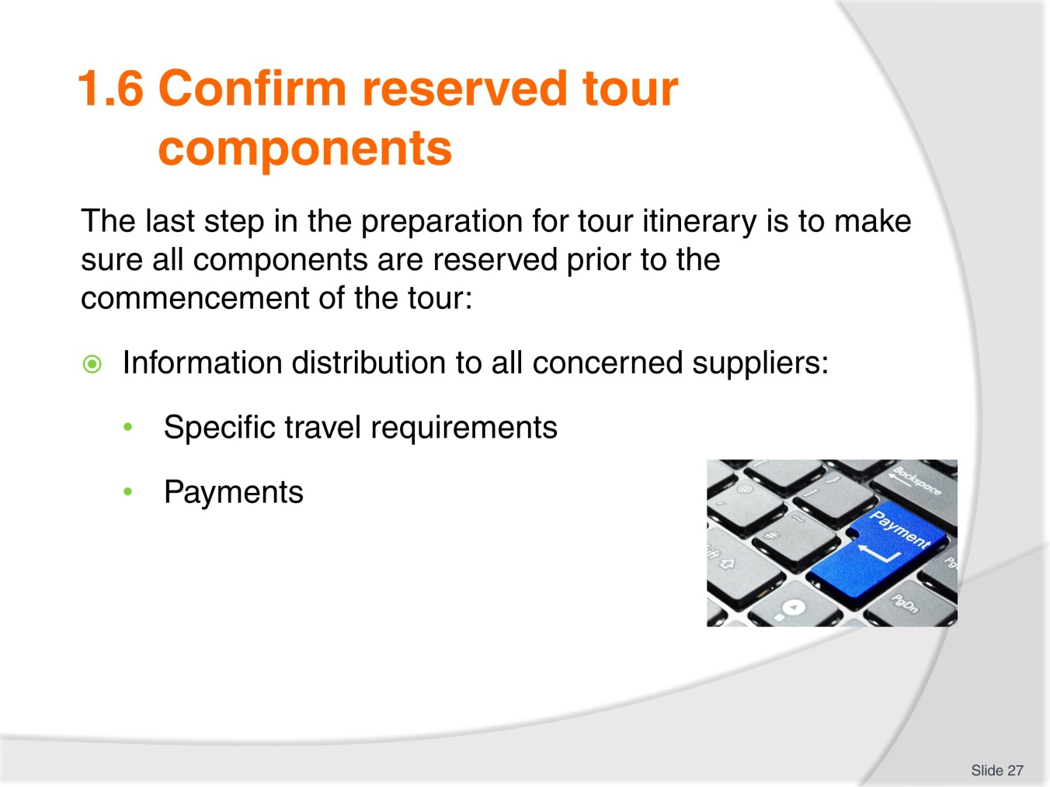
Slide No | Trainer Notes
Official travel requirements such as visa, passport, vaccinations need to be checked and passed onto the relevant body.
Of course, payments need to be processed so that the tour products and services can be delivered.
Working in pairs, trainees to match the information to the relevant body, supplier:
- Passport number
- Customer request for a quiet room
- Organisation records
- Accommodation venue.

Slide
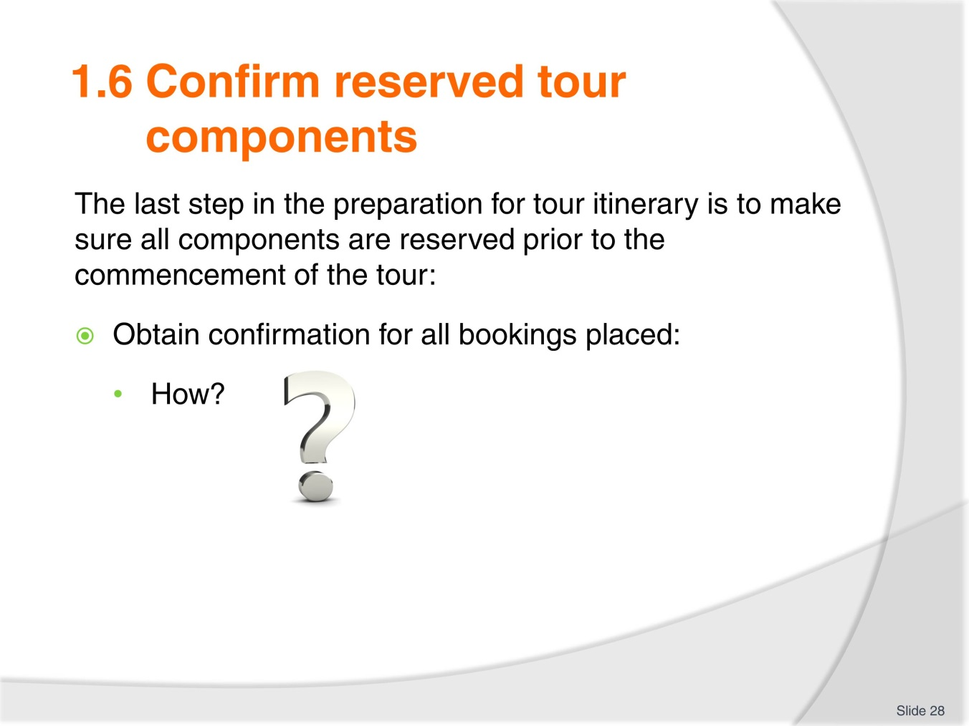
Slide No | Trainer Notes
Trainer to remind trainees of the importance of obtaining a confirmation from each suppliers to make sure they are aware of the impending tour and of the products, services they will provide.
Trainer and trainees to list on the board the various ways confirmations can now be received:
- Hard copy
- Soft copy via: email, Skype, mobile phone.

Slide
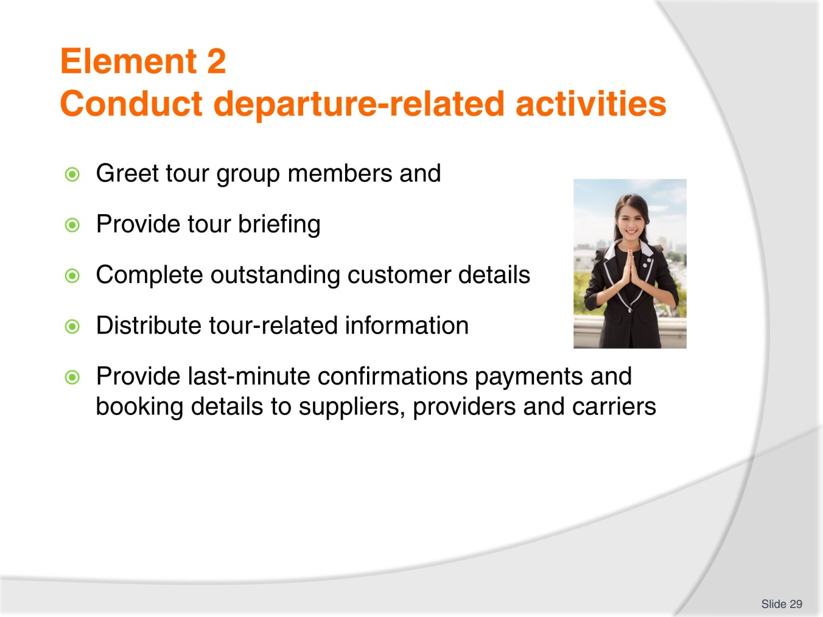
Slide No | Trainer Notes
Trainer to present this new element dealing with conducting departure-related activities.
This is when the tour staff will meet all the tour group members, establish a rapport and check all outstanding details.

Slide
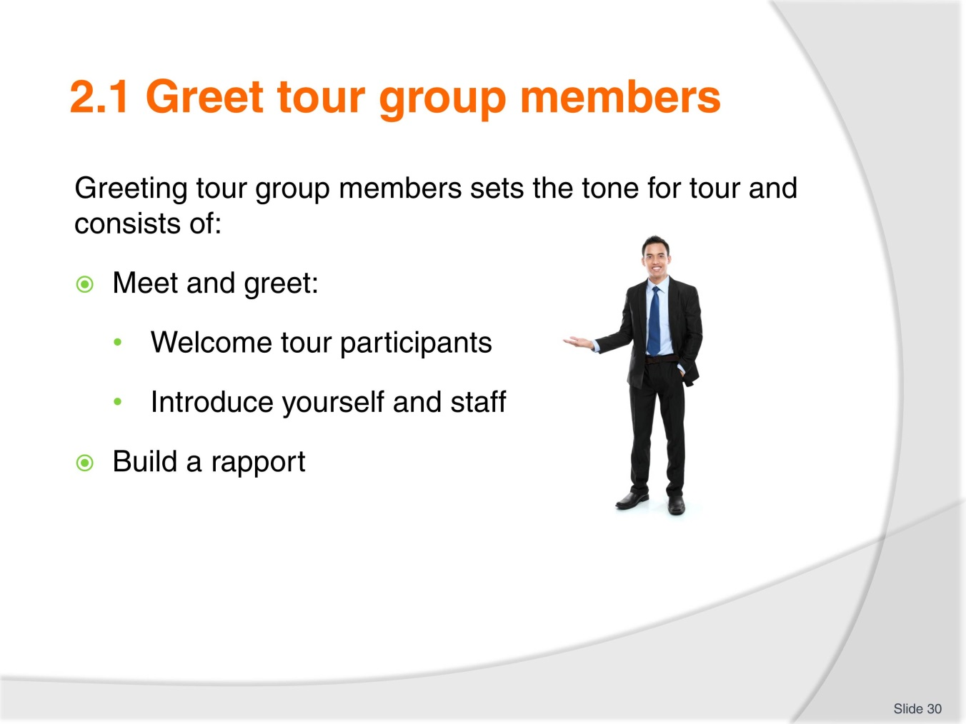
Slide No | Trainer Notes
Trainer to insist on the importance of this stage, its impact for the delivery of the tour.
Trainer to ask trainees to write, in small, groups a few sentences they would use to:
- Welcome the participants
- Introduce themselves and staff.
Groups to read their scenario to the rest of the class. At the completion of the activity, trainer to give opinion on the ‘good scenarios’ and the ones with ‘room for improvement’ and explain why.

Slide
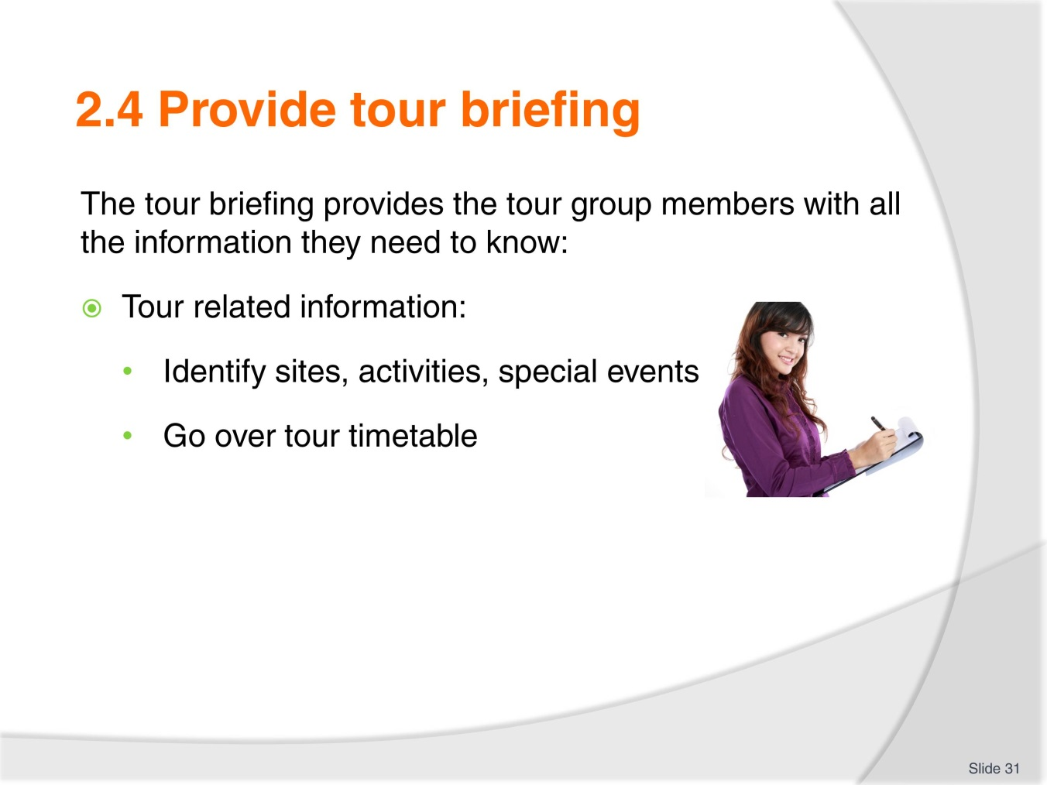
Slide No | Trainer Notes
Trainer to explain that after the tour briefing takes place after the introduction stage.
The briefing will cover all the information required so that the tour group members are clear on:
- What is happening, when and how?

Slide
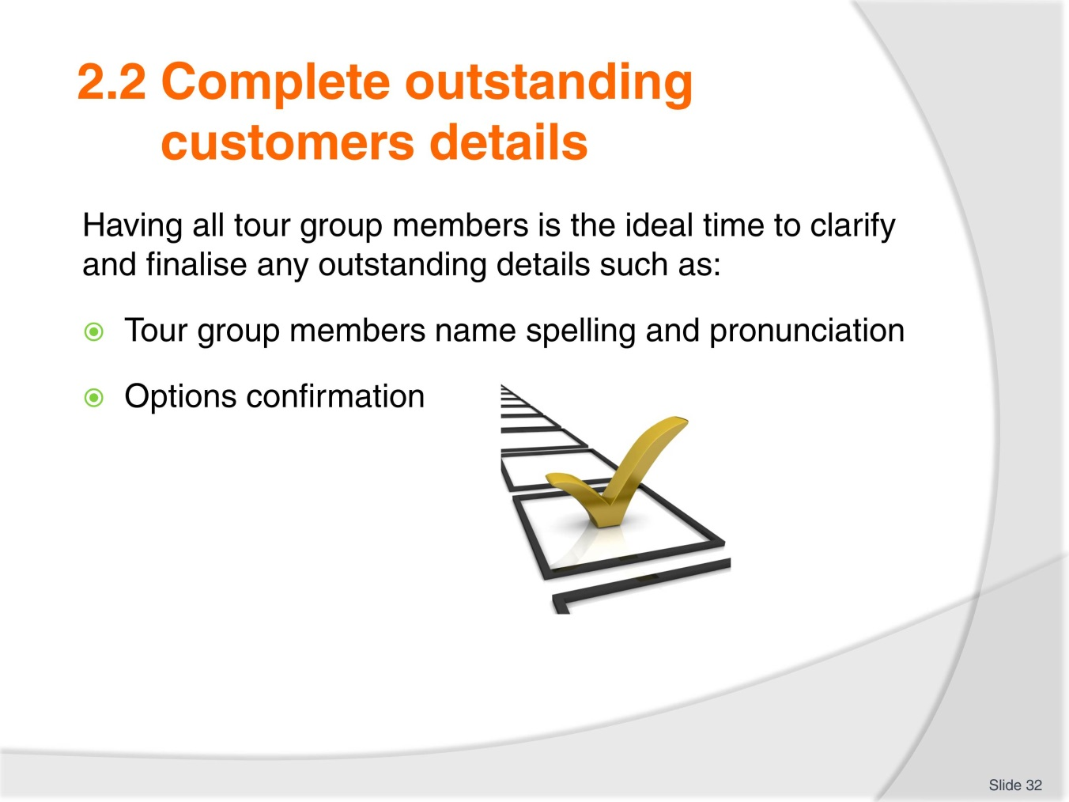
Slide No | Trainer Notes
While all members are present, the tour staff can:
- Check all names and how to say them properly, clarify how tour group members would prefer to be called
- Confirm optional activities participation so you can finalise numbers and informed the relevant supplier.

Slide
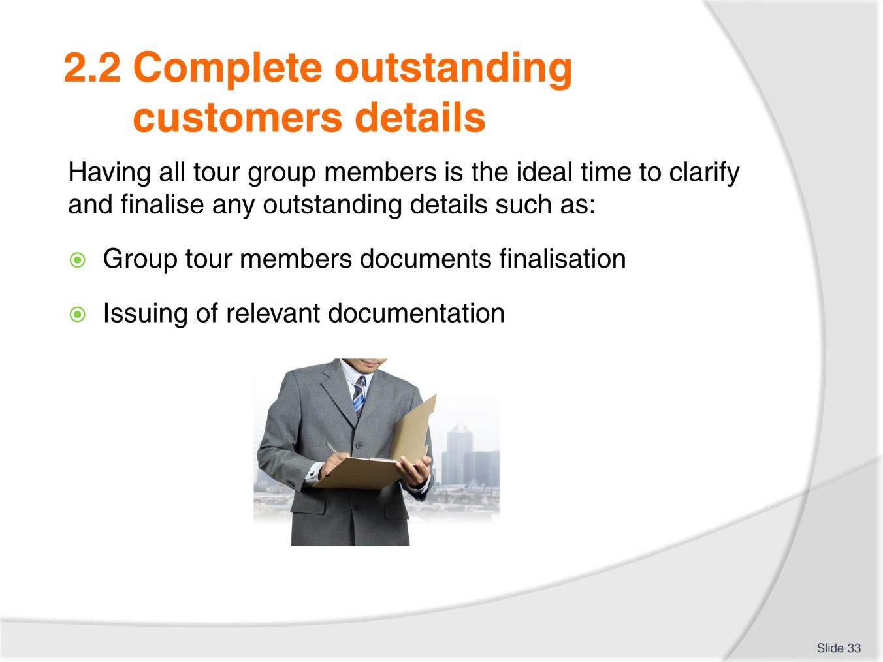
Slide No | Trainer Notes
The last step of completing outstanding details is to make sure you.
Have all the necessary documentation from passport copies to visa and disclaimer forms for high risks activities.
Issue receipts for payments, name badges, luggage (If applicable), vouchers, passes, welcome kit.
Trainer to organise 3 groups of trainees and ask groups to compile a list of items they would put in a welcome bag for:
- One day educational tour visiting a couple of museums
- Overnight cruise on a river
- Historical 2 days trip, visiting places of worship such as temples.

Slide
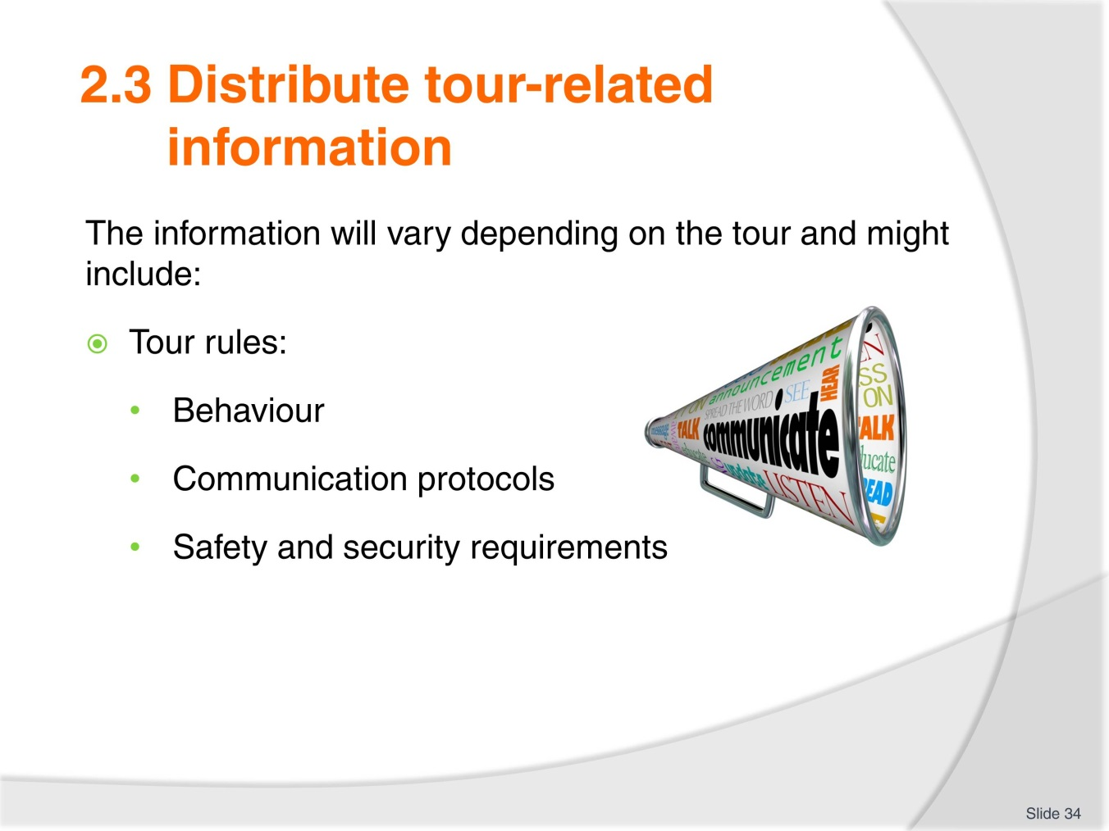
Slide No | Trainer Notes
Tour related information you will pass on and distribute to tour group members will vary according to the type and length of tour and may deal with:
Tour rules: they cover
Appropriate expected behaviour at all times : during the activities specially if the visits include temples, churches with specific dress codes.
Communication protocols at all times : during activities, during business hours, after hours.
Safety and Security information are part of Duty of Care and the tour staff must ensure all tour group members are aware of them and if the use of safety equipment is required, it is imperative all tour group members are shown how to use it and practice how to use it.
Trainer to organise to get some safety equipment such as life jacket, demonstrate how to out it one and use it and then ask trainees to do the same.

Slide
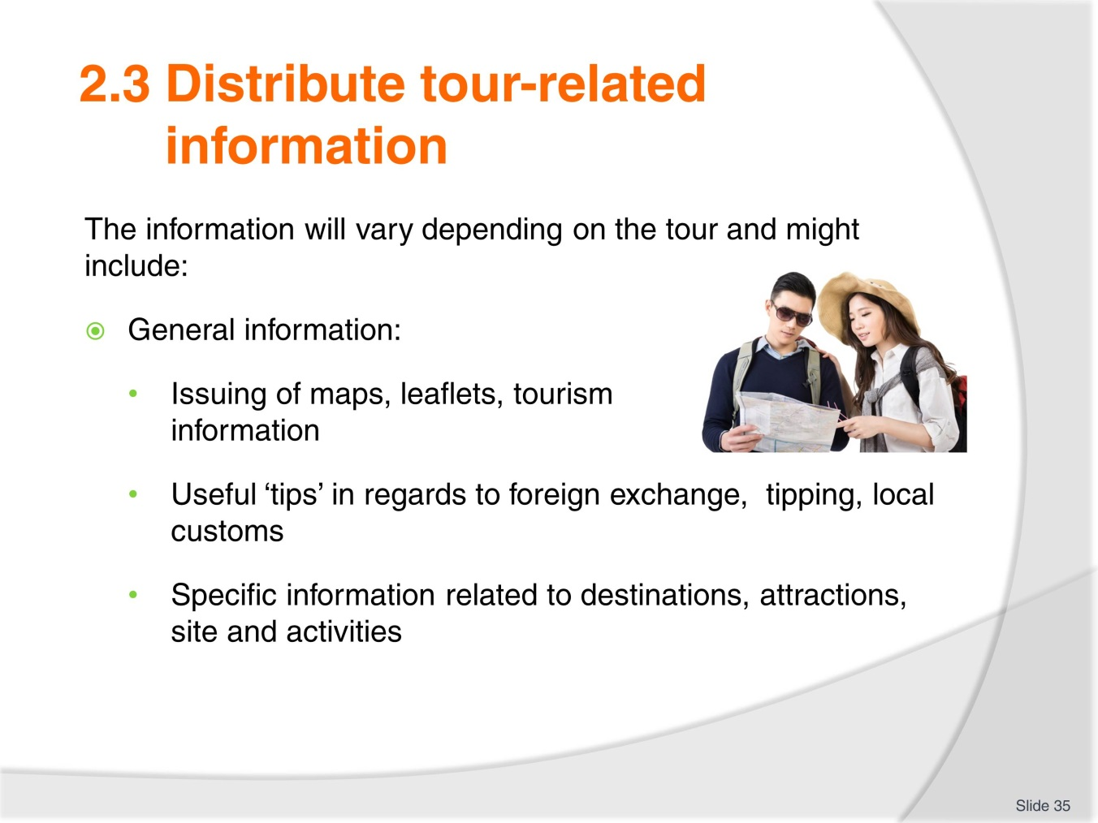
Slide No | Trainer Notes
Trainer to explain the importance of providing all tour group members with useful information on:
- How and where to exchange foreign currency (if overseas)
- How to tip, if appropriate.

Slide
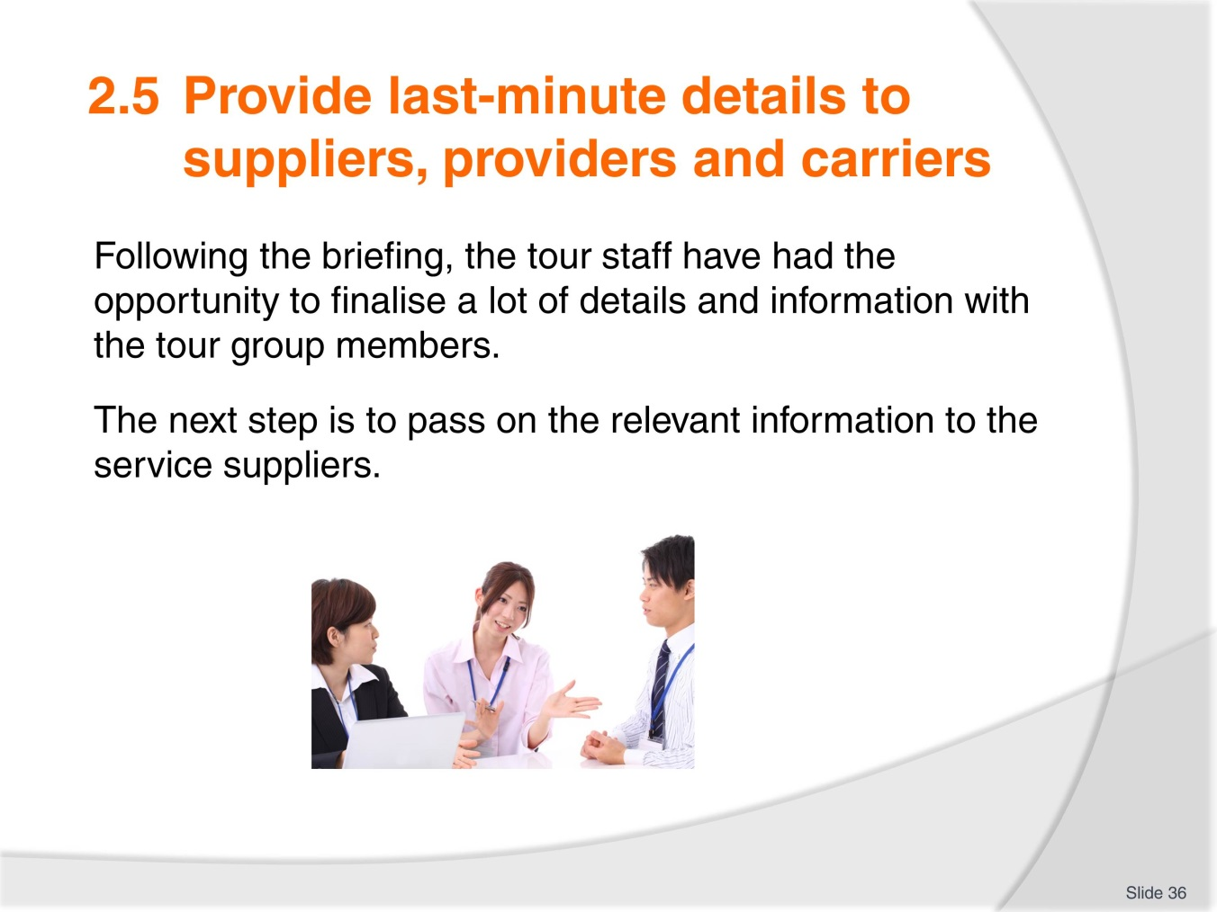
Slide No | Trainer Notes
 | Trainer to remind class of the importance for all concerned parties to have the latest information to deliver the product and services booked.

Slide
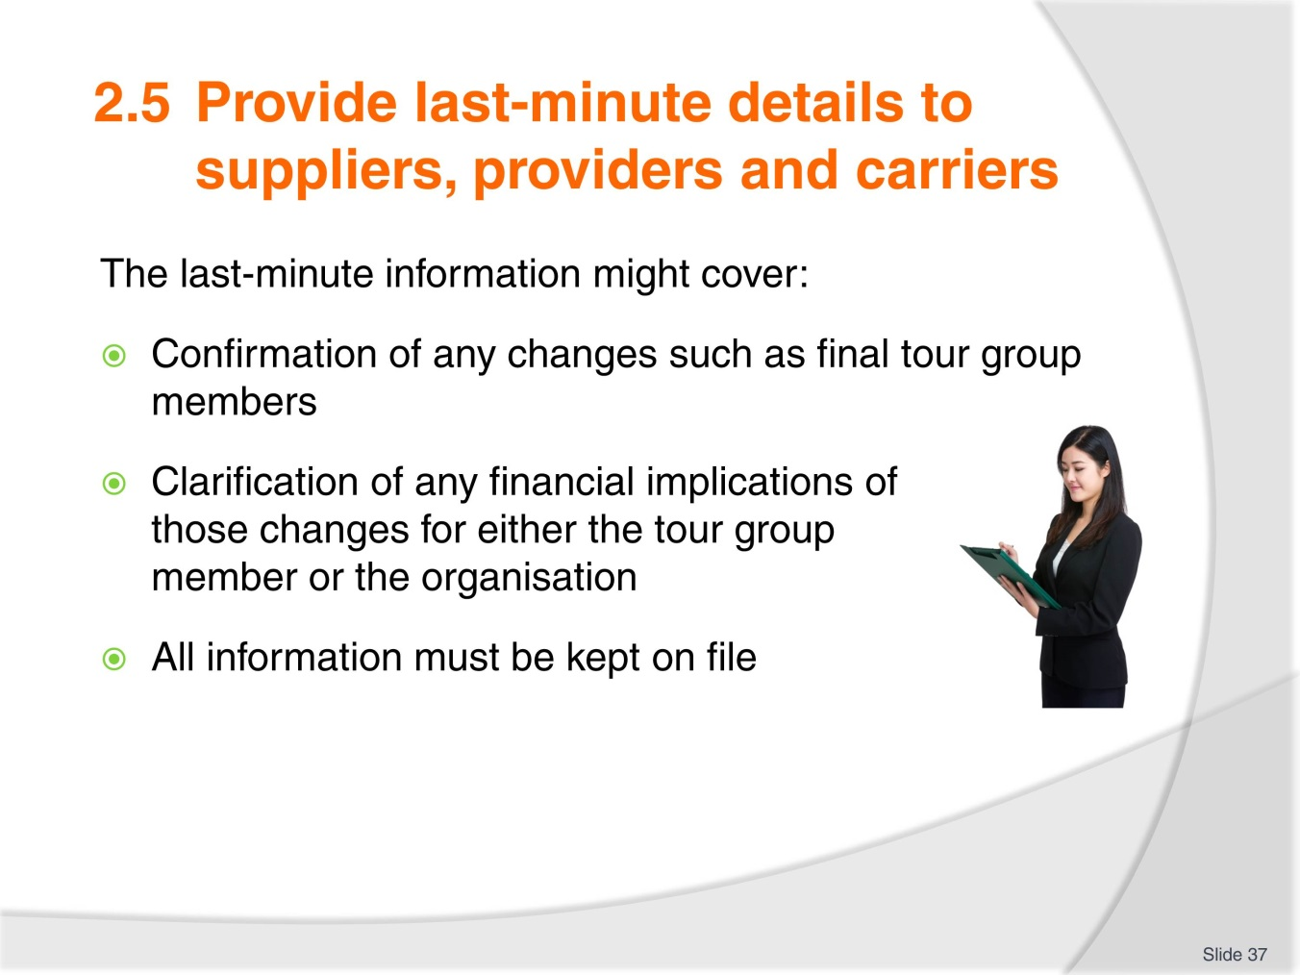
Slide No | Trainer Notes
Trainer to remind the trainees of the importance of actioning last minute changes, payments.
Service suppliers must be informed to deliver their products, services.
Trainer and trainees to compile a list of possible last minute changes that could happen for a half day city tour including a visit to a park and to a tower with a famous city view platform.

Slide
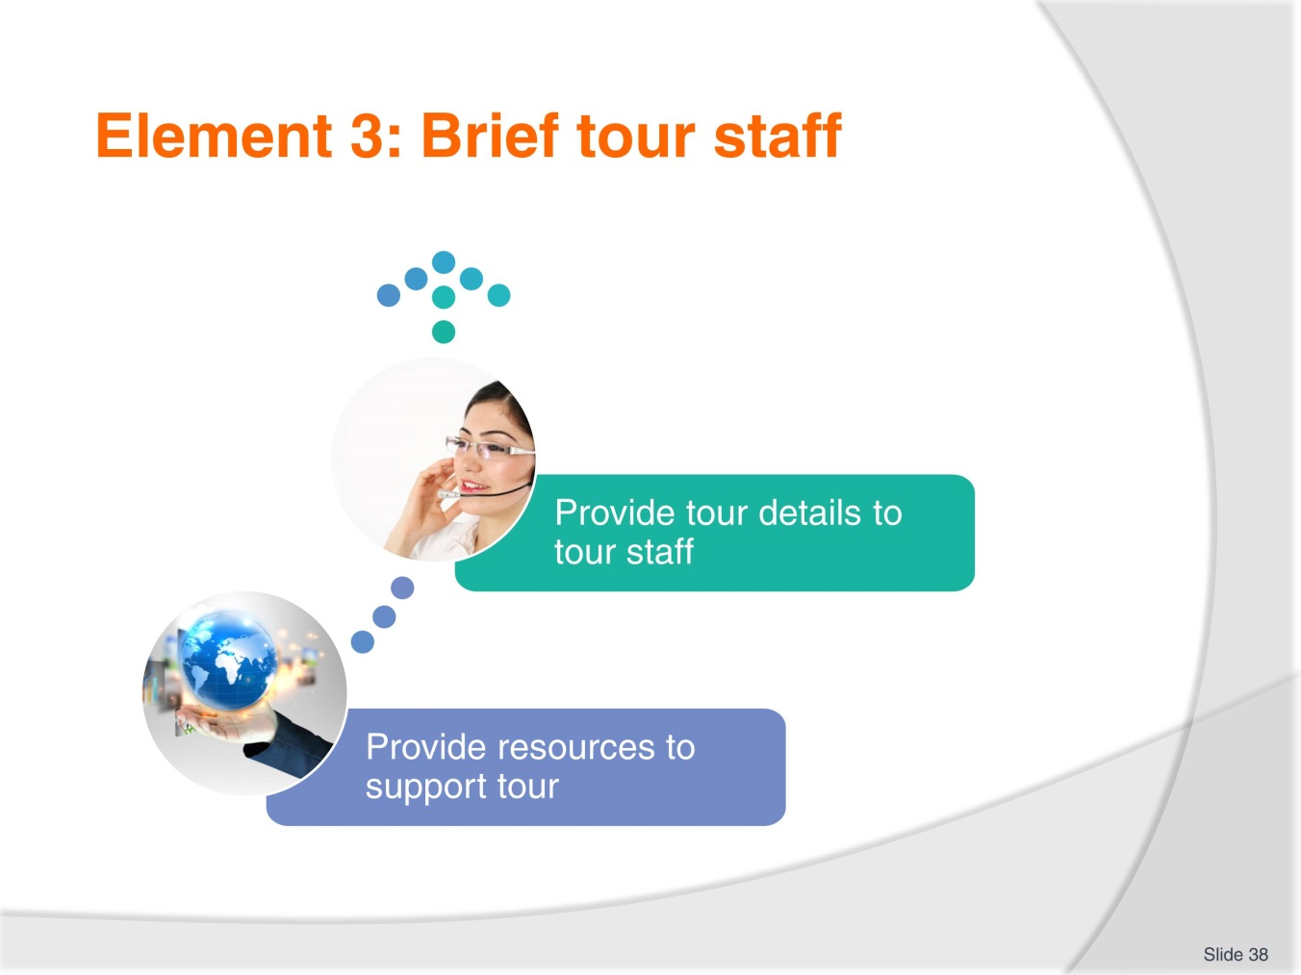
Slide No | Trainer Notes
Trainer to explain that this element deals with the tour staff in regards to managing the itinerary:
- 2 topics will be covered.

Slide
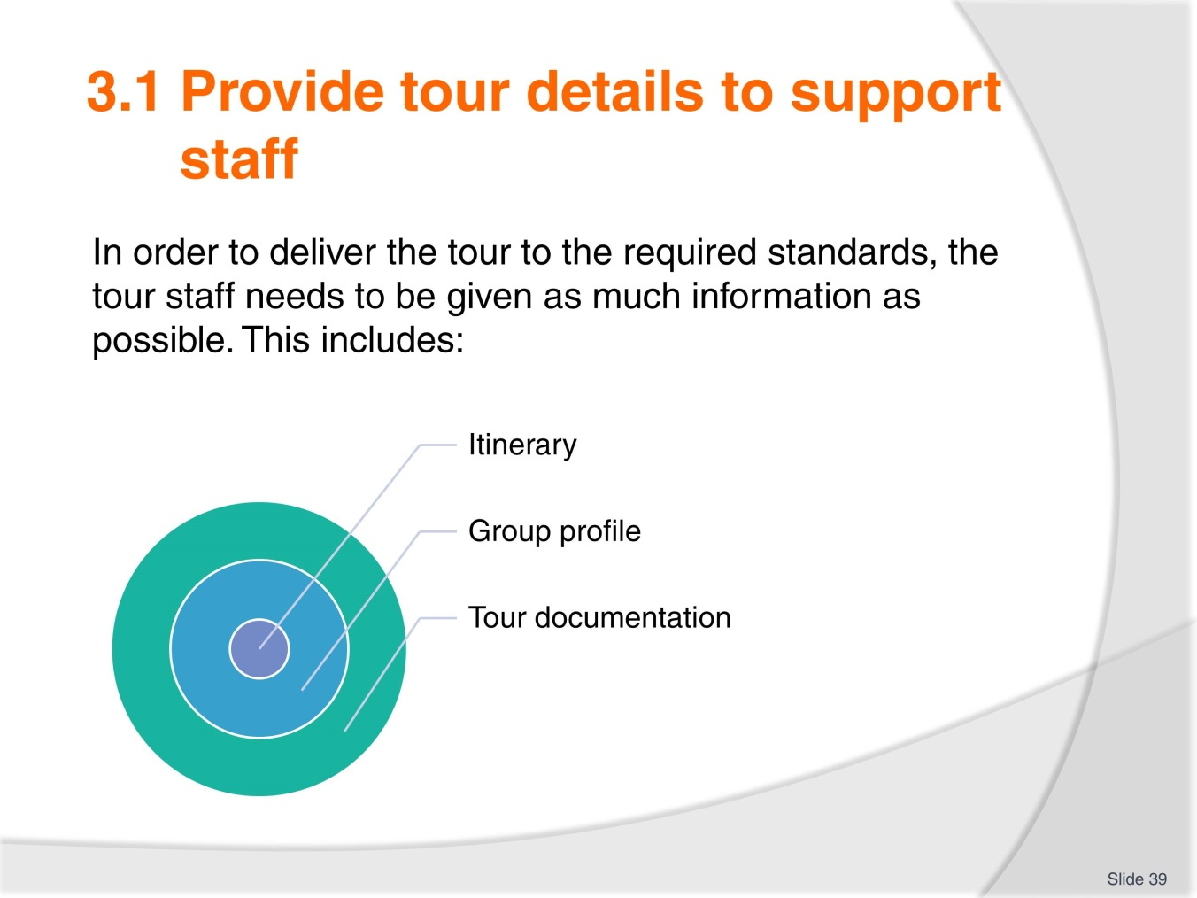
Slide No | Trainer Notes
 | Trainer to list the topics.

Slide
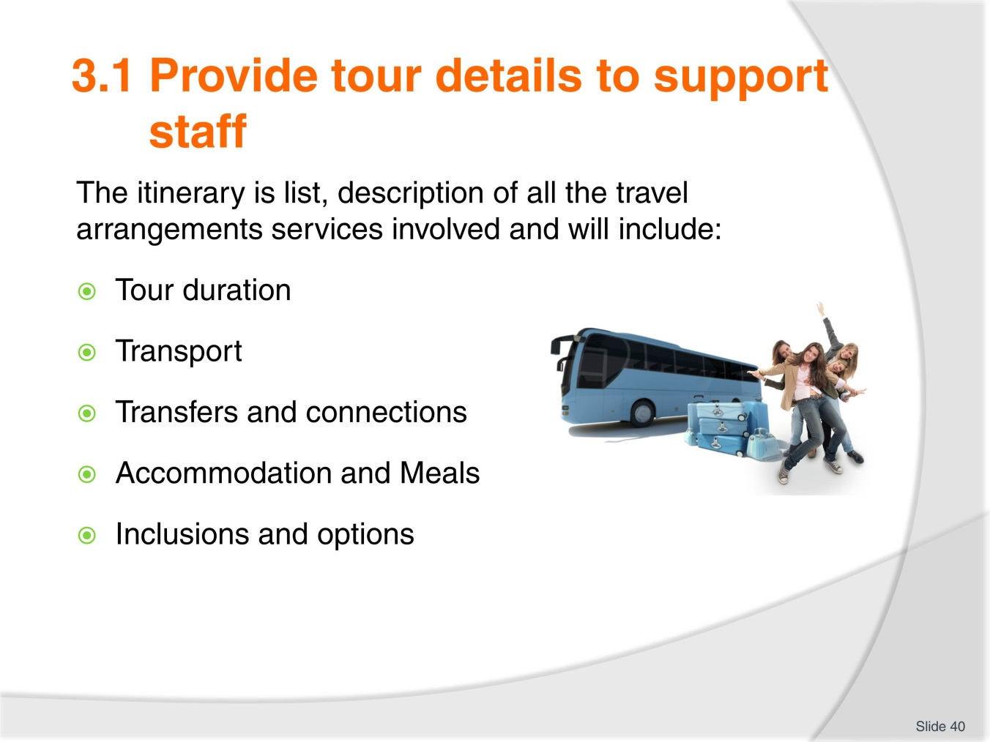
Slide No | Trainer Notes
Trainer to stress that the itinerary must be explained in detail to the tour staff so they can deliver the tour in the most efficient way possible.
Tour staff needs to pay special attention to the tour schedule, timetable, transfer times, visits times, accommodation and meals times and requirements.
They also need to be familiar with all inclusions and options as they will be managing them.

Slide
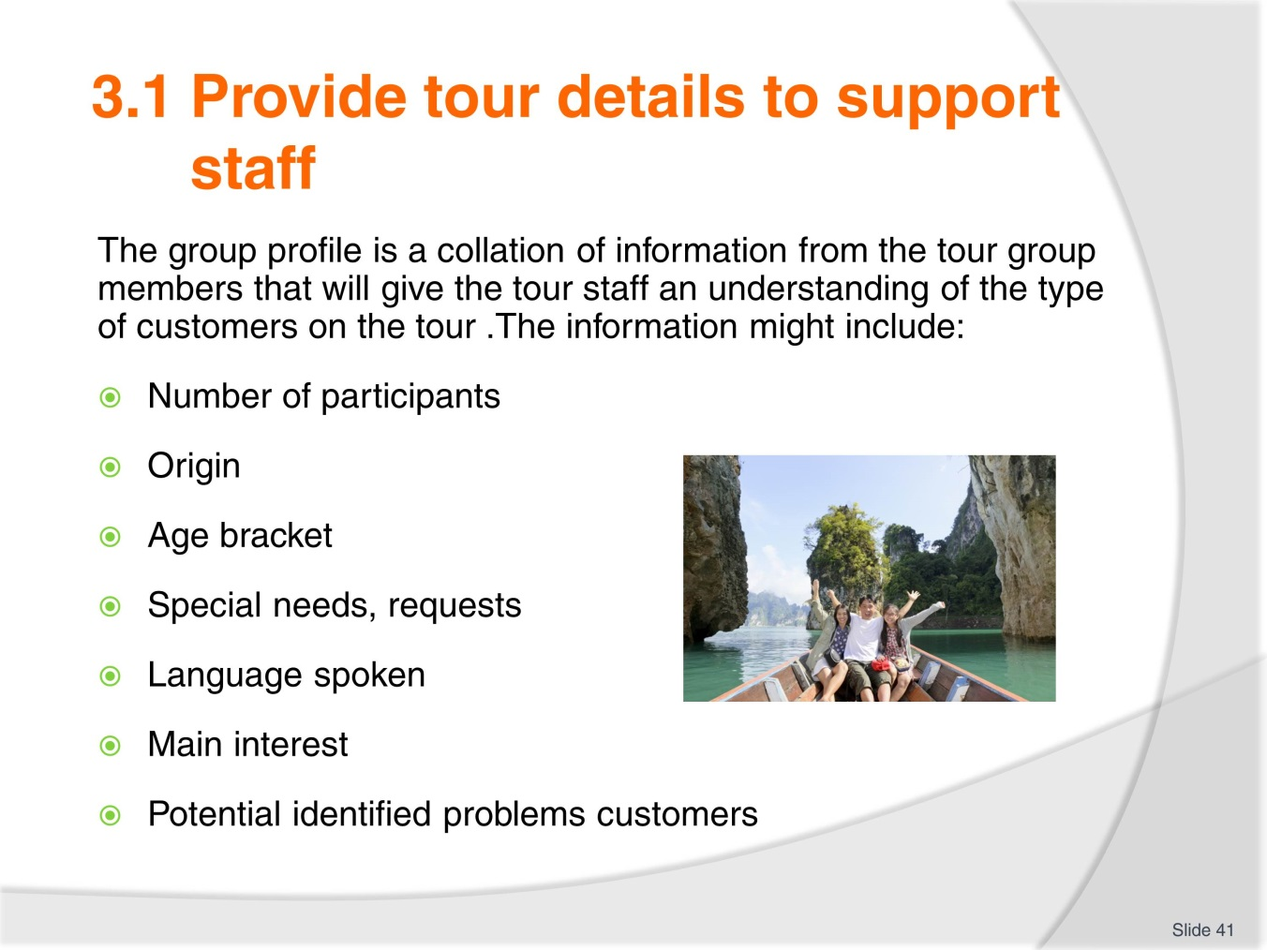
Slide No | Trainer Notes
Trainer to remind trainees that good customer service is one of the keys element to deliver a successful tour.
Knowing your audience will help with ensuring you meet the group tour members expectations.
Case study: during the tour briefing it emerges that a large majority of the overnight indulgence, luxury tour participants are not fluent in English. In pairs, decide what steps, strategies you will put in place to ensure the success of the tour.

Slide
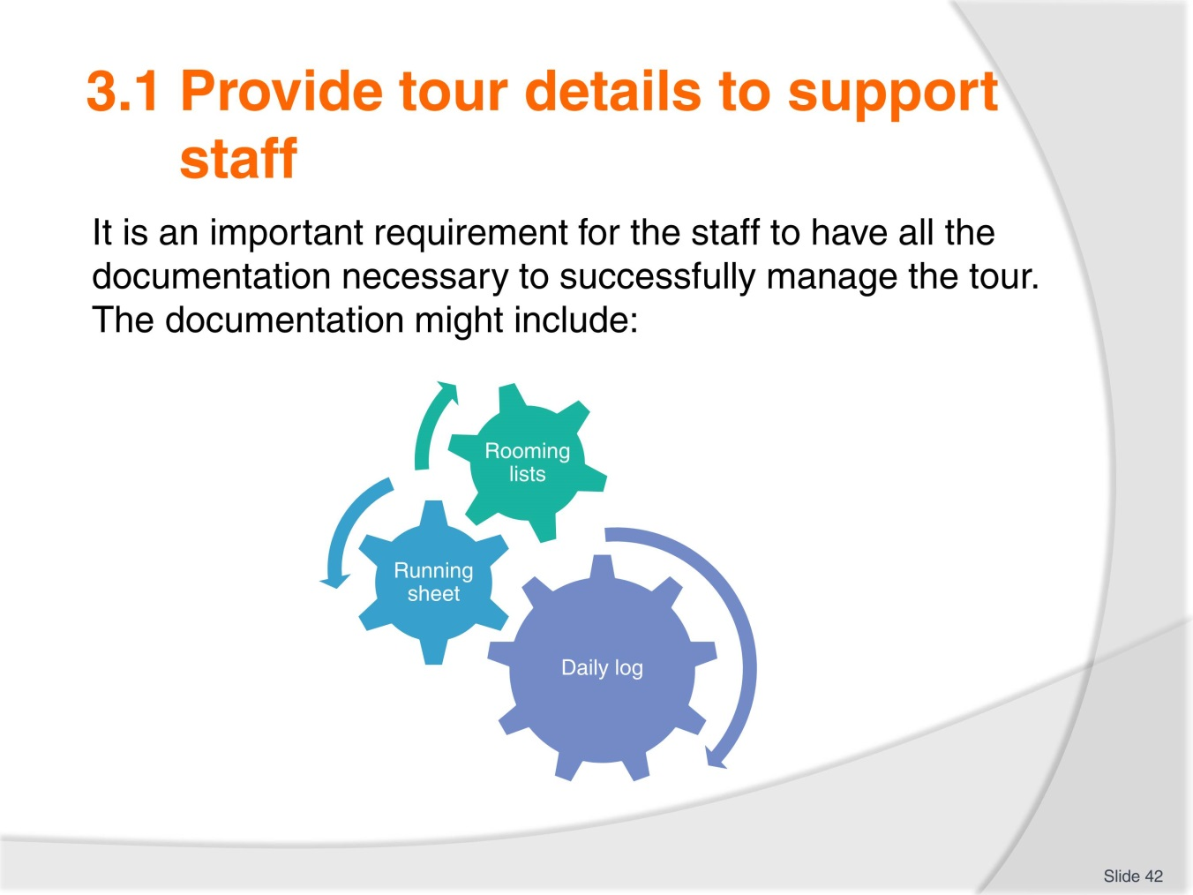
Slide No | Trainer Notes
Trainer to explain to the trainees what is a:
- Rooming list
- Running sheet
- Daily log and
- Why those documents are important.

Slide
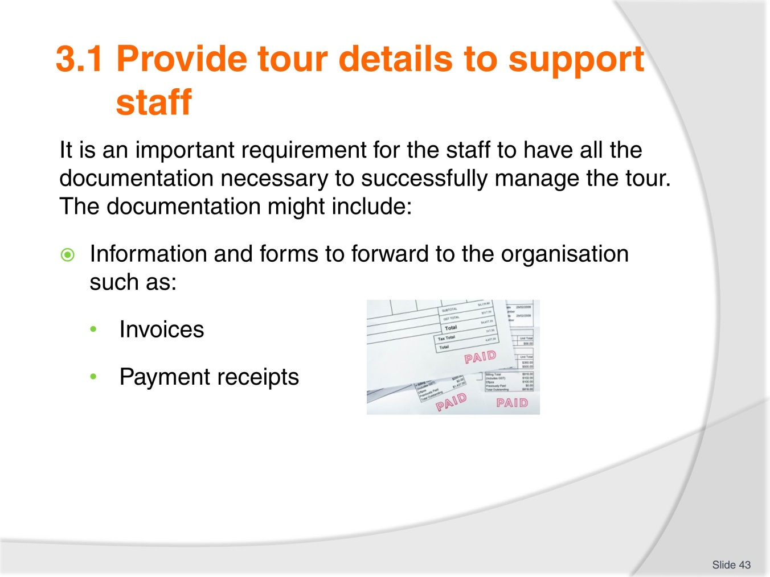
Slide No | Trainer Notes
Trainer to remind the trainees that the administration side of any tour is important as it serves to keep transaction records that will be used for:
- Accounting purposes
- For future reference

Slide
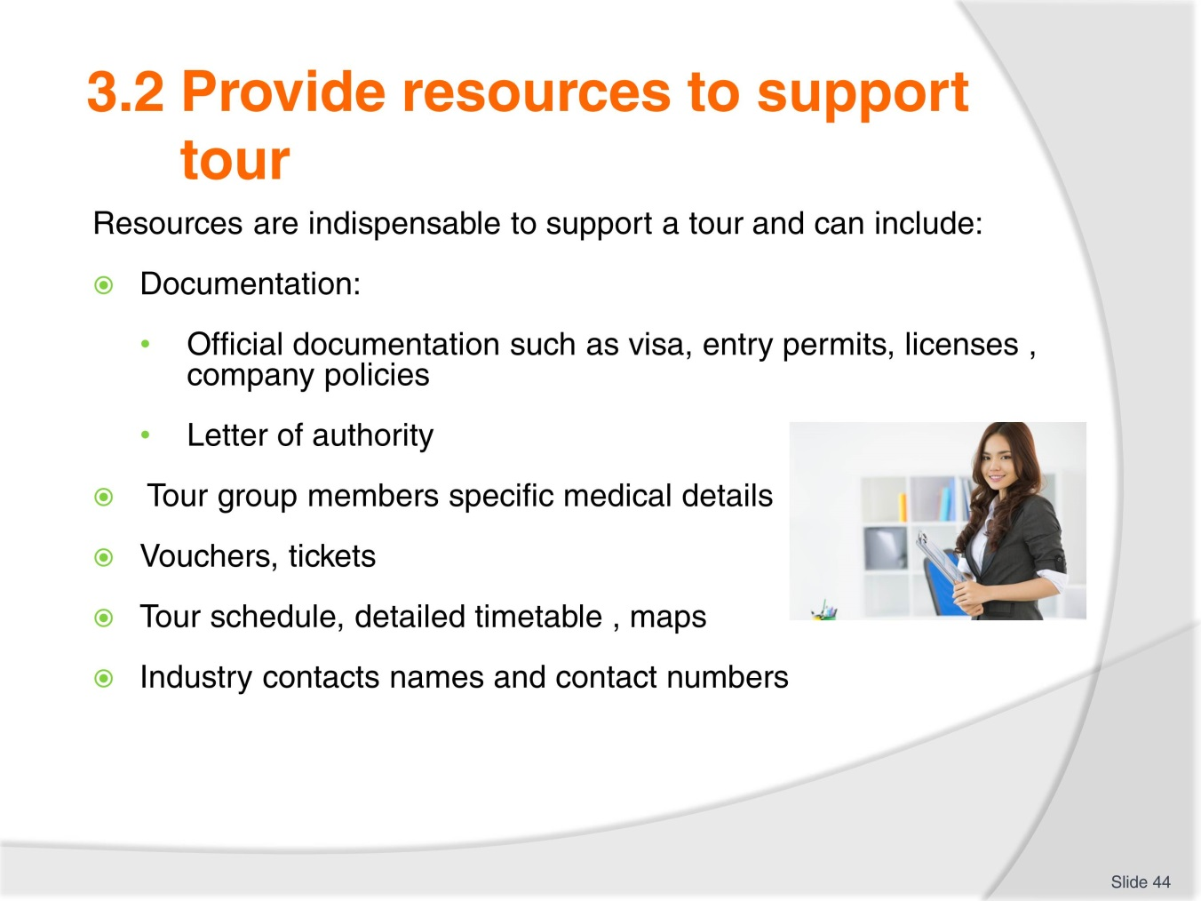
Slide No | Trainer Notes
Trainer to go through what resources to support tour can cover:
- Documentation as listed above
- Industry contacts.

Slide
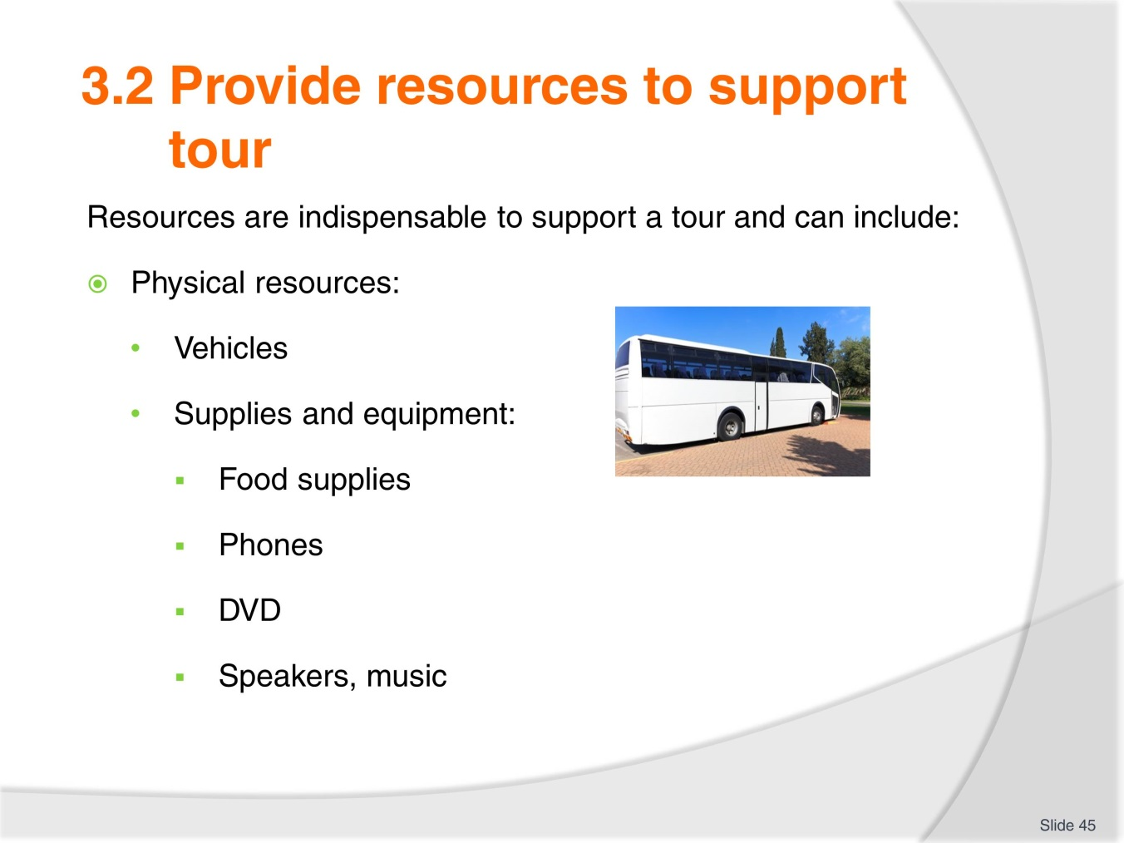
Slide No | Trainer Notes
Trainer to go through the list and remind trainees that different tours will have different resources requirements.
Trainees to complete some research and put together a physical resources list for a 2 nights bush camping tour and share their findings with the class when the list is completed.

Slide
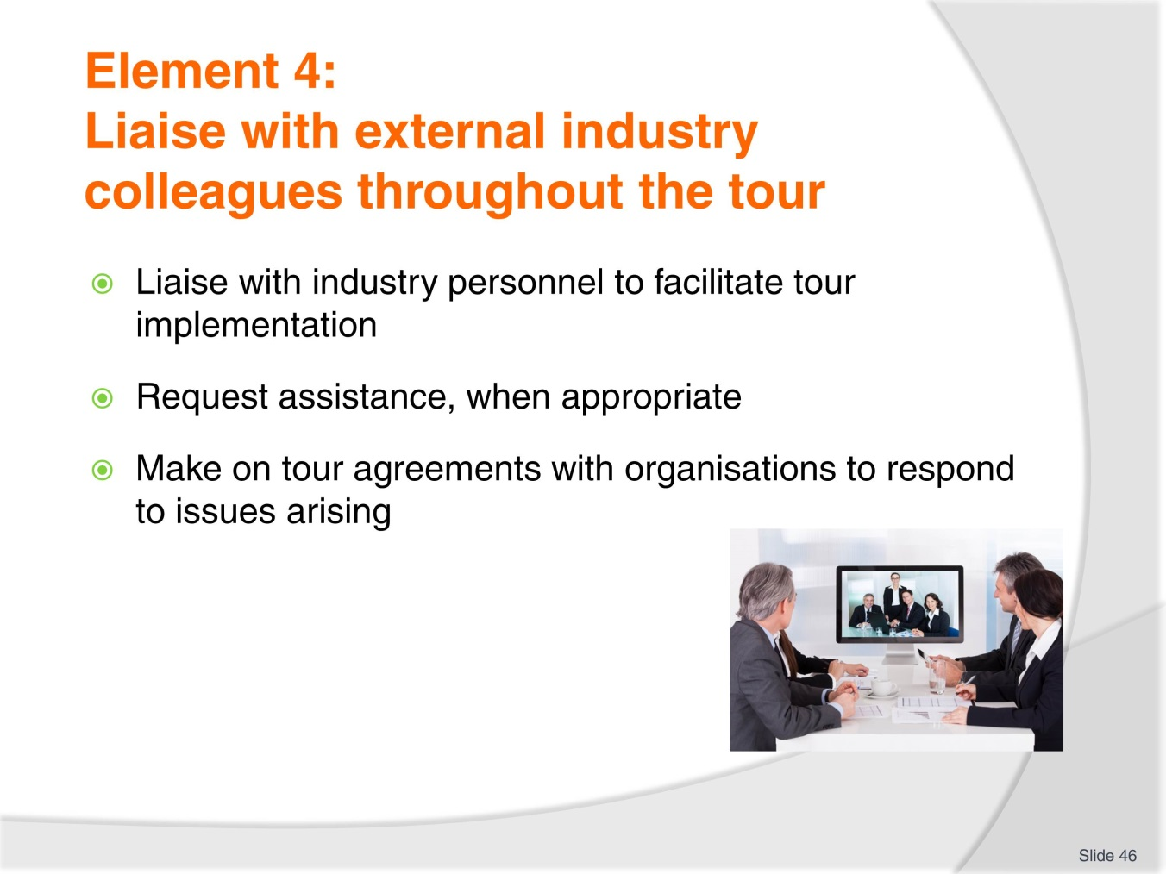
Slide No | Trainer Notes
 | Trainer to explain that this 4th element is about liaising with all external colleagues, suppliers.

Slide
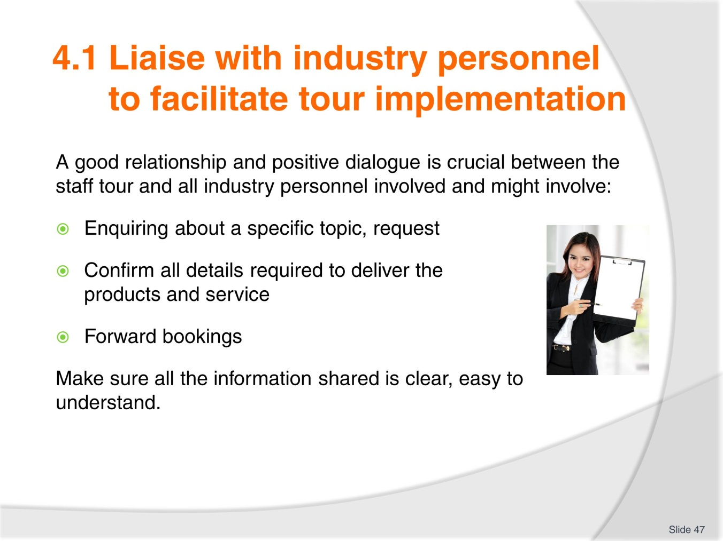
Slide No | Trainer Notes
Trainer to use the examples from the workbook or his/her examples to illustrate the points on the slide.
Trainer to ask trainees to explain, in your own words, the importance of liaising with industry personnel using an example.

Slide
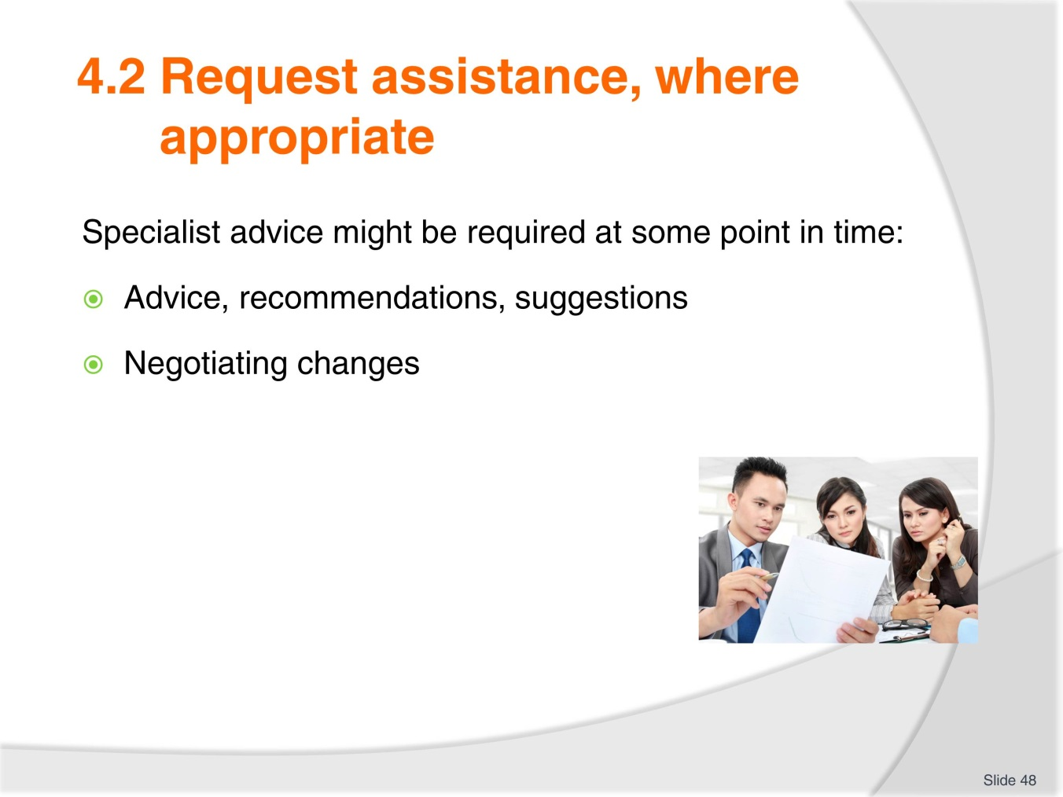
Slide No | Trainer Notes
Again, using the workbook examples or others, the trainer will explain how specialist advice might be required during the tour and changes negotiated, if required.
Class activity
Trainees to find examples when legal advice due to change.

Slide
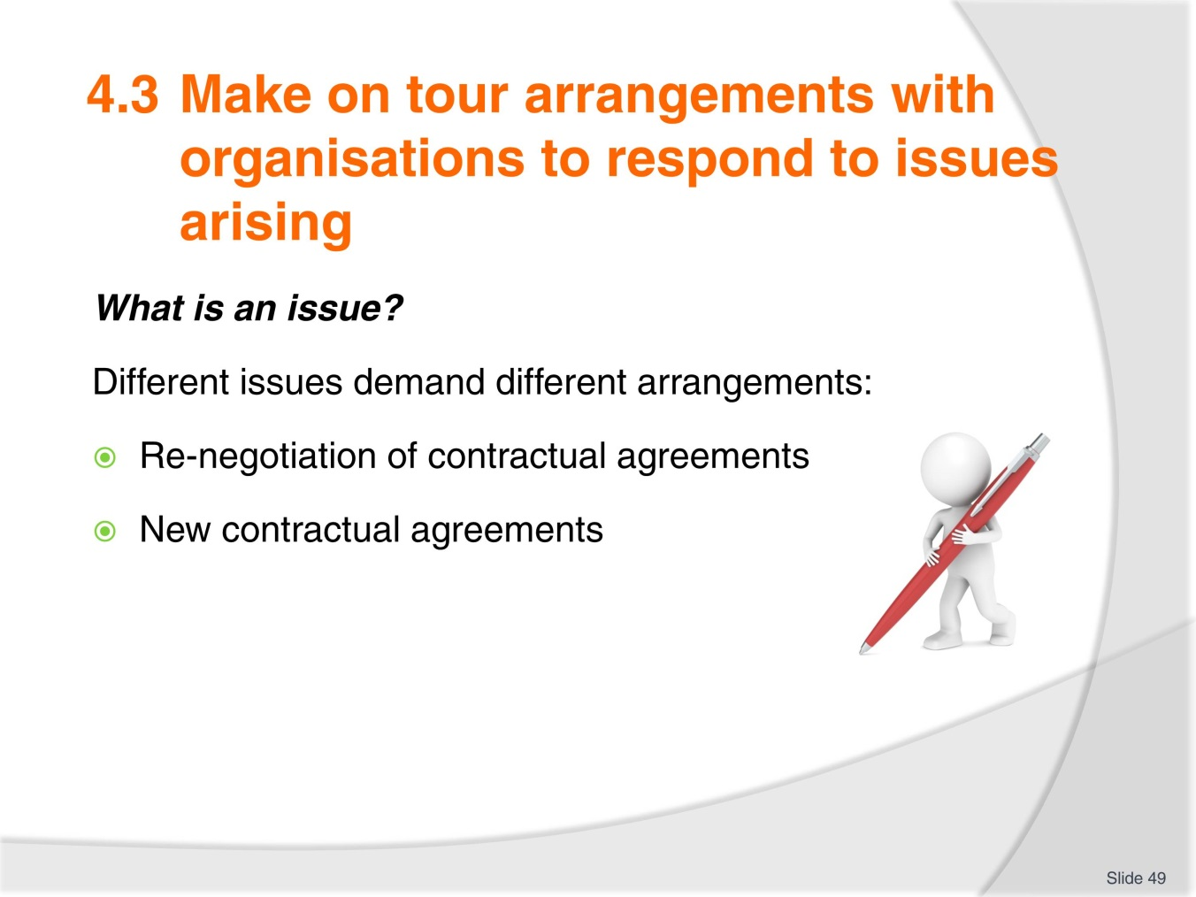
Slide No | Trainer Notes
Trainer to brainstorm with the trainees examples of issues that might arise during a tour.
Trainer to explain the difference between issue and emergency.
Trainer to explain, as per the workbook examples, what measures can be put in place to respond to issues arising from organising transport to change a booking.

Slide
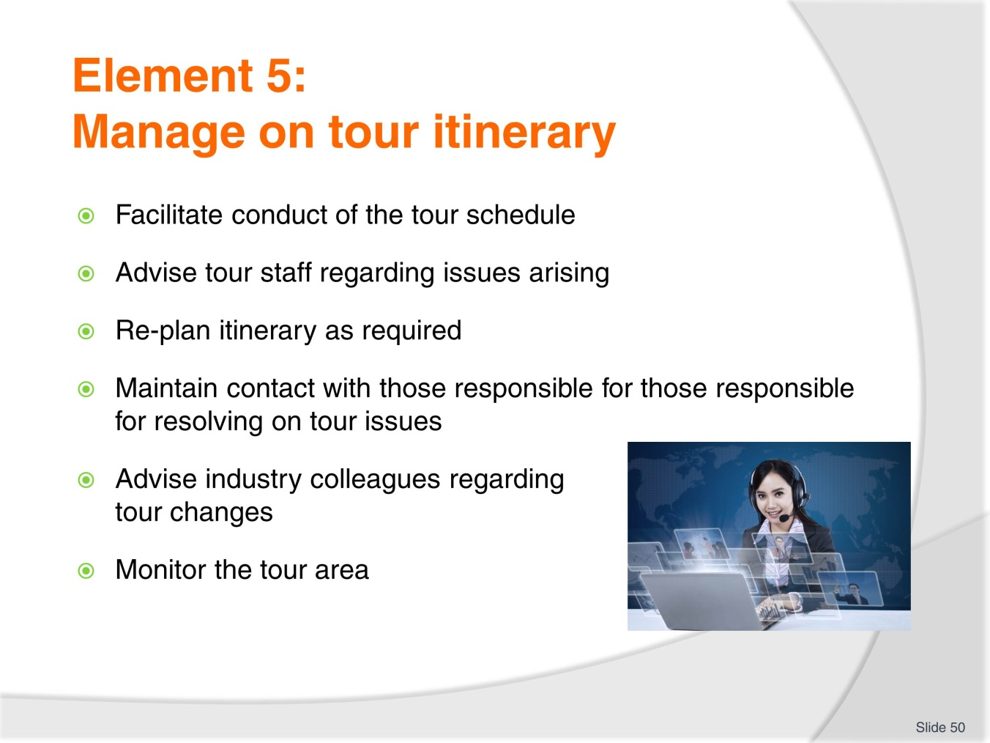
Slide No | Trainer Notes
 | Trainer to go through the 6 criteria and insist we are now dealing with the management of the tour itinerary.

Slide
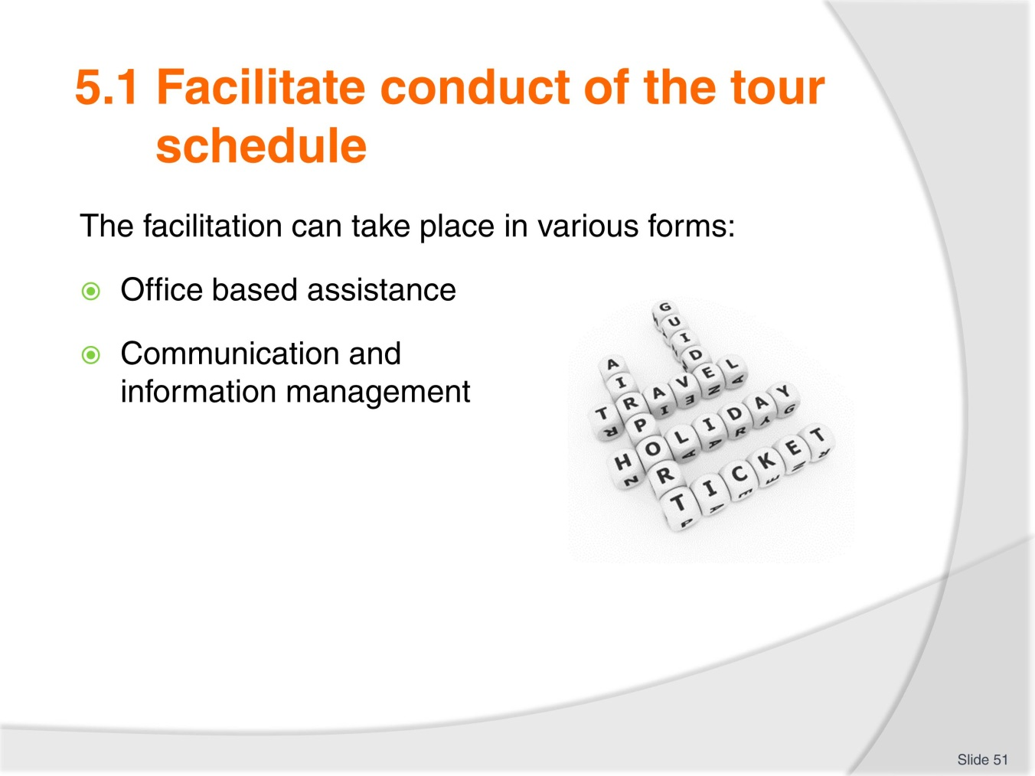
Slide No | Trainer Notes
Trainer to explain the importance of the tour schedule and keeping to it to make sure all the activities, options etc. can take place on time and when scheduled.
The facilitation can be provided both by the office and on the ground by the tour staff dealing with all products and services suppliers, support systems such as emergency numbers if required.

Slide
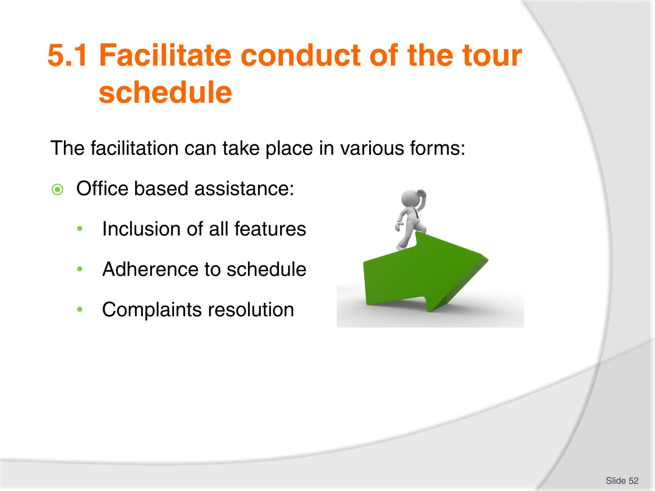
Slide No | Trainer Notes
 | Trainer to provide the trainees with some tour organisations contact name and number. Trainees to find the type of office based support the organisation provide to the tour staff while on tour. Findings to be shared with the class when the activity is completed and compared with the items listed in the workbook.

Slide
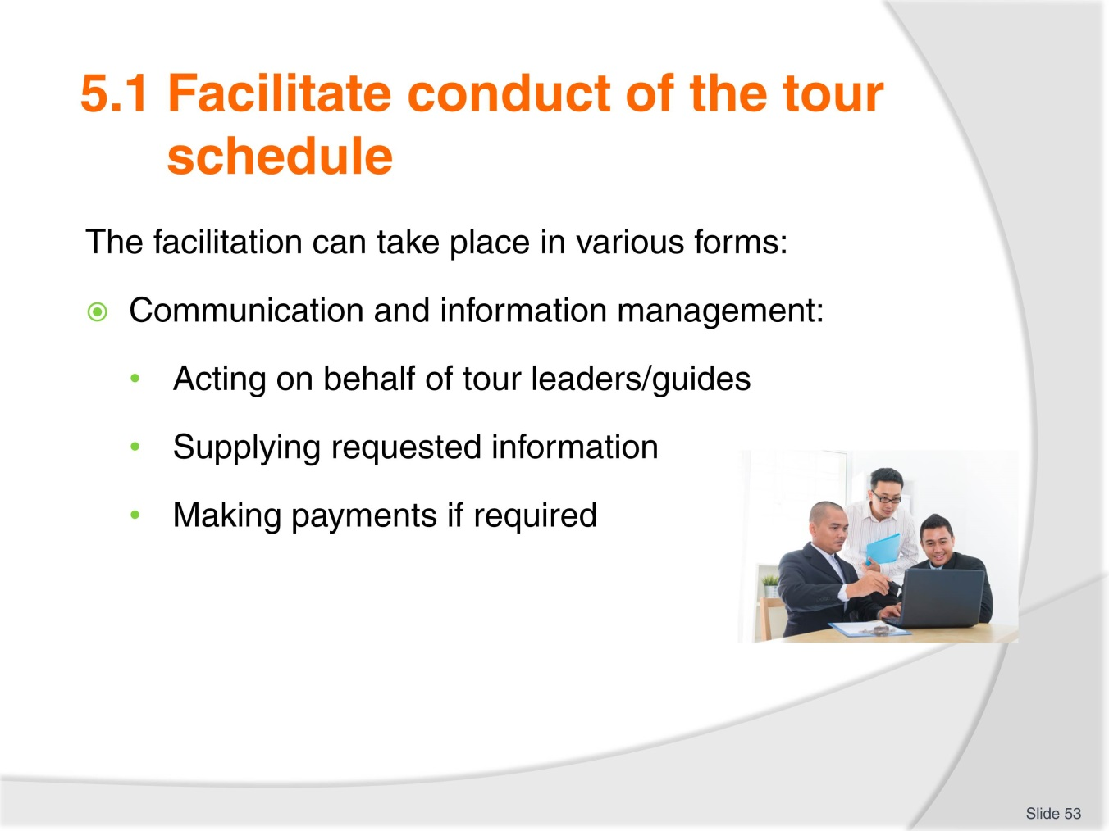
Slide No | Trainer Notes
 | Trainer to explain how those points are also designed to support the staff while on tour and illustrate the points with a few examples from the region, country.

Slide
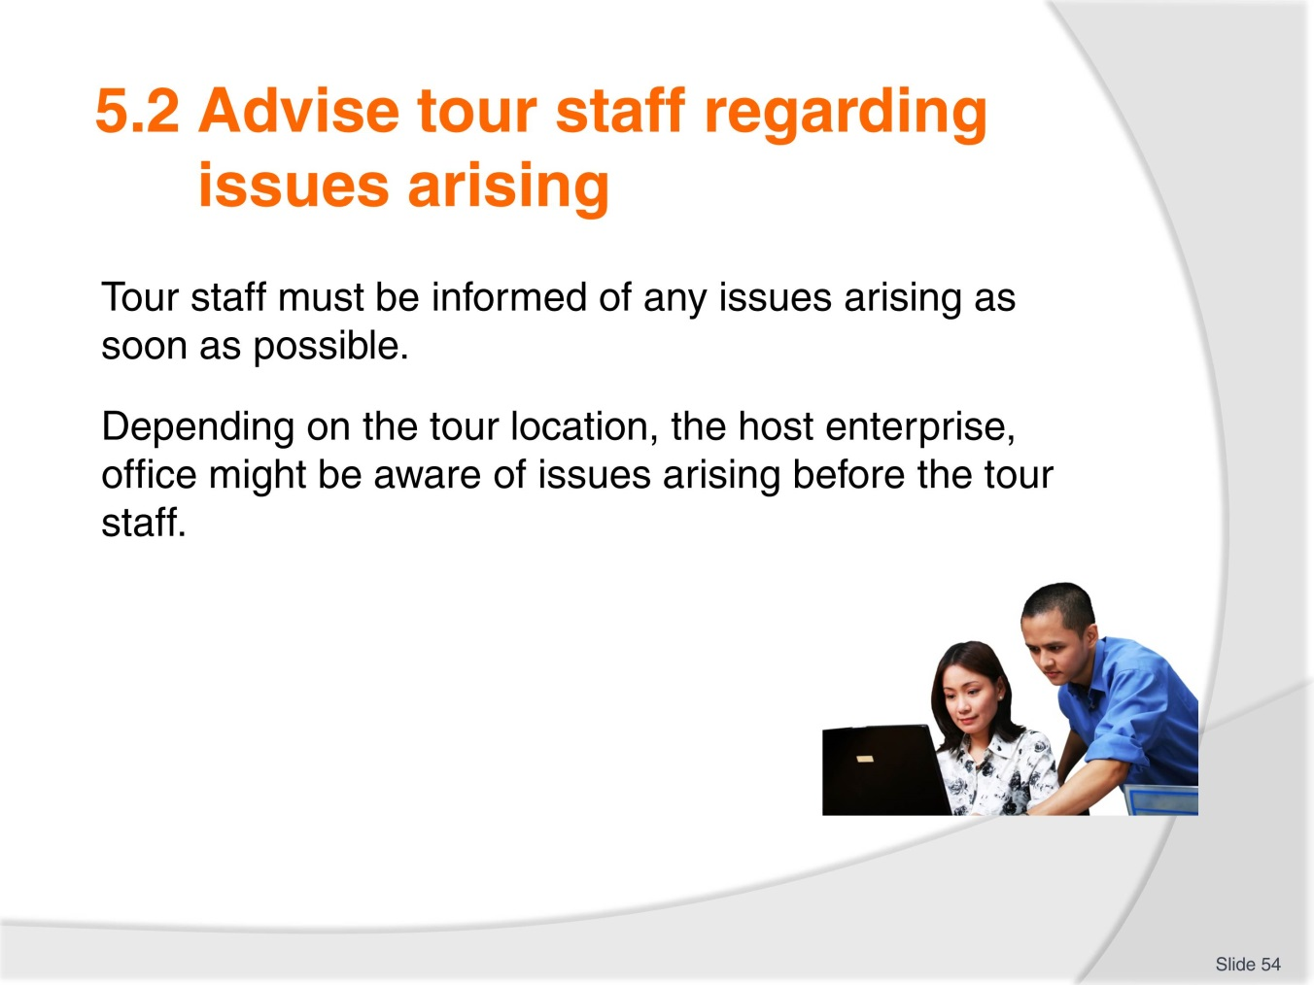
Slide No | Trainer Notes
 | Trainer to conduct internet research with trainees within their country to identify specific locations where the situation explained on the slide would take place due to remote location and difficulty in communication.

Slide
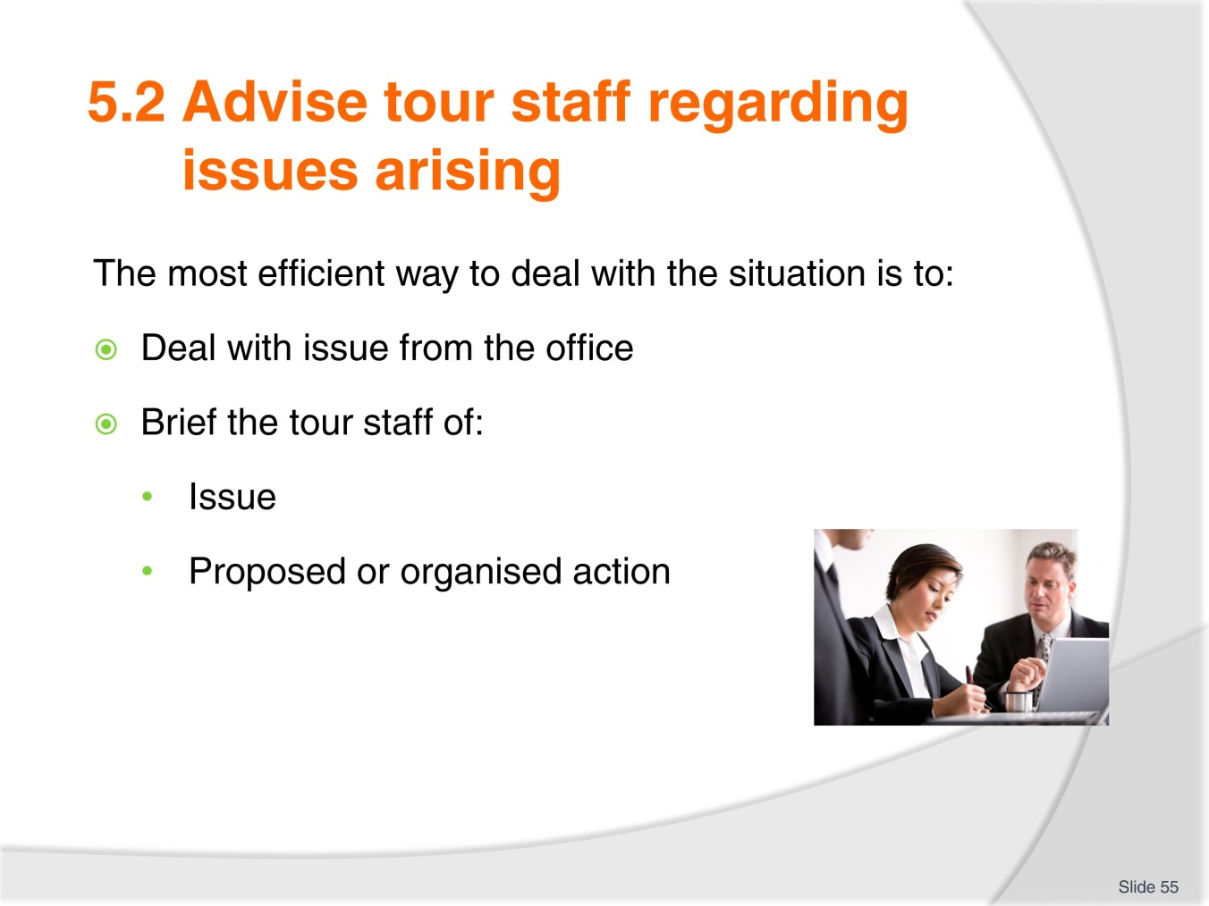
Slide No | Trainer Notes
 | Trainer to comment on the examples in the workbooks or use his /her own to illustrate the point.

Slide
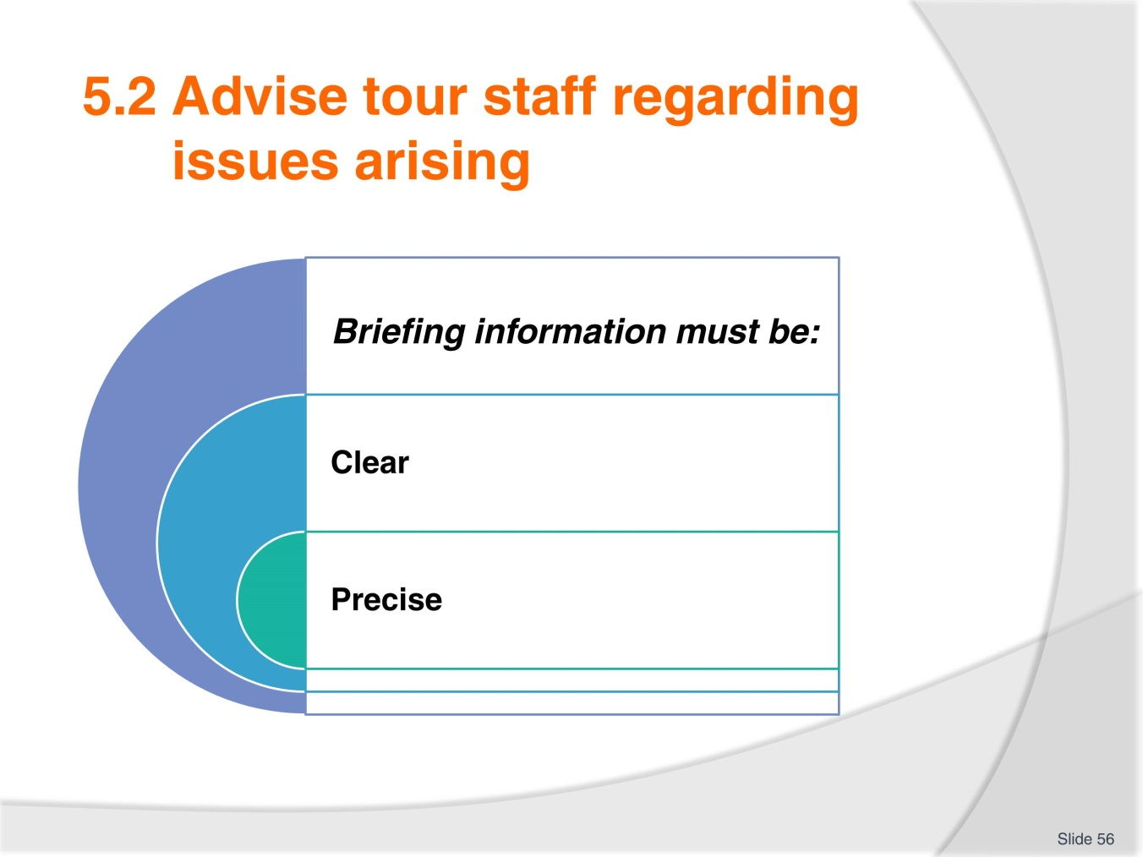
Slide No | Trainer Notes
 | Trainer to comment on slide and also remind trainees about the wellbeing of tour group members being more important than financial considerations.

Slide
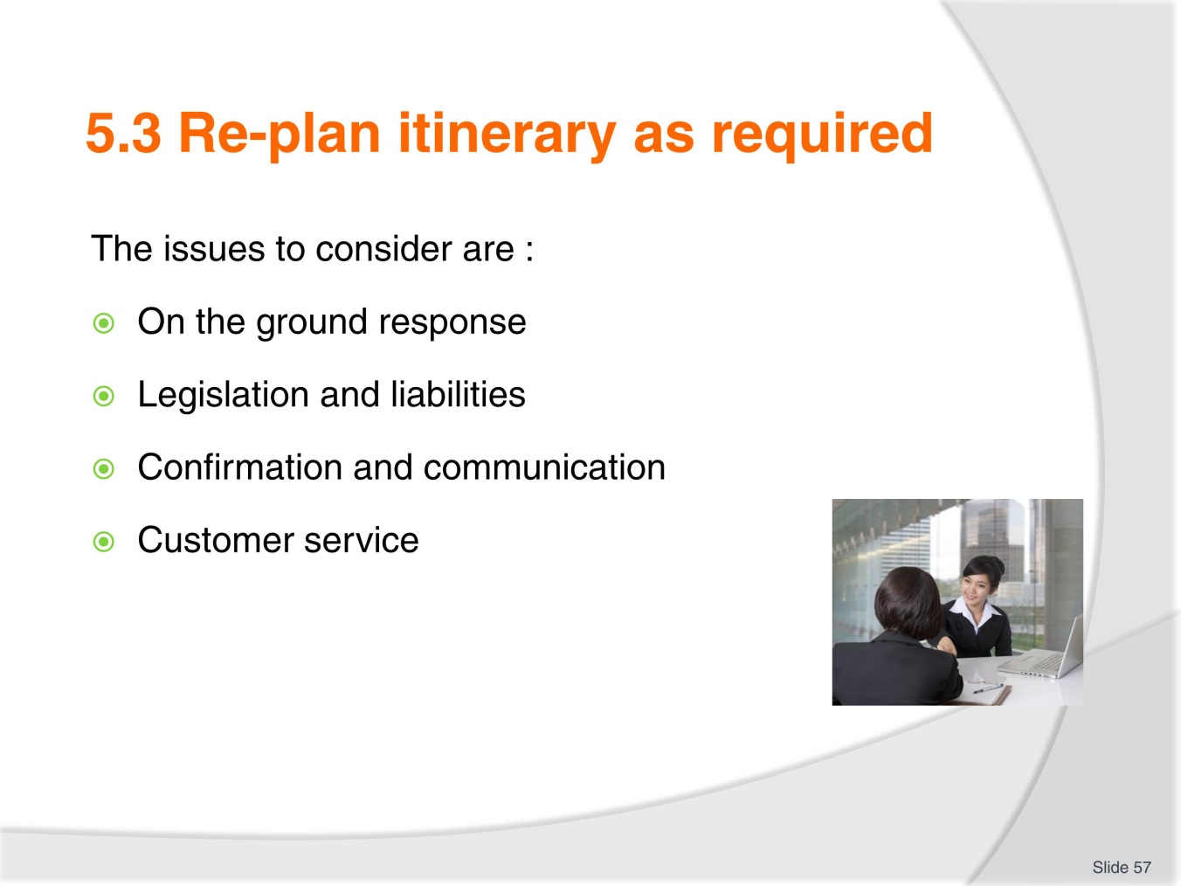
Slide No | Trainer Notes
 | Trainer to explain that re planning an itinerary is going to require team work and all 4 points listed need to be carefully considered.

Slide
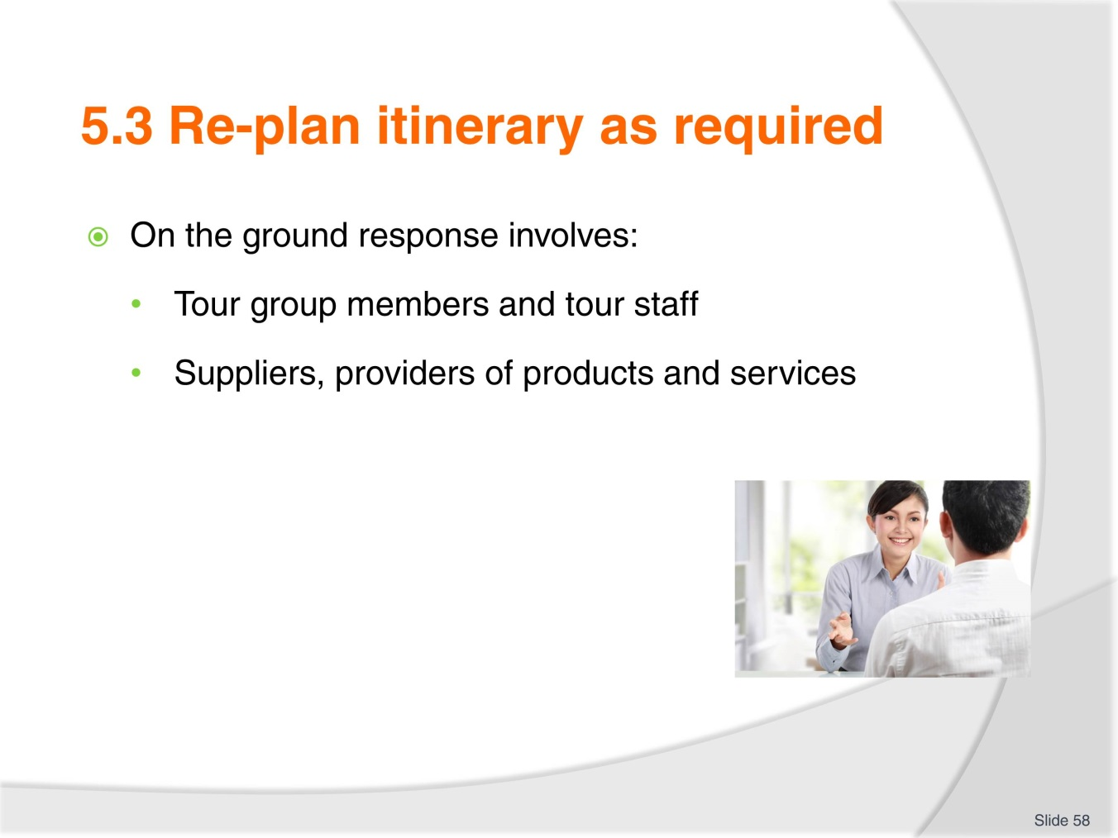
Slide No | Trainer Notes
Trainer to explain the consequences of re-planning itinerary using workbook examples or his/her own.
Trainer to stress the importance of putting the tour group members first.

Slide
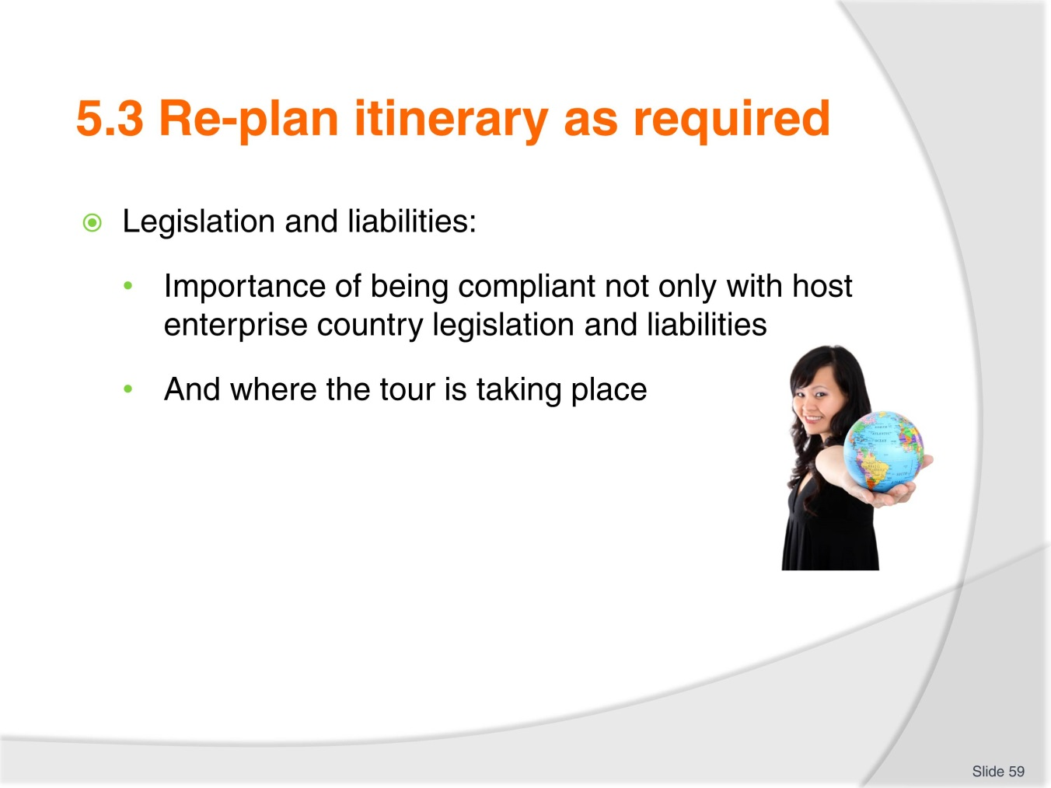
Slide No | Trainer Notes
Trainer to explain the differences between countries legislation, liabilities, duty of care etc.
Class activity
Trainees to find the relevant country legislation , guidelines or even examples in regards to tour operator liabilities when a change of itinerary takes place.

Slide
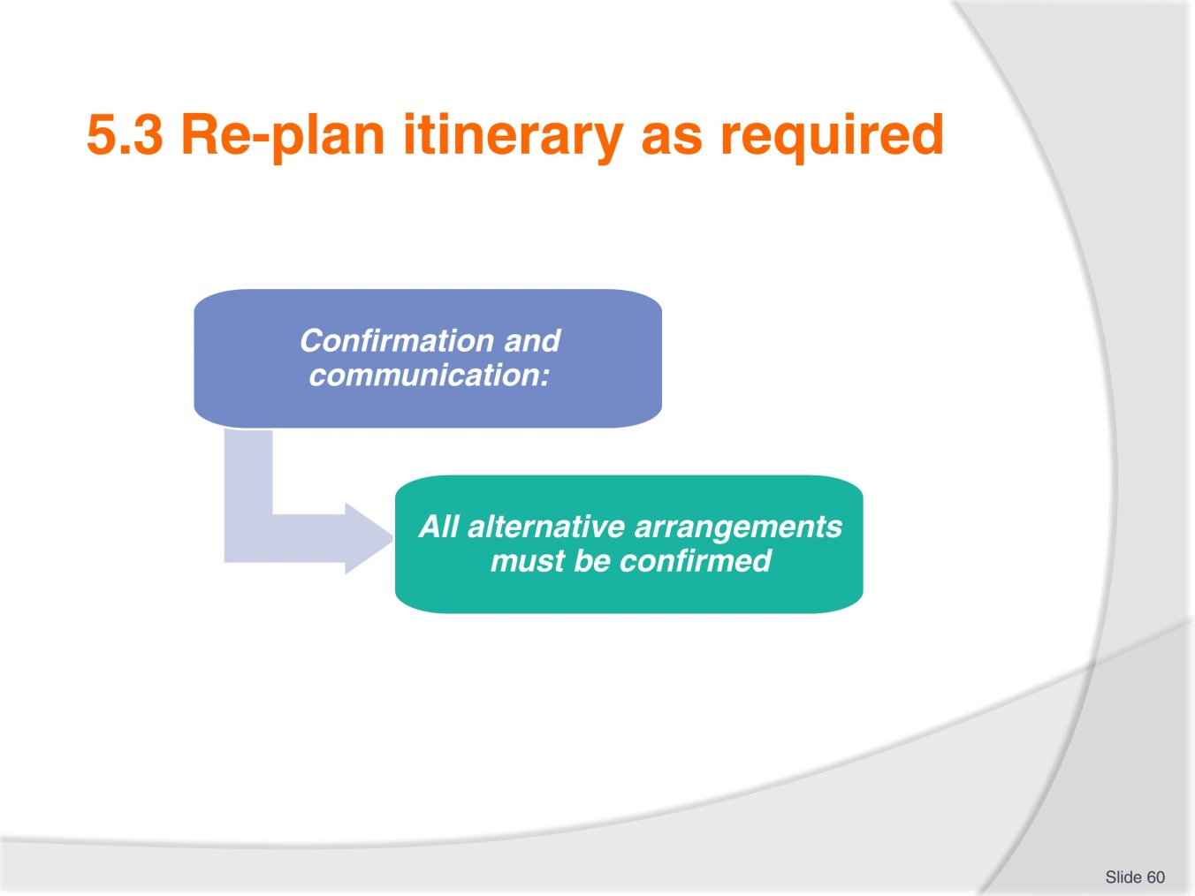
Slide No | Trainer Notes
 | Trainer to discuss with trainees the various ways alternative arrangements can be confirmed and communicated to all concerned parties nowadays.

Slide
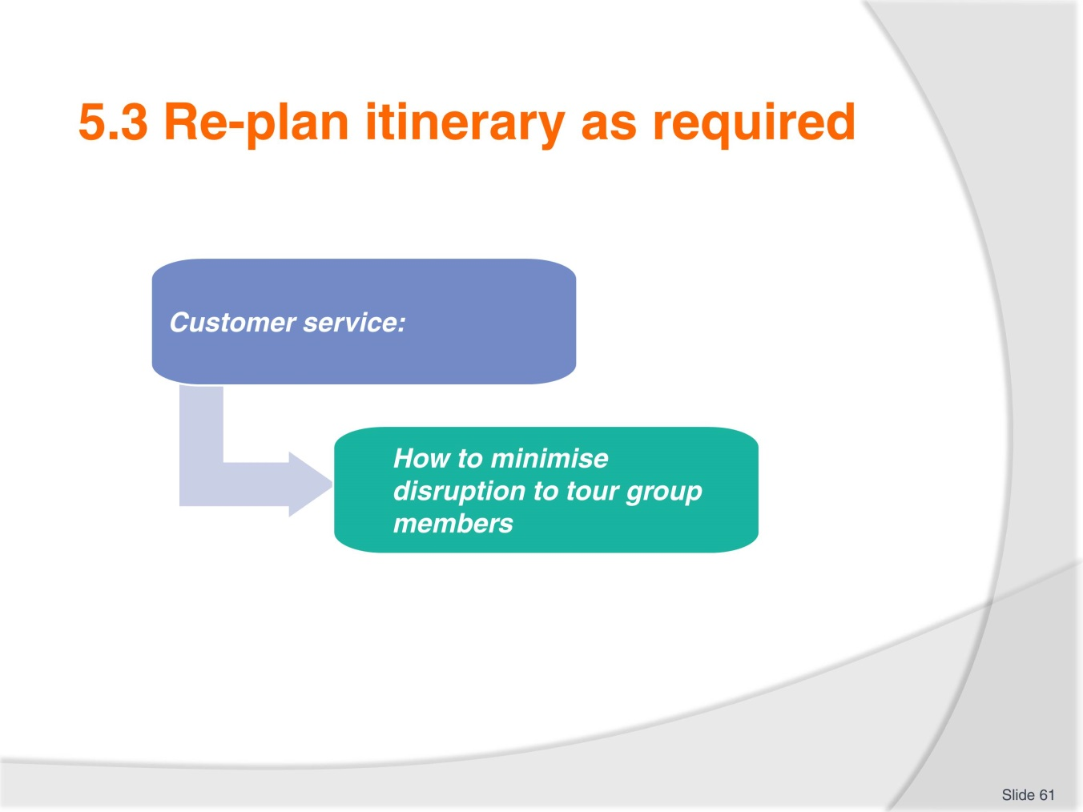
Slide No | Trainer Notes
Trainer to illustrate the point by asking the trainees in groups of 4 to write a scenario about a change of itinerary due to a road closure.
Trainees to role play what the tour staff would say to the tour group members to minimise disruption and dissatisfaction.

Slide
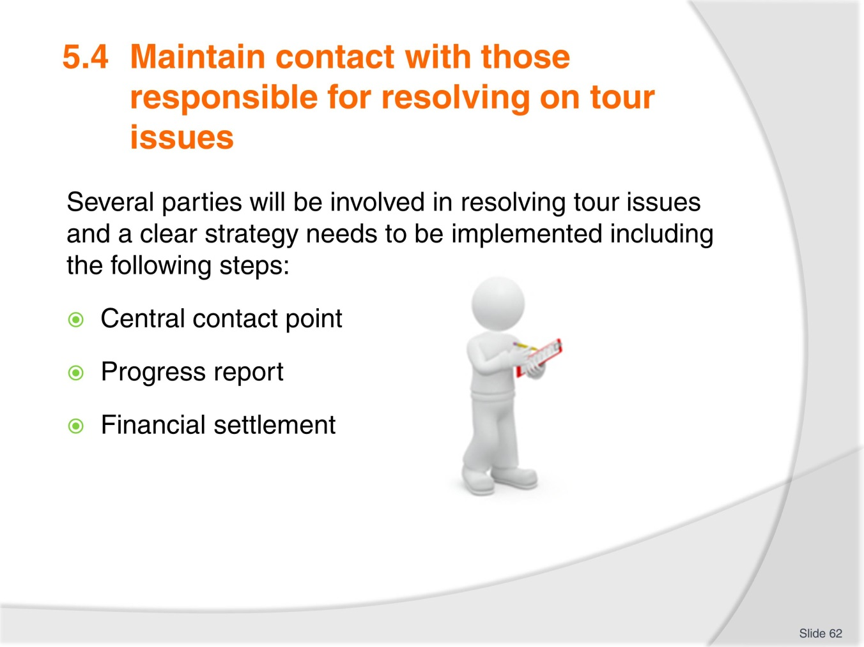
Slide No | Trainer Notes
Trainer to split the class into 3 groups. Groups to read the workbook content and then explain it to the rest of the class:
- One group will cover central contact point
- One group progress report
- One group financial settlement.

Slide
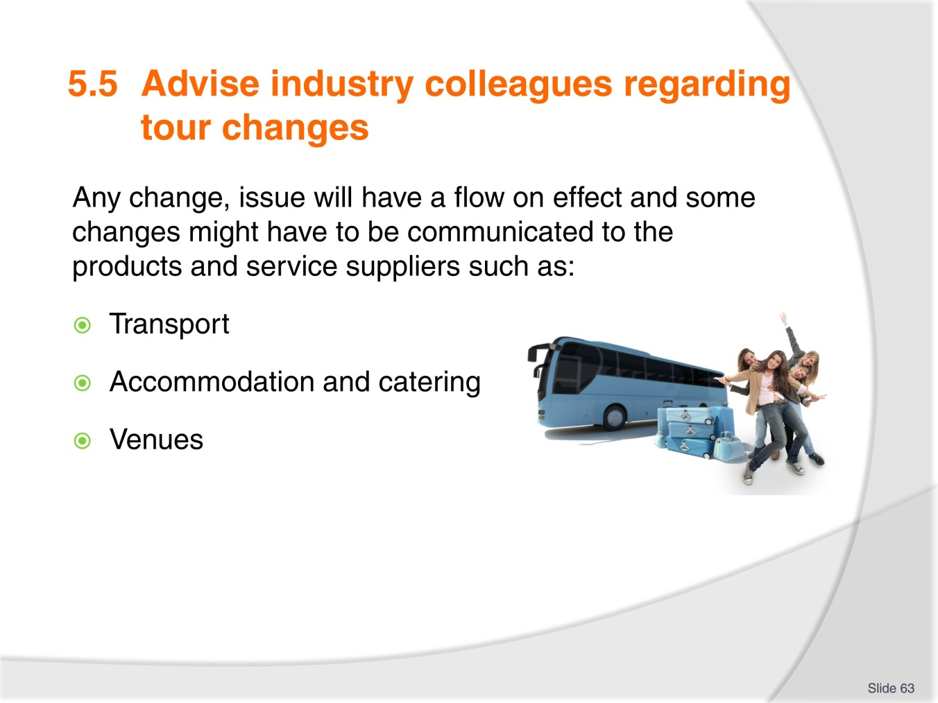
Slide No | Trainer Notes
 | Trainer to illustrate the slide content with the workbook examples or his/her own.

Slide
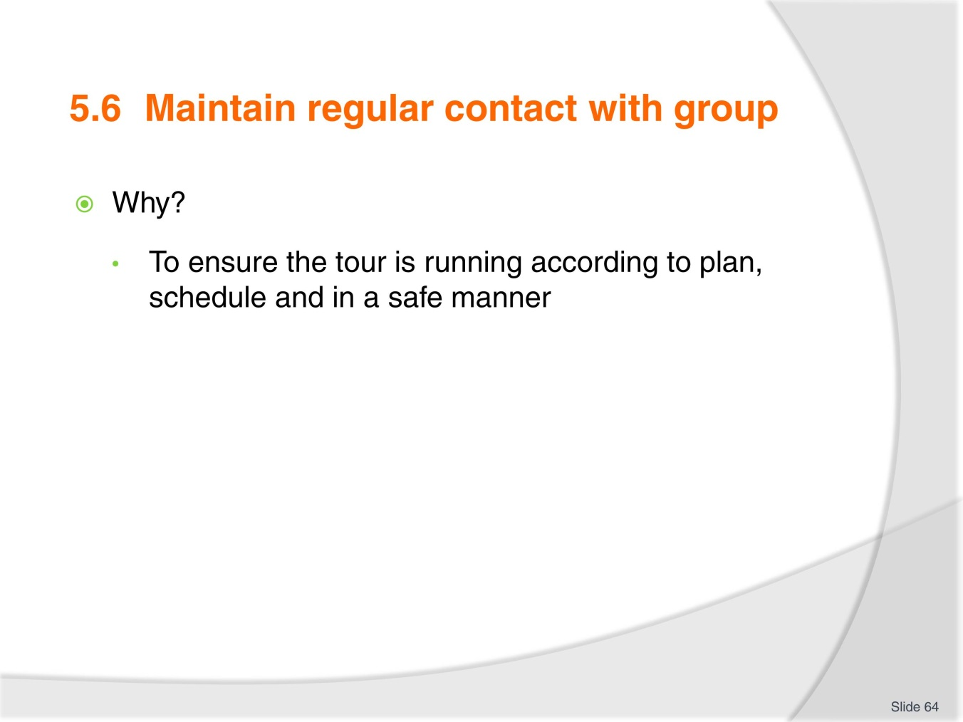
Slide No | Trainer Notes
 | Trainer to remind trainees of the importance of the support role the host enterprise needs to plan when managing on tour itinerary.

Slide
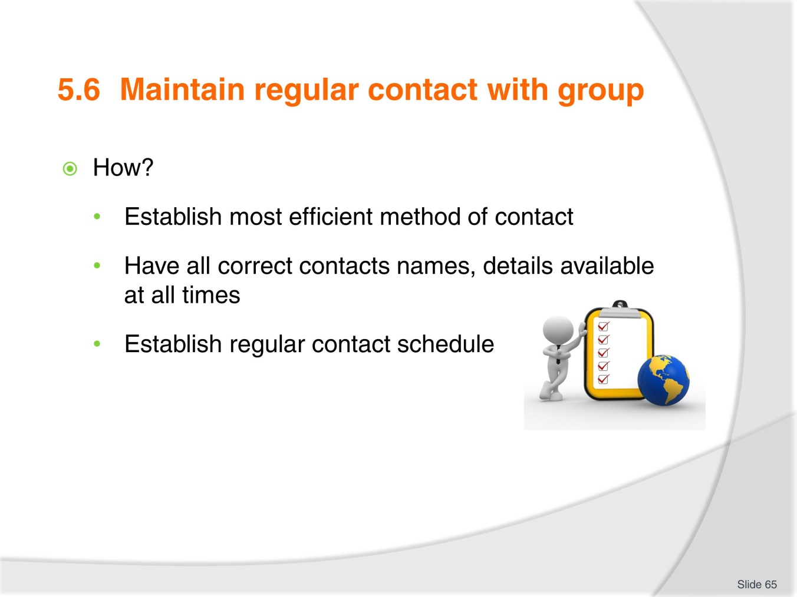
Slide No | Trainer Notes
 | Trainer to explain this follows onto the importance of keeping in touch and ensuring that, even if the tour is in a remote location, regular contact can be made and maintained

Slide
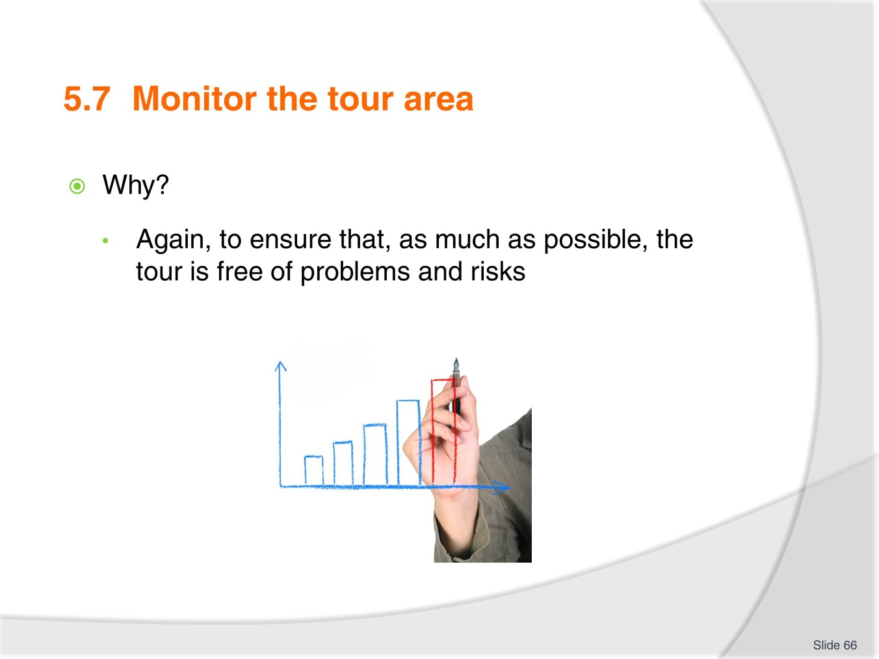
Slide No | Trainer Notes
 | Trainer to remind trainees of the host enterprise legal responsibilities and duty of care.

Slide
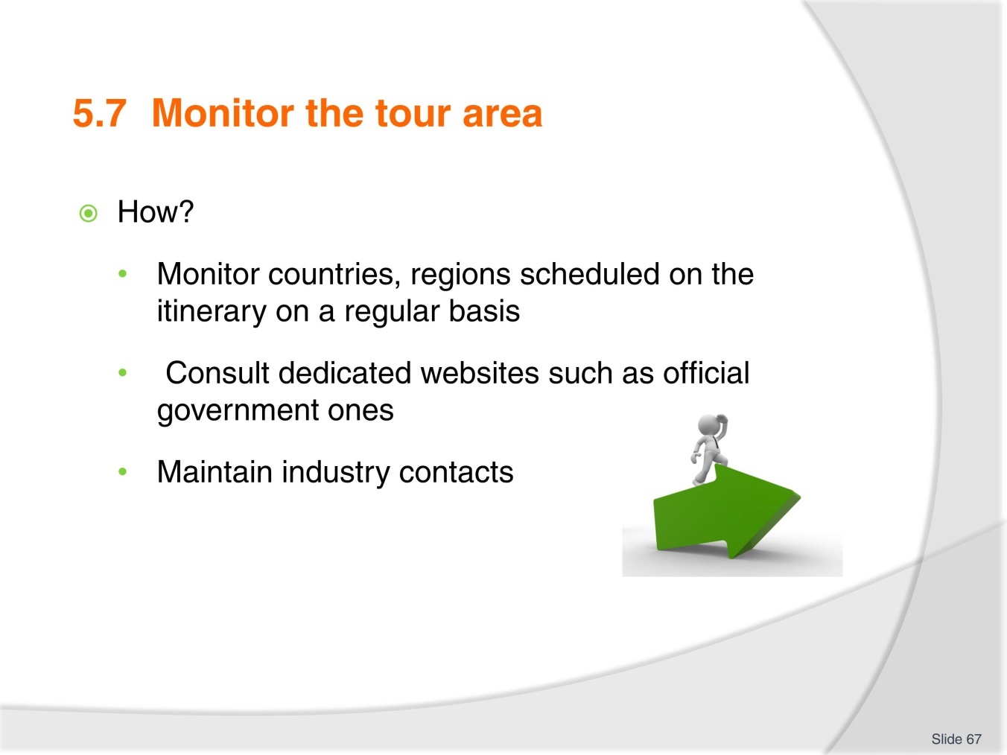
Slide No | Trainer Notes
Trainer to illustrate the points on slide by researching with trainees official websites such as Smart traveller in Australia:
- www.smartraveller.gov.au/.

Slide
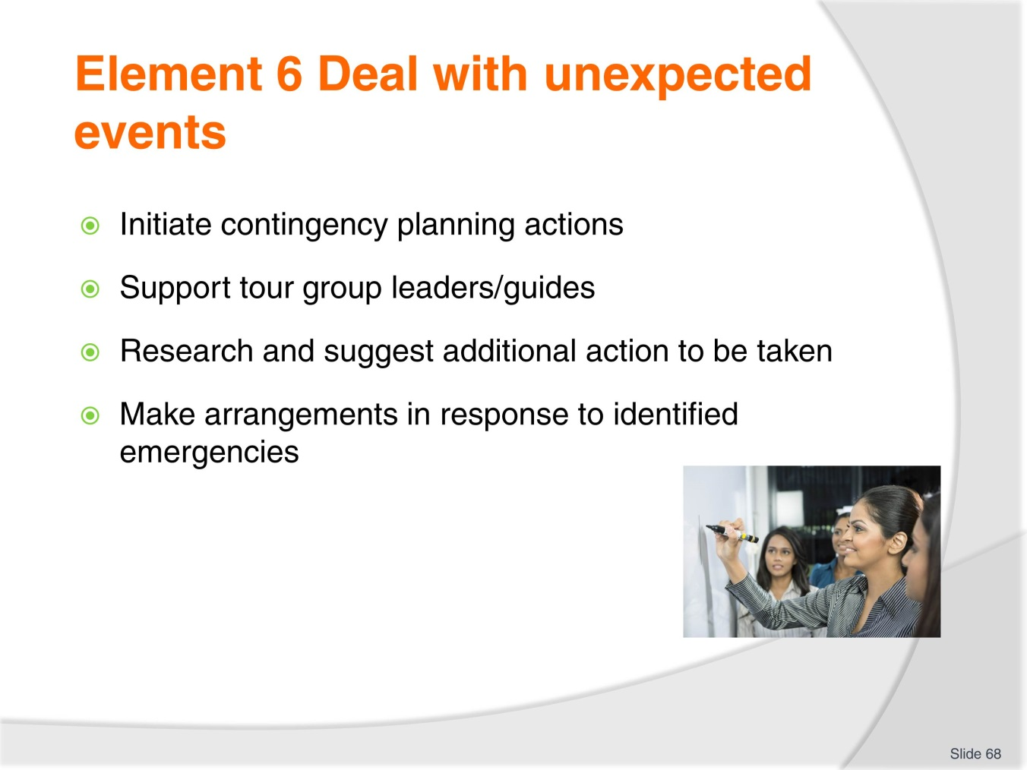
Slide No | Trainer Notes
Trainer to introduce this element dealing with unexpected events and their impact on the tour:
- Trainer to detail the 6 performance criteria.

Slide
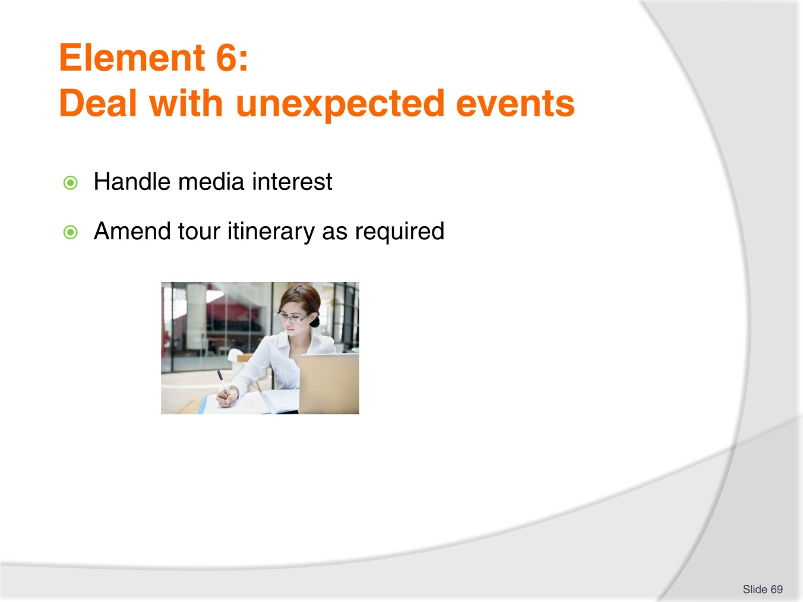
Slide No | Trainer Notes
Trainer to introduce this element dealing with unexpected events and their impact on the tour:
- Trainer to detail the 6 performance criteria.

Slide
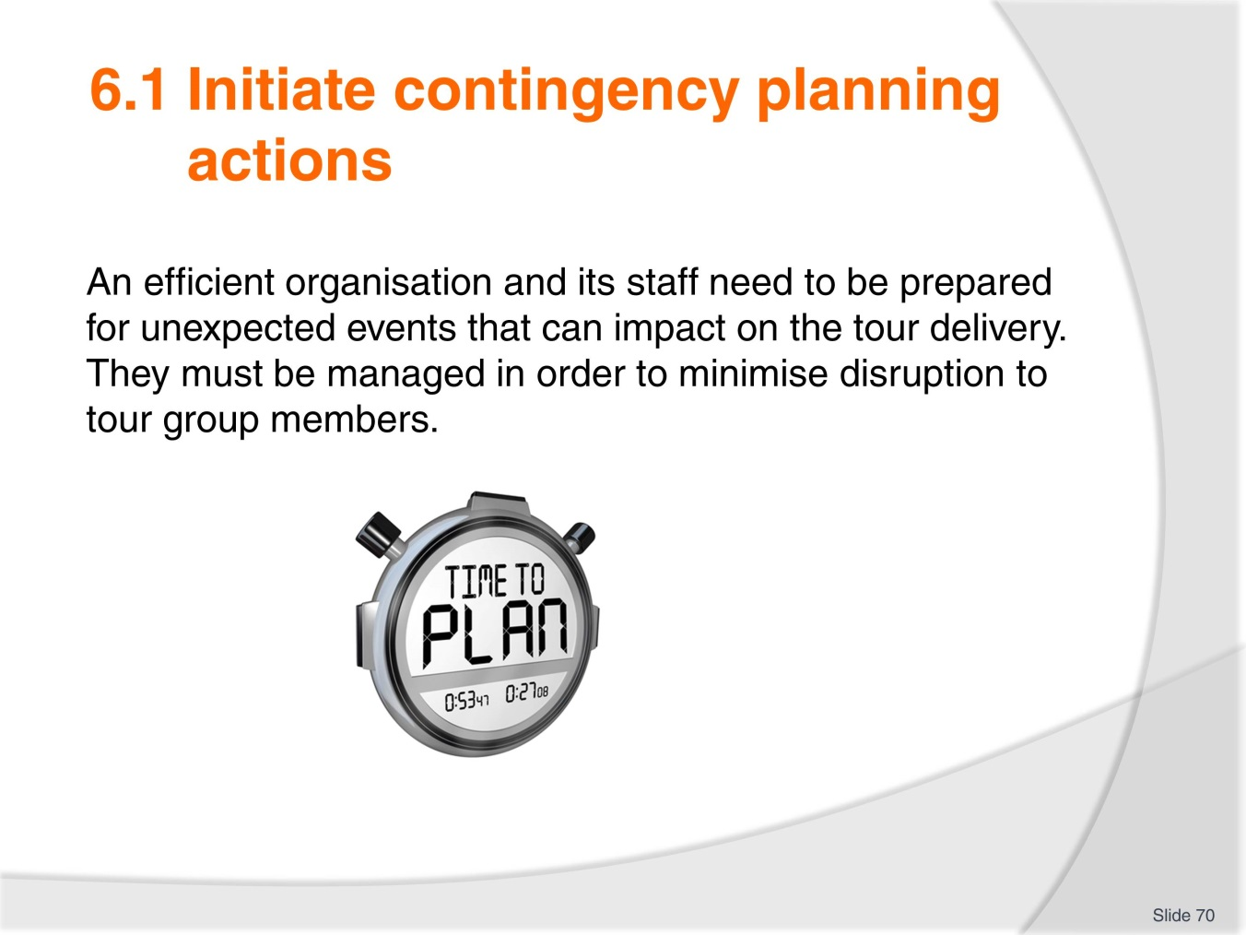
Slide No | Trainer Notes
 | Trainer to remind the trainees of the importance of knowing what to do when the unexpected happens and stress the organisation’s responsibilities in having a EMP (Emergency Management Plan) and making sure all tour staff are familiar with it.

Slide
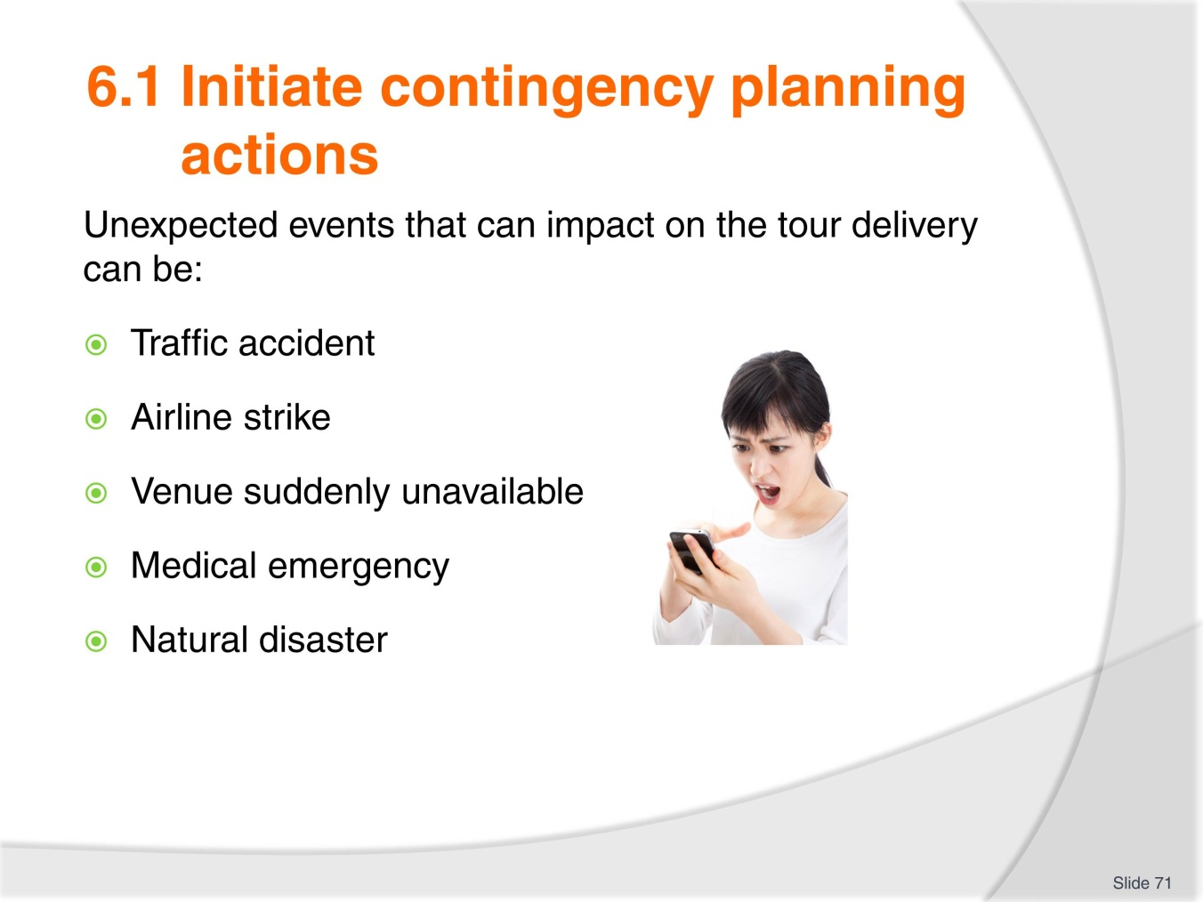
Slide No | Trainer Notes
 | Trainer to explain this list is not exhaustive and ask trainees for other examples.

Slide
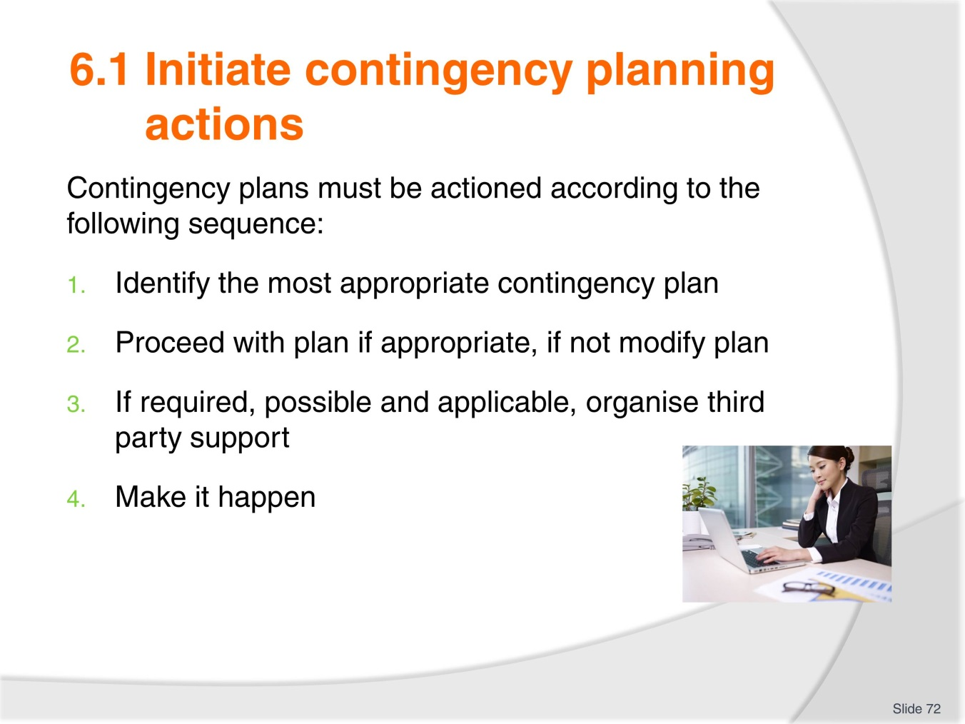
Slide No | Trainer Notes
 | Trainer to detail each step and options to make sure the contingency planning actions are the best for dealing with the unexpected event.

Slide
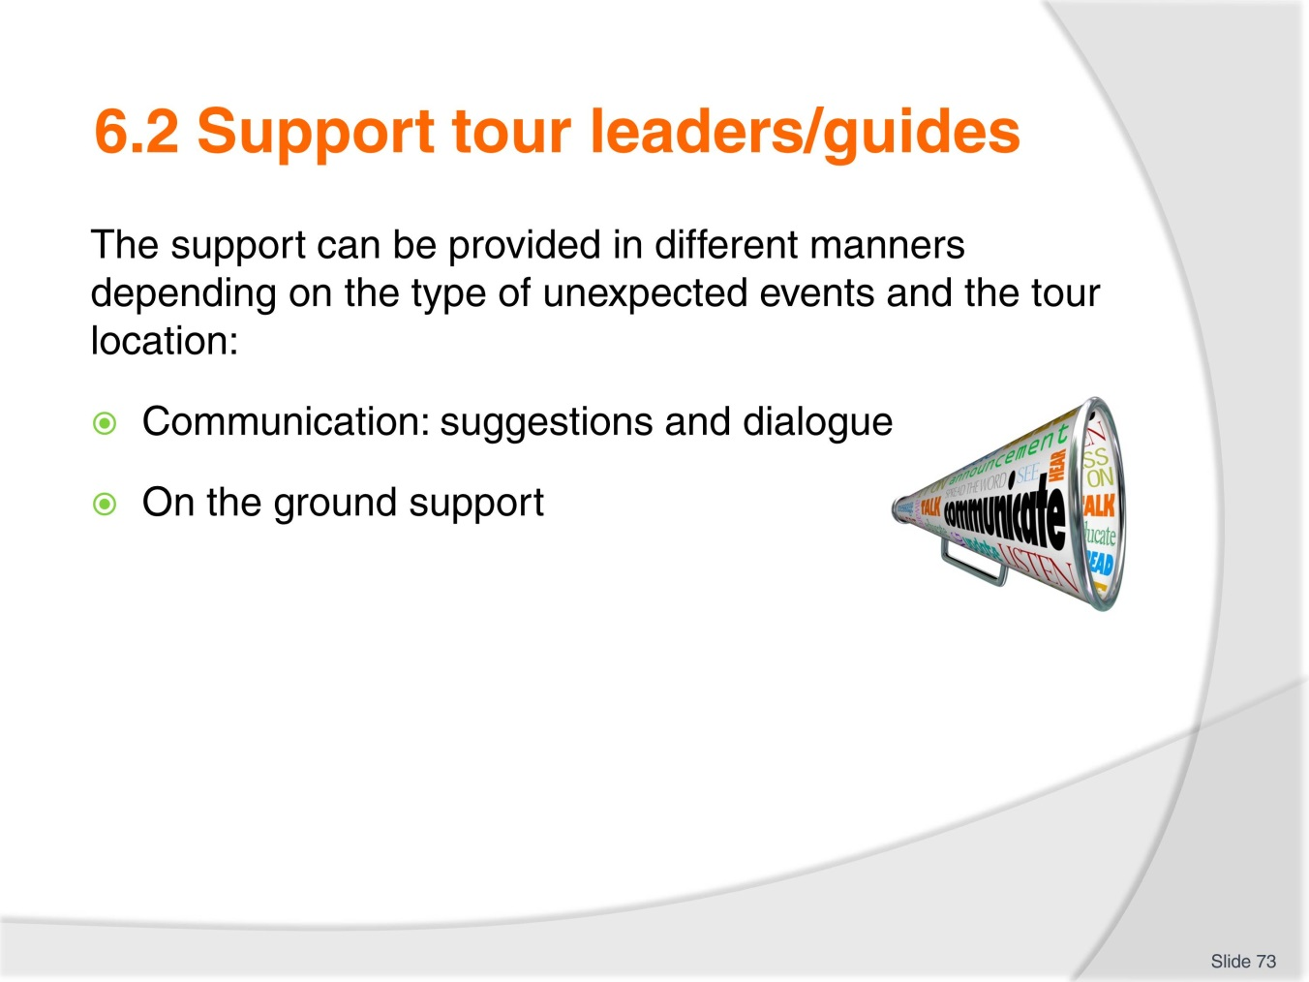
Slide No | Trainer Notes
 | Trainer to insist on the importance of the 2 topics , one being more office based and the other one on the ground support.

Slide
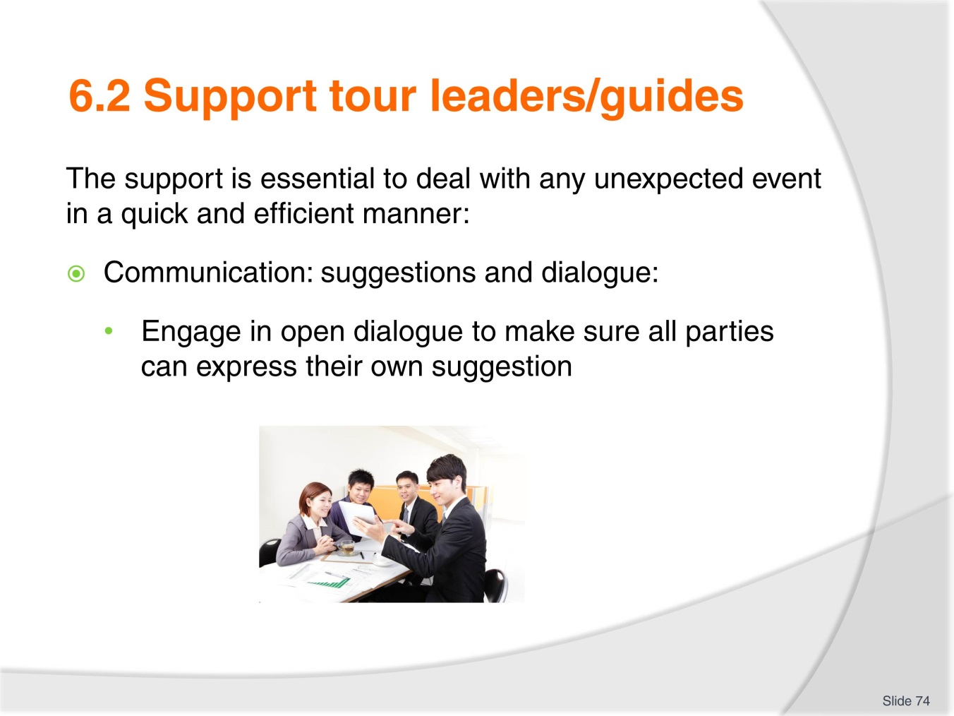
Slide No | Trainer Notes
 | Trainer to stress how important it is to listen to all parties as they might come from difference perspective and offer different strategies to deal with the unexpected event. The office based staff might have had more time to do research as the staff on the ground.

Slide
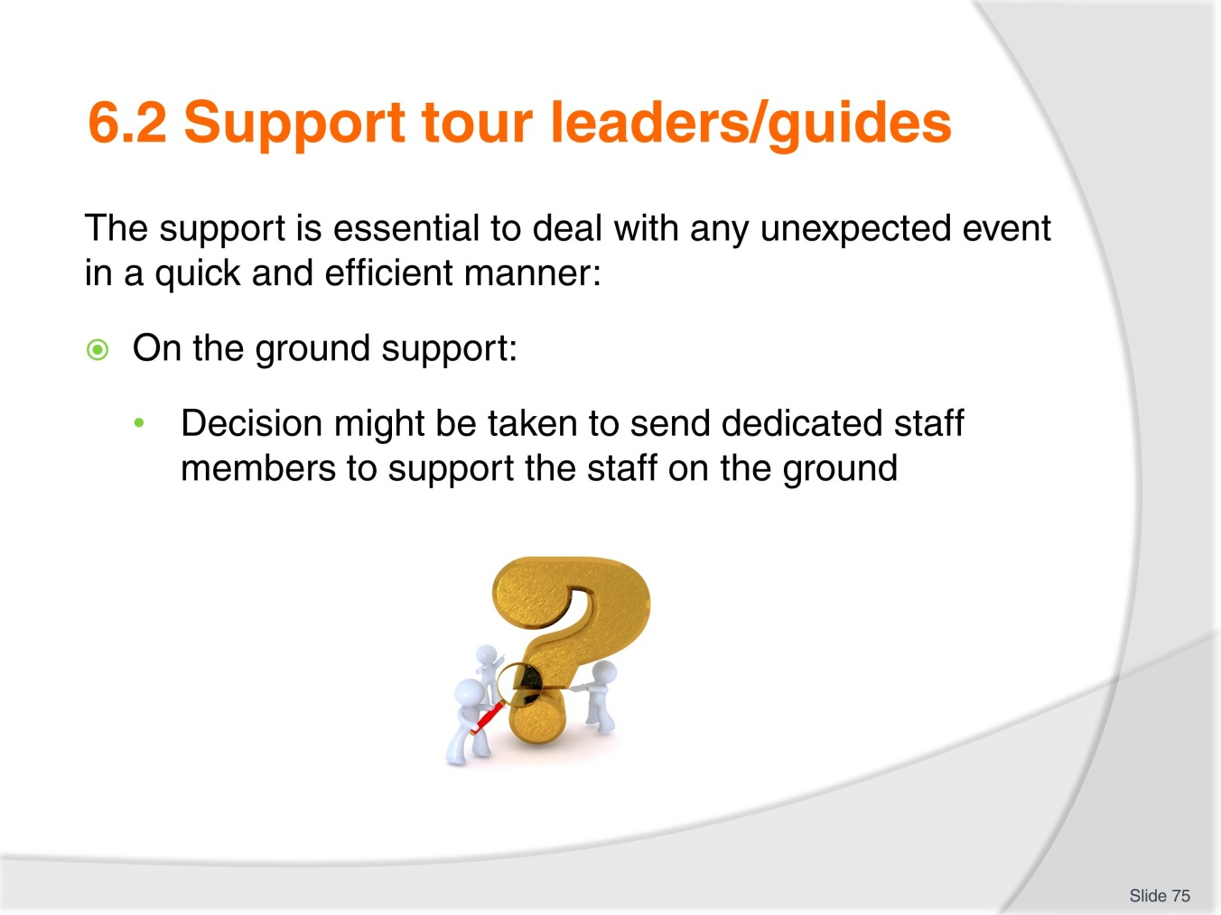
Slide No | Trainer Notes
Trainer to go over the examples in the workbook and explain the difference between a:
- Crisis management team
- Designated business representative.
Trainer to ask the trainees to write, in their own words, how sending staff on the ground will provide moral support.

Slide
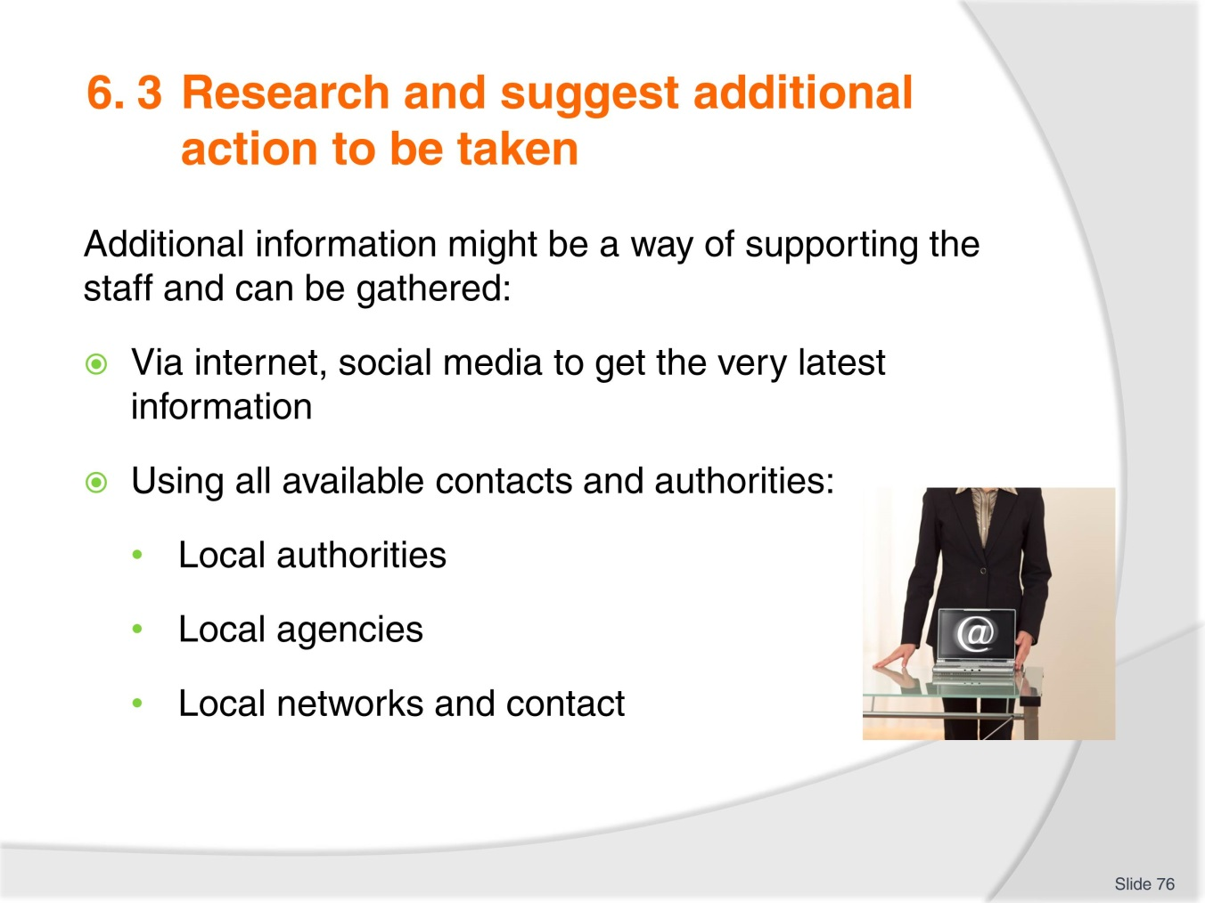
Slide No | Trainer Notes
 | Trainer to explain that ‘knowledge is power’ and one of the best outcome of data gathering is to find and get in touch with parties, people who have gone through the same unexpected even and discuss : what happened-what was one and how and use the information and experience.

Slide
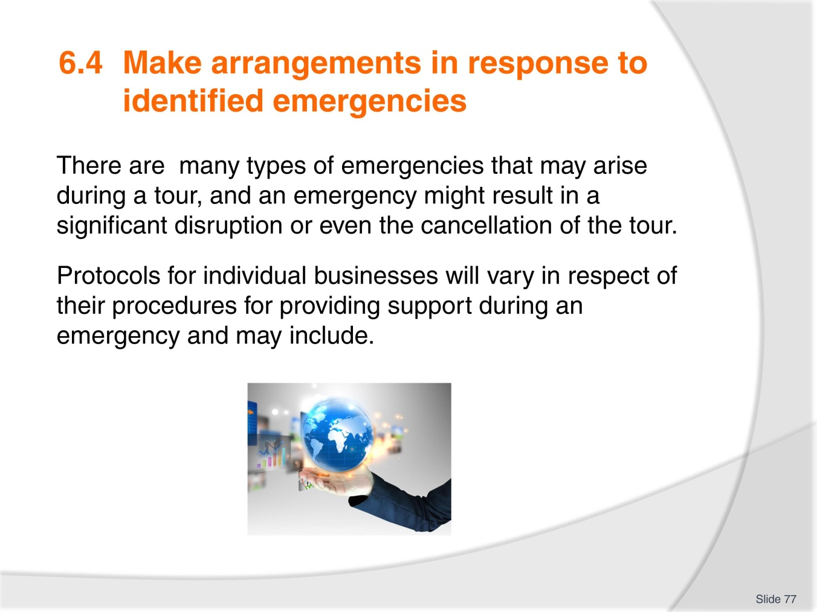
Slide No | Trainer Notes
 | Trainer to have a brainstorming session with trainees and list as many emergencies as possible on the board or flip chart.

Slide
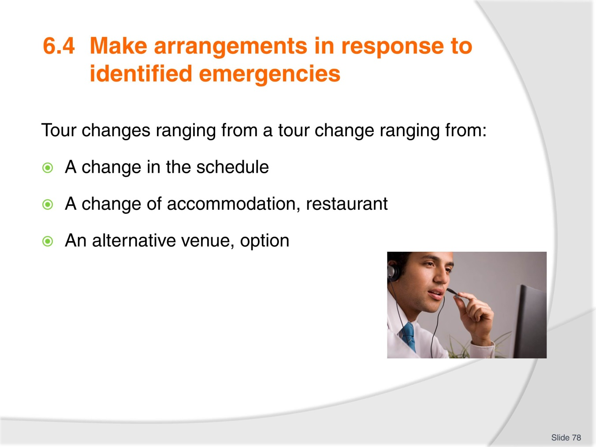
Slide No | Trainer Notes
Trainer to explain that any change needs to be take place with the minimum disruption for the tour group members.
Trainer to direct the trainees to do complete research on how various organisations dealt with the Iceland volcano eruption situation in April 2009 when 100,00 planes were grounded and 10 million passengers stranded at some point in time and their travel plans disrupted . Findings to be shared with the class.

Slide
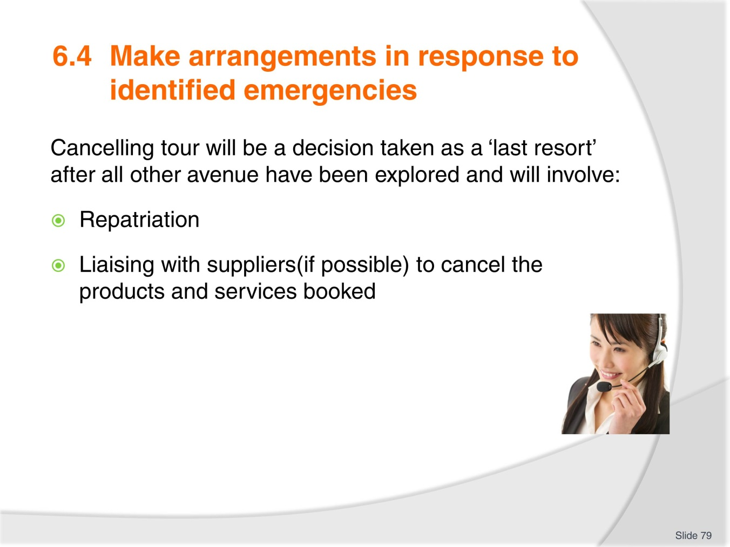
Slide No | Trainer Notes
Trainer to insist on the fact that a tour that has already started will be cancel only as a last resort.
Discuss the points on slide with trainees.
Discuss the possible flow on effect in regards to the host enterprise, tour operator reputation.

Slide
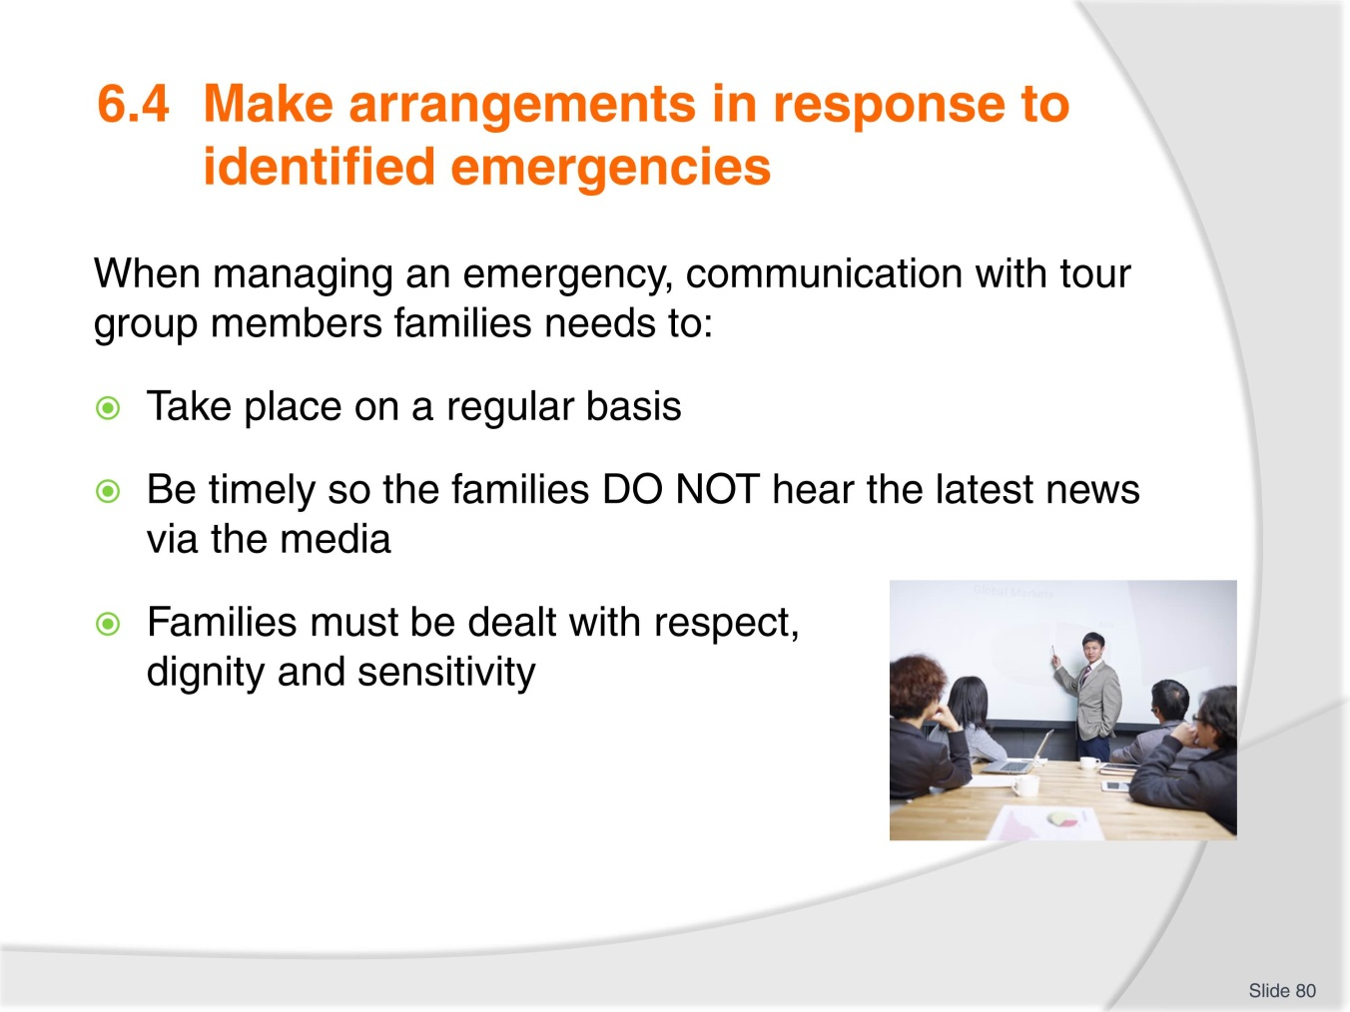
Slide No | Trainer Notes
 | Trainer to impart on the trainees the importance of this public relation aspect of an emergency.

Slide
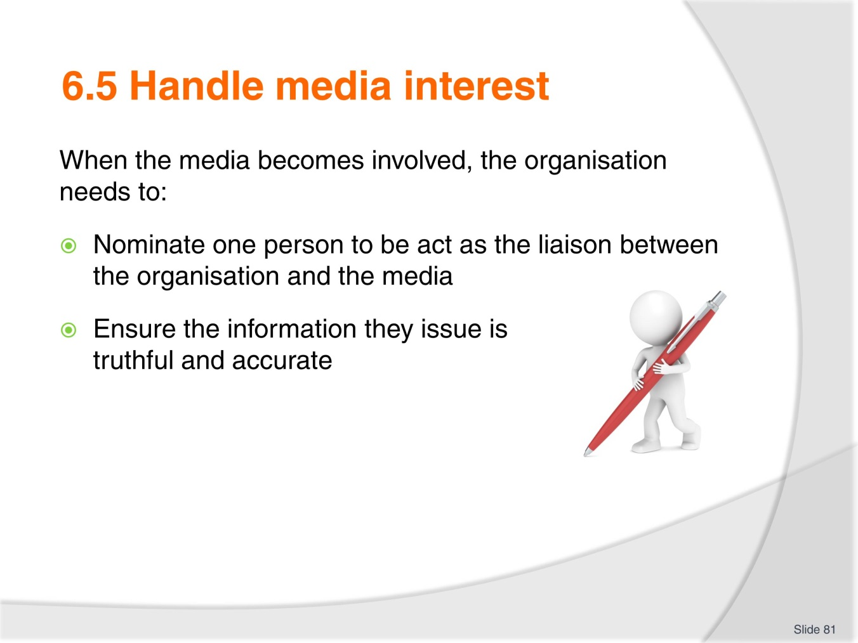
Slide No | Trainer Notes
Trainer to explain each organisation should have a protocol in place for those times when the media will become involved.
Trainer and trainees to do some research and/or use recent publicised tour unexpected events and discuss how each company, organisation dealt with the media attention from printed media to Facebook and twitter.

Slide
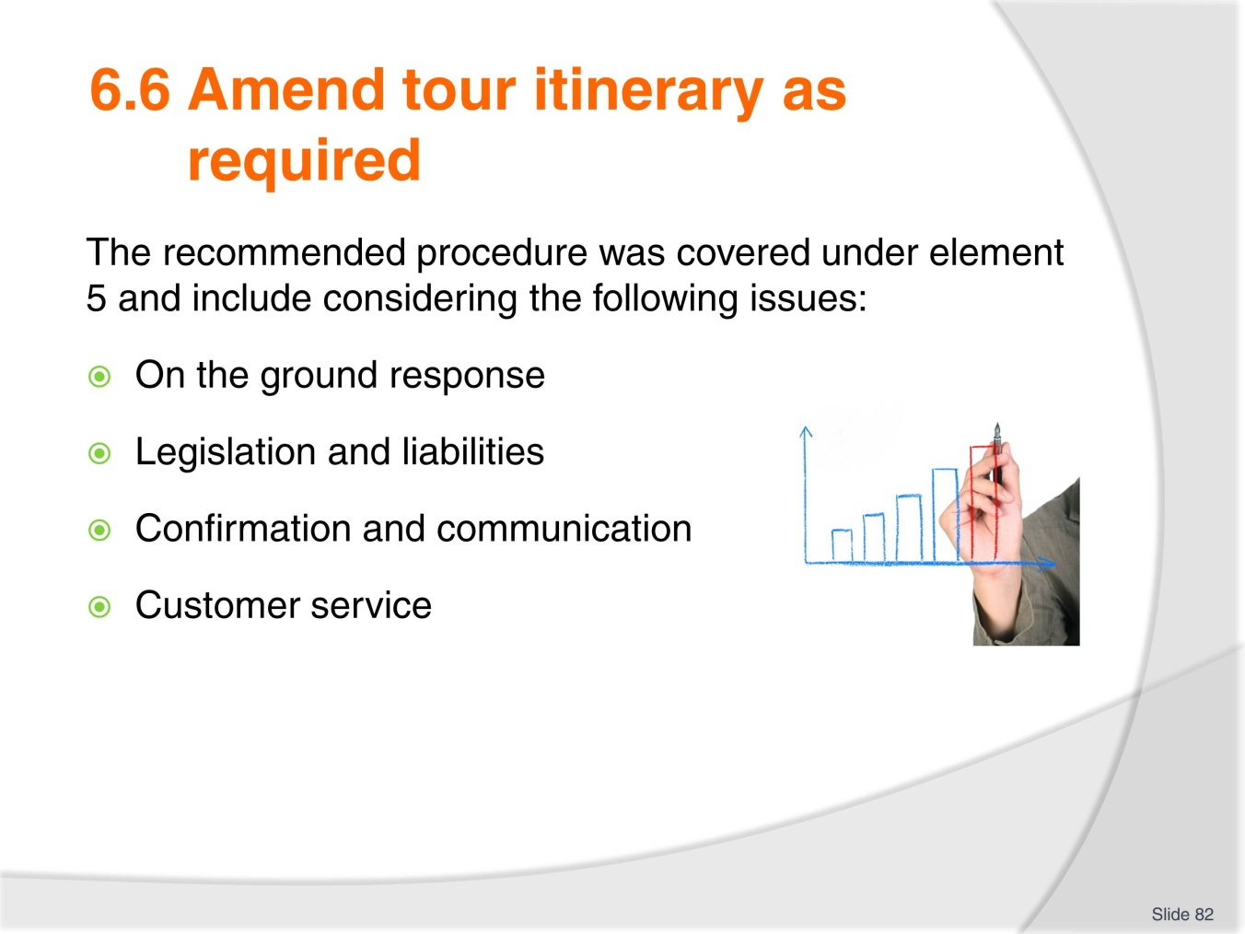
Slide No | Trainer Notes
 | Trainer to use this as revision from 5.3.

Slide
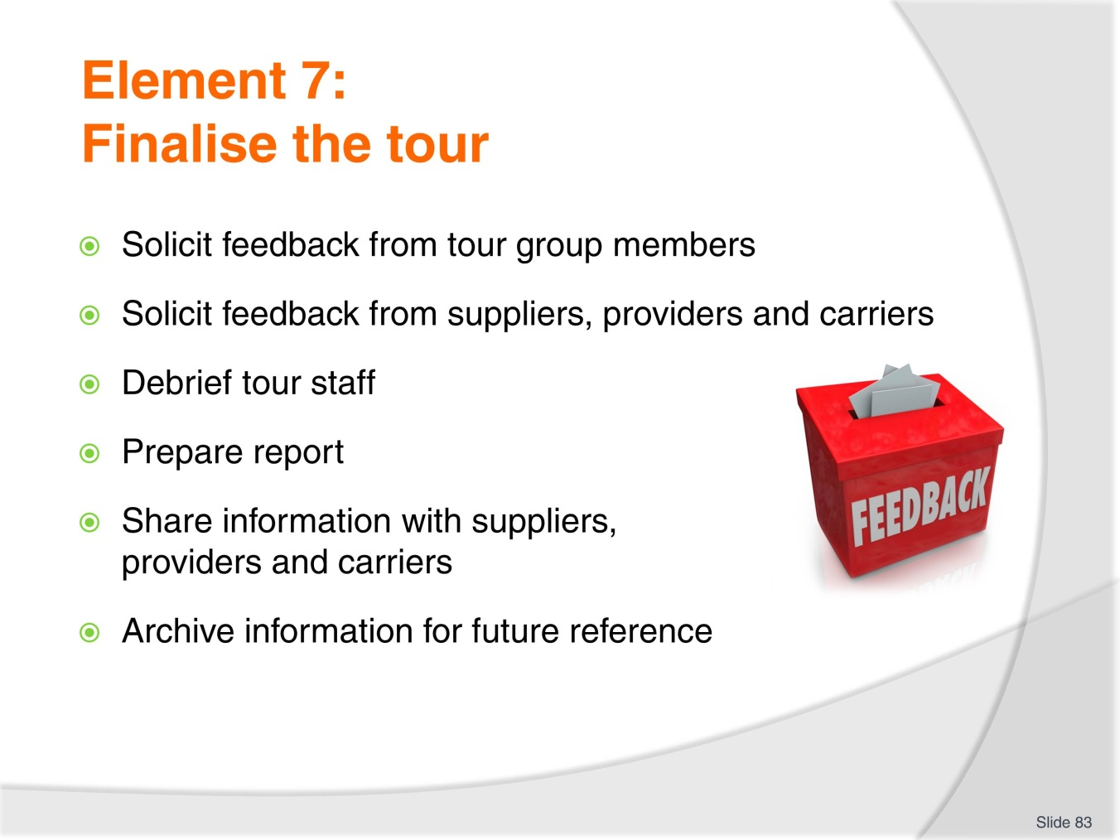
Slide No | Trainer Notes
Trainer to explain this is the last element of the unit and it covers the tasks to complete after the tour completion:
- This element has 6 topics (criteria).

Slide
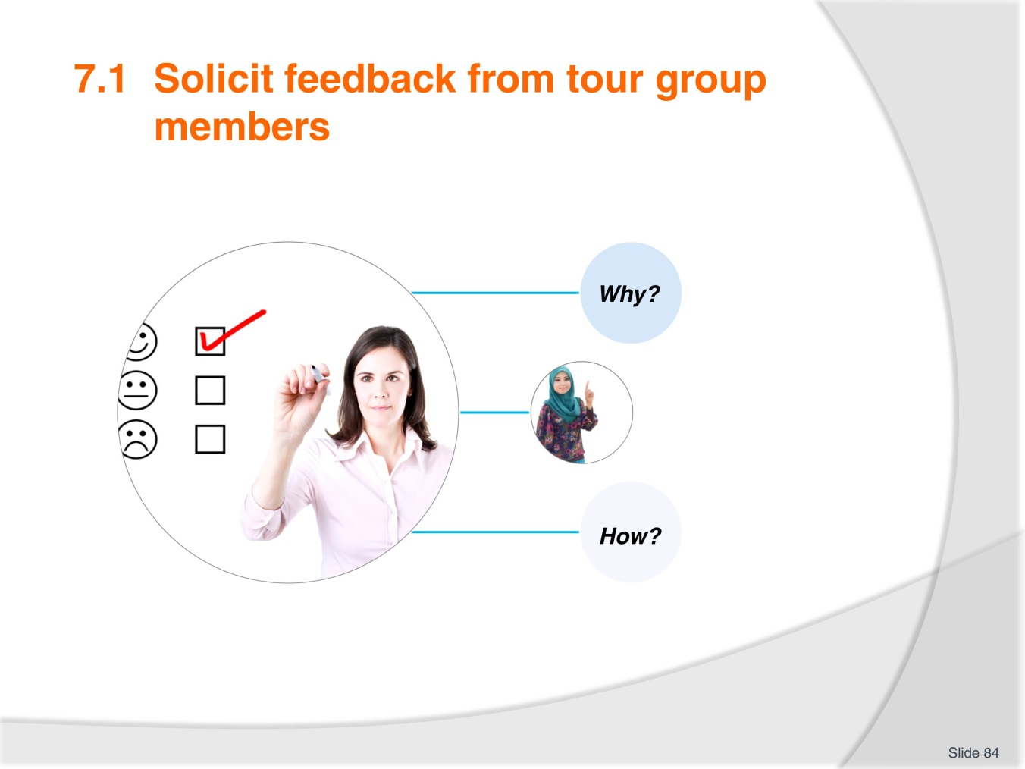
Slide No | Trainer Notes
Trainer to explain the importance of feedback from all concerned parties. Feedback enables any organisation to know how they are doing with customers and criticism should be seen as an opportunity to improve.
Trainees to research the various ways feedback can be obtained and share with the class.

Slide
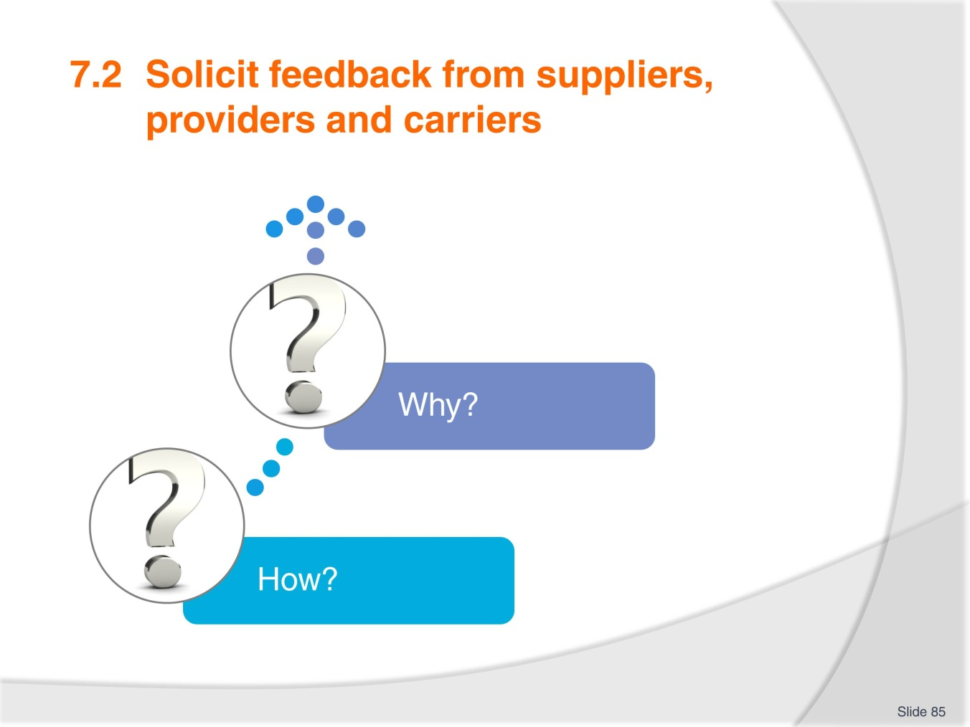
Slide No | Trainer Notes
Trainer to explain that the industry colleagues you work with can also provide useful feedback on your tours, business and potential ways to improve the way you conduct your business, identify trends and your relationship with them.
How you obtain can be similar to soliciting feedback from tour group members: verbal, written, questionnaires, web based feedback.
Trainees to work in pairs and pretend they are a product or service supplier for a large tour operator: what would they expect from the company so the business relationship is viable and strong? All findings to be shared and discussed further.

Slide
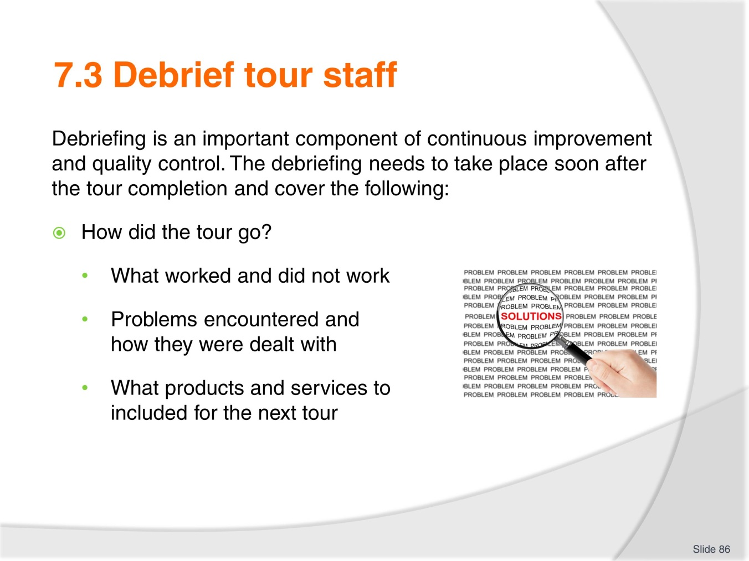
Slide No | Trainer Notes
Trainer to cover the various aspects to cover to support the organisation continuous improvement and quality control.
What worked and did. If any problem/s, what happened and how was it handled/were they handled?
This is the first stage of the debrief.

Slide
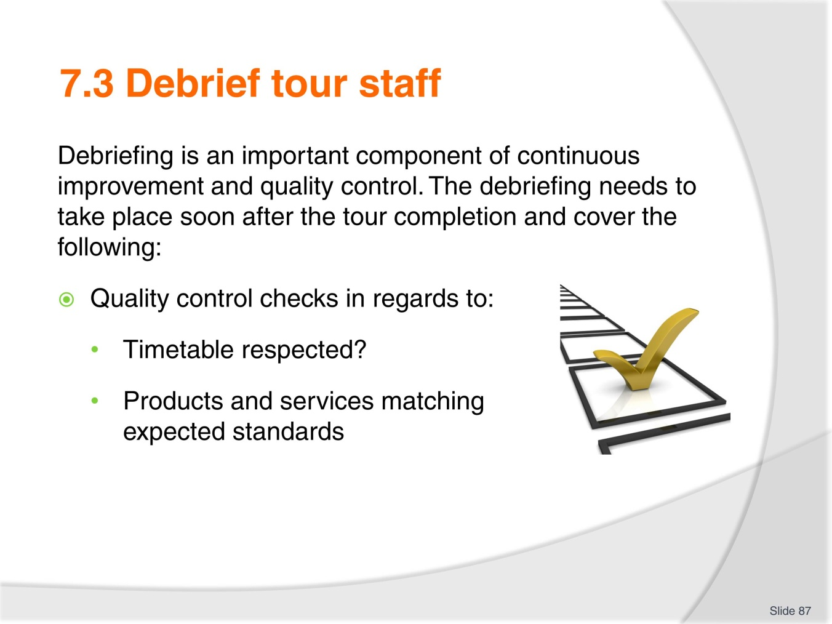
Slide No | Trainer Notes
The second stage deals with quality control components such as:
- Was the timetable followed?
- Was the delivery of services matching the products and services standards?

Slide
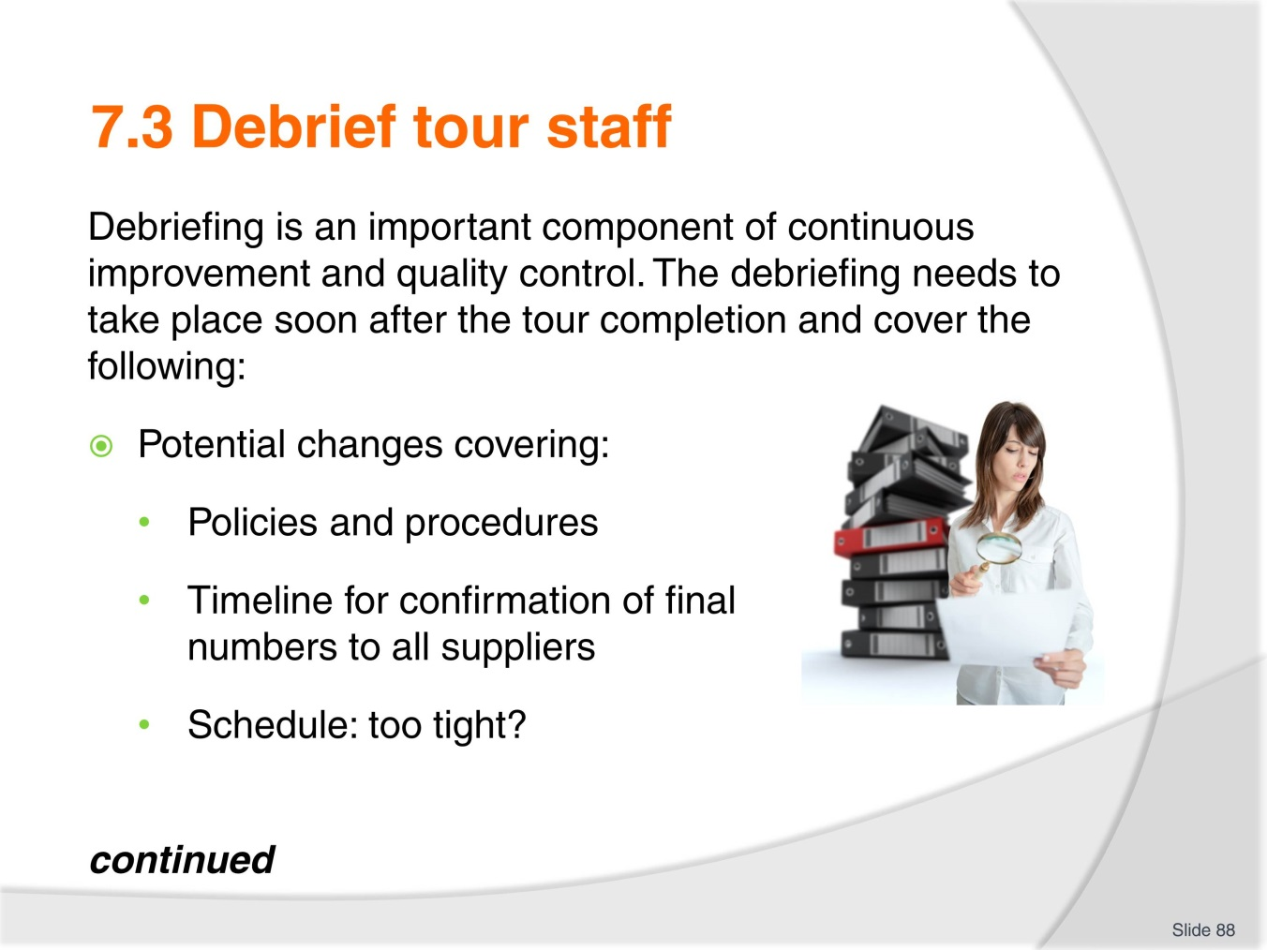
Slide No | Trainer Notes
Last stage:
Potential changes : trainer to explain the debrief is an opportunity to get the tour staff feedback ‘first hand’ as they are on the ground and experience firsthand what works or not.

Slide
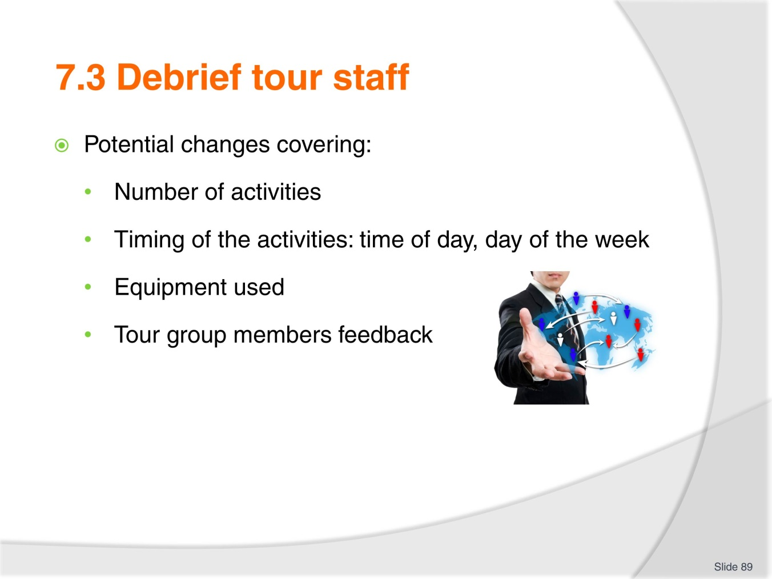
Slide No | Trainer Notes
Trainer to explain the more feedback, the better
Class activity
Trainees to do some research via phone, internet, or even using the trainer’s industry connections to find out:
- 1 or 2 organisations Standard Operating Procedures in regards to the timeline between a tour completion and the tour staff debrief.
Trainees to share their findings with the rest of the class when they have gathered the information.

Slide
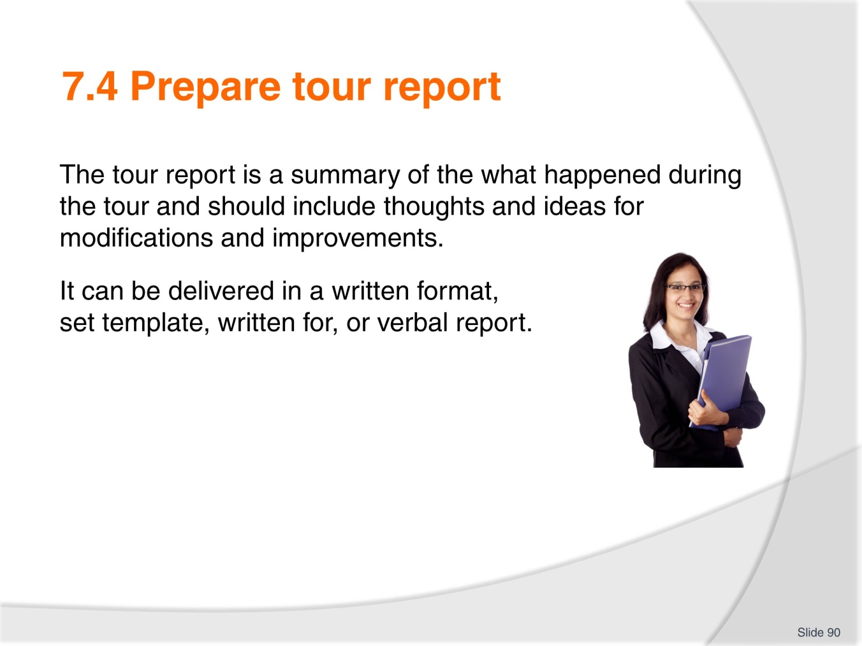
Slide No | Trainer Notes
Trainer to clarify that the tour report is indeed a summary of what happened during the tour and , in most organisations, is simply the extension of the debrief.
Trainees to research on the internet templates that could be used for a tour report and present them to the class explaining their choice.

Slide
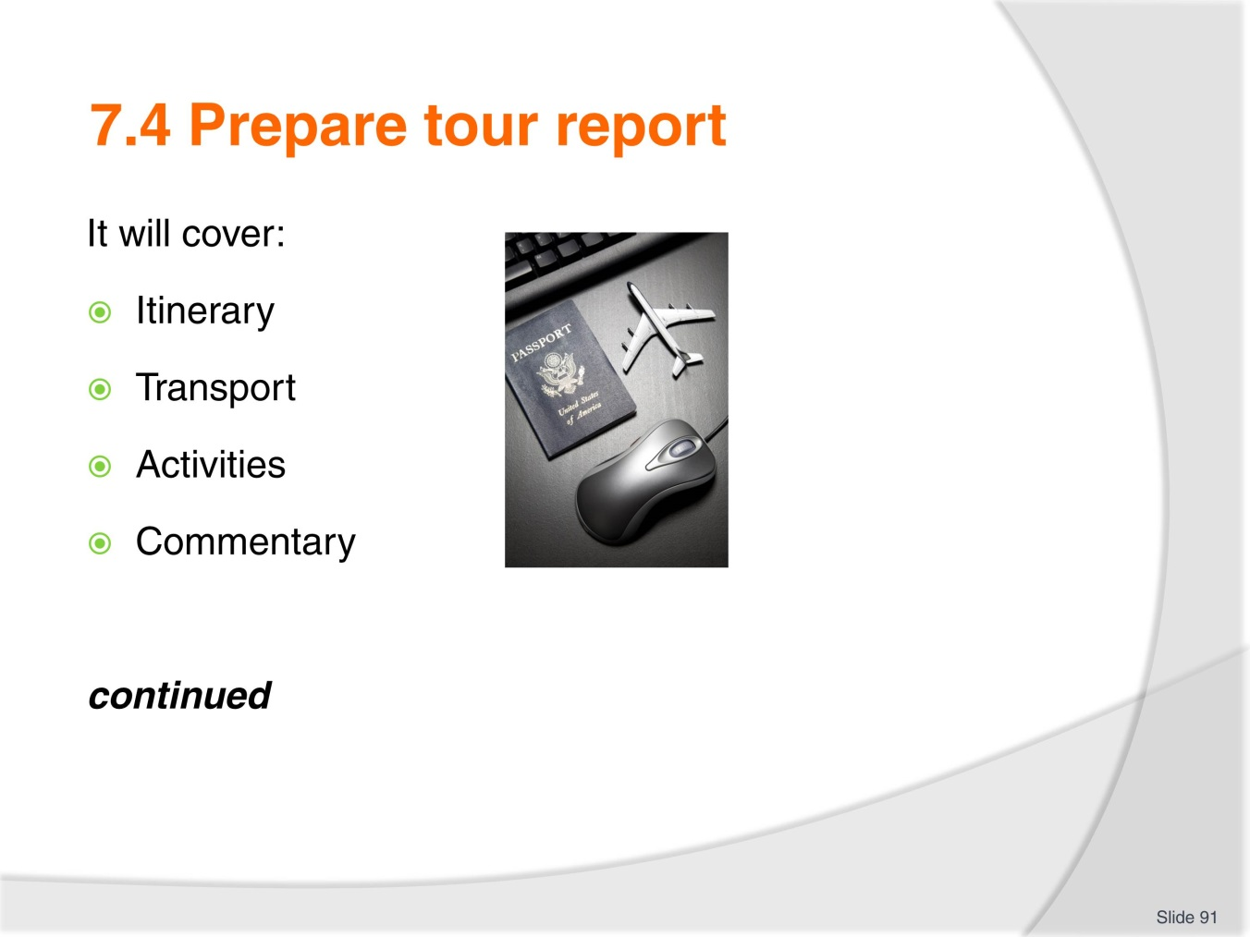
Slide No | Trainer Notes
 | Trainer to ask each trainee to list one topic, item that can be part of the tour report and write it on board.

Slide
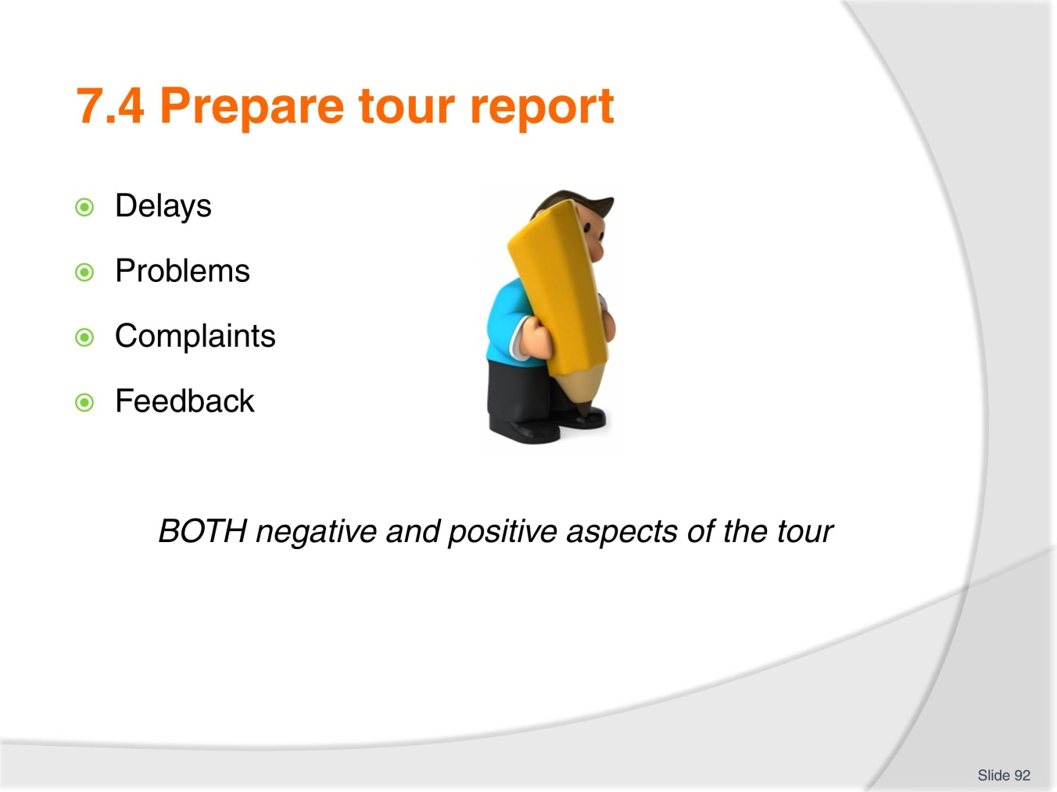
Slide No | Trainer Notes
Trainer to ask each trainee to list one topic, item that can be part of the tour report and write it on board.
Once the list is completed, trainees to research on the internet templates that could be used for a tour report and present them to the class explaining their choice.

Slide
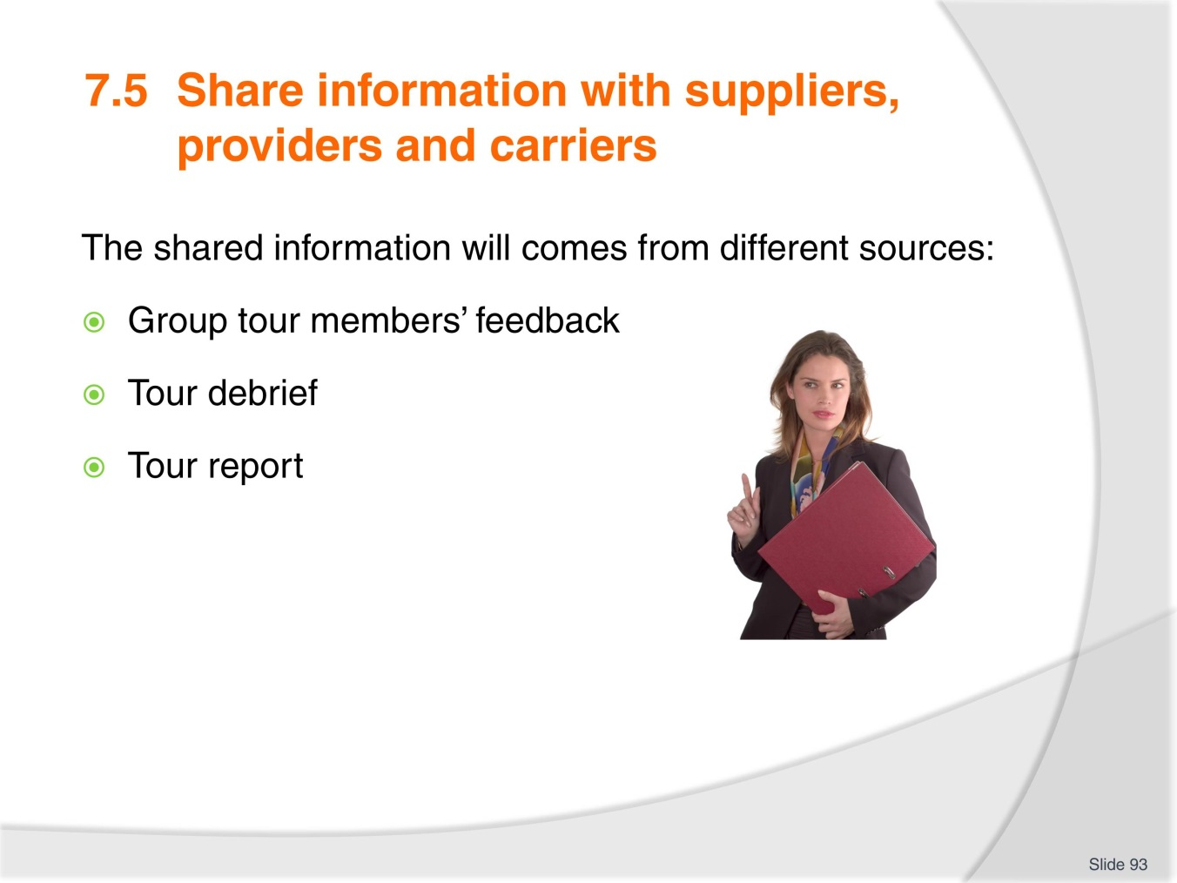
Slide No | Trainer Notes
Trainer to insist on the importance of sharing all the information obtained as part of the debrief/report with all the industry partners having provided products, services to the tour and also remind trainees the information needs to be qualitative and quantitative(sales numbers etc.)
- Trainees to work in groups of 3 or 4 and write
- 1 advantage in sharing the information with suppliers, providers and carriers
- 1 disadvantage in sharing the information with suppliers, providers and carriers.

Slide
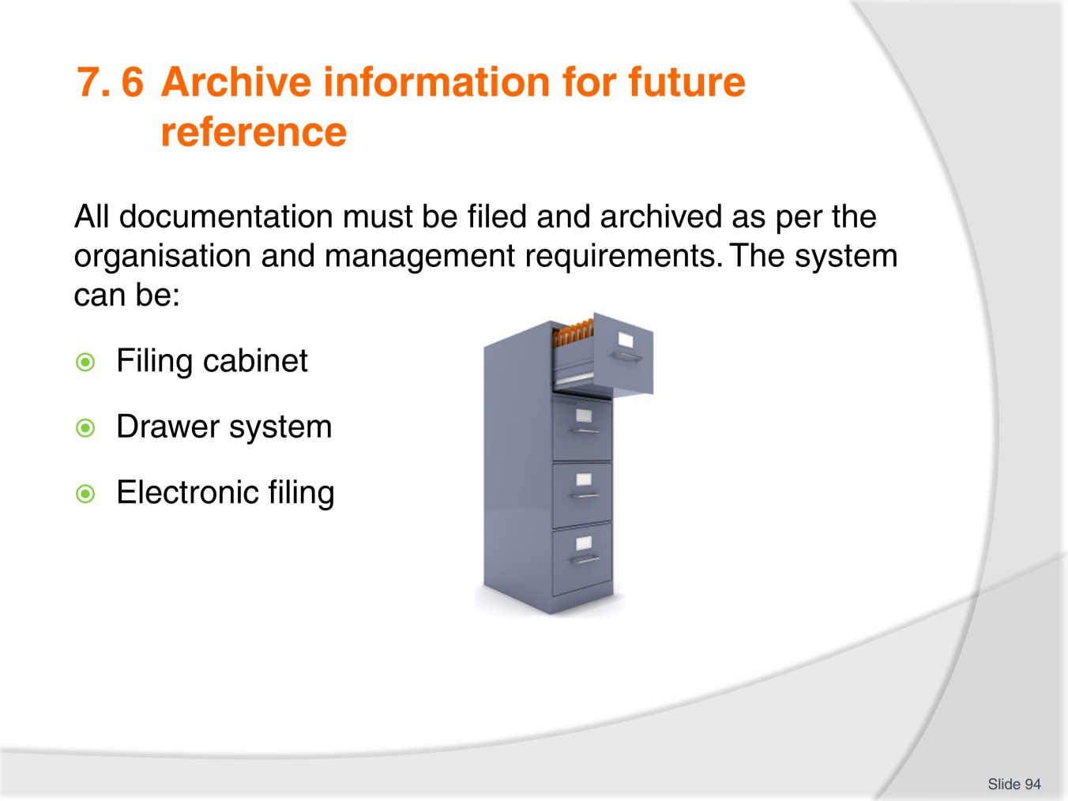
Slide No | Trainer Notes
 | Trainer to explain that the archiving system will be different from one organisation to the other, stressing that nowadays electronic filing is become prevalent.

Slide
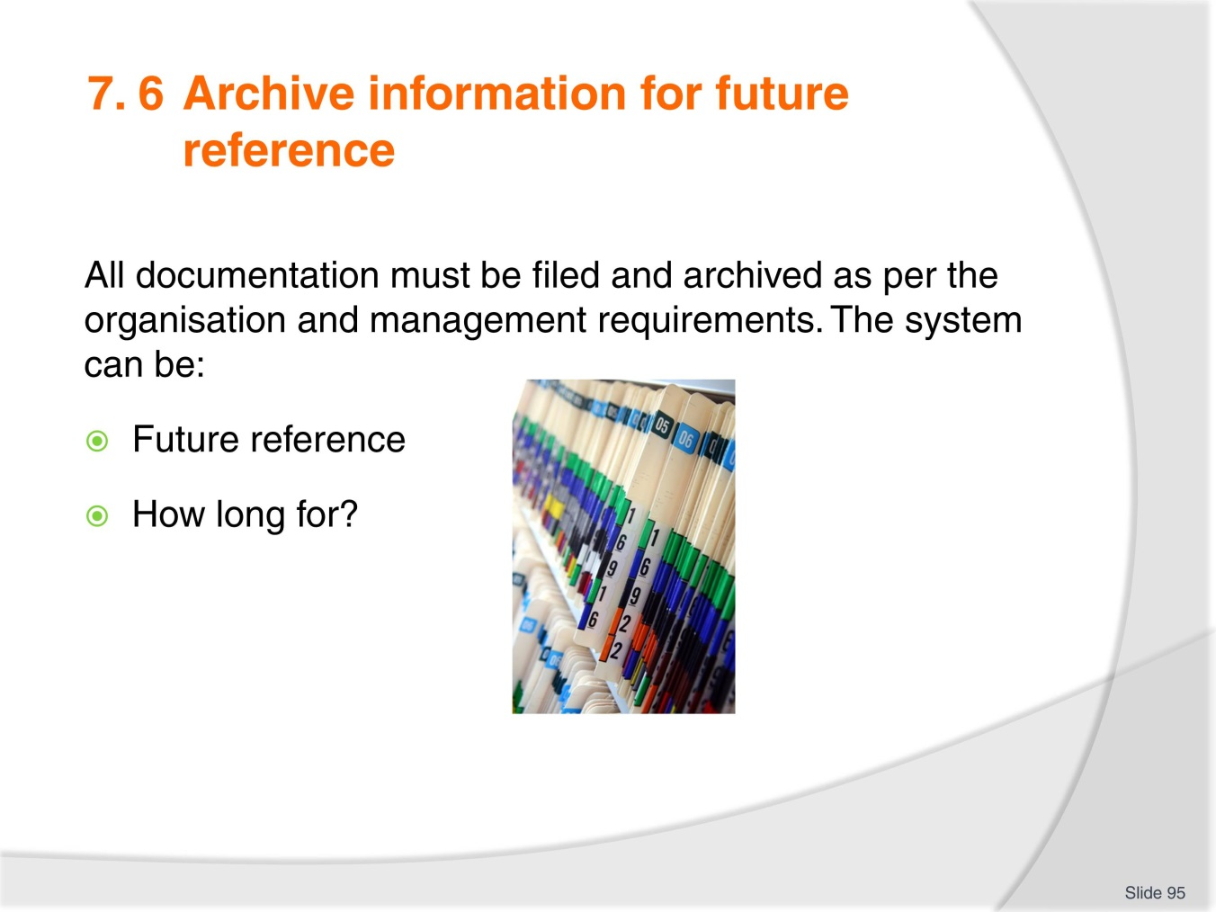
Slide No | Trainer Notes
Trainer to discuss with the trainees why is important is to make sure the information will be easy to access for future reference
Lastly, explain to the trainees that every organisation needs to follow the law or regulations in regards to how long official documents need to be kept for. This varies depending on the country.

Recommended training equipment
- Computers (one per student) with internet and email access
- Note pads and pens
- Board and Flip charts
- Printer
- Printing paper
- Templates for checklists (if appropriate)
- Examples: hard copies and soft copies of tour operators terms and conditions.

Instructions for Trainers for using
PowerPoint – Presenter View
Connect your laptop or computer to your projector equipment as per manufacturers’ instructions.
In PowerPoint, on the Slide Show menu, click Set up Show.
Under Multiple monitors, select the Show Presenter View check box.
In the Display slide show on list, click the monitor you want the slide show presentation to appear on.
Source: http://office.microsoft.com
Note:
In Presenter View:
You see your notes and have full control of the presentation
Your trainees only see the slide projected on to the screen
More Information
You can obtain more information on how to use PowerPoint from the Microsoft Online Help Centre, available at: http://office.microsoft.com/training/training.aspx?AssetID=RC011298761033
Note Regarding Currency of URLs
Please note that where references have been made to URLs in these training resources trainers will need to verify that the resource or document referred to is still current on the internet. Trainers should endeavour, where possible, to source similar alternative examples of material where it is found that either the website or the document in question is no longer available online.

Appendix – ASEAN acronyms
AADCP | ASEAN – Australia Development Cooperation Program
ACCSTP | ASEAN Common Competency Standards for Tourism Professionals
AEC | ASEAN Economic Community
AMS | ASEAN Member States
ASEAN | Association of Southeast Asian Nations
ASEC | ASEAN Secretariat
ATM | ASEAN Tourism Ministers
ATPMC | ASEAN Tourism Professionals Monitoring Committee
ATPRS | ASEAN Tourism Professional Registration System
ATFTMD | ASEAN Task Force on Tourism Manpower Development
CATC | Common ASEAN Tourism Curriculum
MRA | Mutual Recognition Arrangement
MTCO | Mekong Tourism Coordinating office
NTO | National Tourism Organisation
NTPB | National Tourism Professional Board
RQFSRS | Regional Qualifications Framework and Skills Recognition System
TPCB | Tourism Professional Certification Board





